You’re Ref: hull-25431
29/05/15

Dear Sirs

RE: Cindy Marie Parsonage 12/01/1964
With reference to the above, we are pleased to report that the subject has been traced to the
NEW ADDRESS as follows:

Address : 37 East End Road Preston Hull HU12 8UJ
Phone: 07939638477

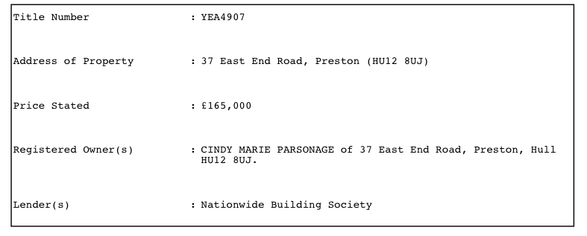

The subject is the sole registered owner of the above property. There is a mortgage attached with Nationwide Building Society.

We can advise that a Mr Cameron Young is also known at the address with the subject.

We would advise some surveillance at the above address to obtain further evidence

Kindest Regards
Roubina Ahmed
Roubina Ahmed
Senior Case Manager

This report does not include any information disclosed in breach of the Data Protection Act 1984 (as amended) or obtained by any improper or unlawful means.

