A simple and straight-forward directory comparer tool with Java. Choose folder 1, choose folder 2, click on run button, comparison is done and a text file is output. The screenshots below show the idea of what I am looking for. When you open the executable file (jar file?), the dialog opens.

Select the 2 folders, then click the Start button. The comparison runs.
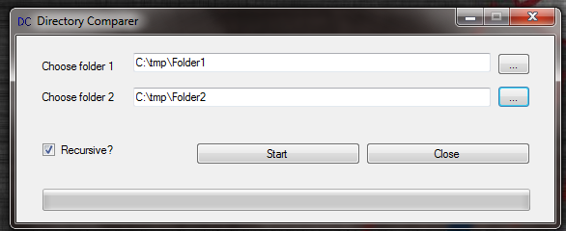

The output should be a text file that shows file name, folder and whether they match, exists is folder 1 or exists in folder 2.
