Scenario
We grade Discussion Boards and Individual Projects using three project criteria: Task Requirements, Demonstration and Application of Knowledge, and Academic Writing and Format. We score each project criterion using four performance values: Unsatisfactory, Developing, Effective, and Proficient. Please see the following tables for the details.
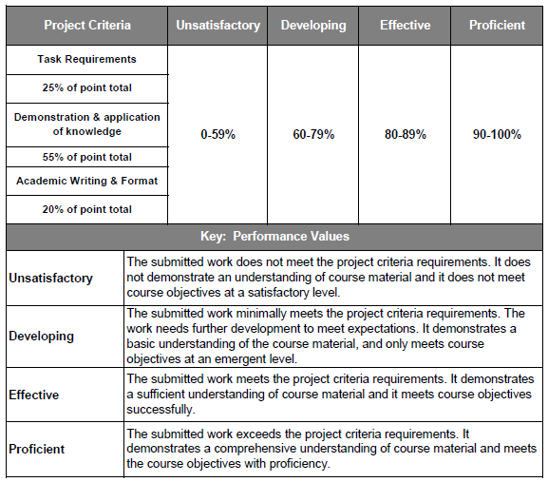
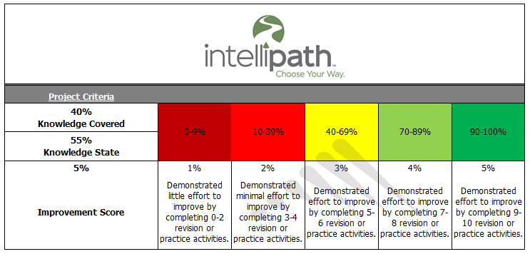
Apix Printing, Inc.
Apix Printing, Inc. is a private, domestic United States printer of periodicals, newspaper inserts, and advertising materials that accompany distributions of Sunday and weekday circulations of large metropolitan newspapers. The company, headed by chief executive officer (CEO) John Matthews, generates $450 million in revenues from three product lines (periodicals, inserts, and advertising) and has long-term contracts with several large U.S. retailers to produce weekly sales flyer inserts as well as metropolitan newspapers to produce Sunday magazine inserts and coupons. Its printing presses are characterized by offset print technology and are capable of high-capacity output; in addition, the company recently migrated to water-soluble inks, which considerably reduces manufacturing emissions.
The company’s executive team, employees, and above all, its vice president (VP) of Production, Luke Stewart, are committed to environmentally-sustainable manufacturing practices. Presently, the only substrate Apix uses is paper, specifically newsprint of various weights. Trim and waste are recycled in accordance with the company’s sustainability commitment. Manufacturing divisions are geographically aligned with customers’ locations to minimize logistics costs and response time to customer requirements; however, a centralized corporate entity administers functions such as human resources, information technology, and financial reporting. The VP of sales and administration, James Simeon, oversees administration and quality compliance among the various divisions. There are presently five manufacturing divisions: Northwest, Southwest, Northeast, Southeast, and Midwest.
Currently, Apix is only marginally profitable, and as such, the chief financial officer (CFO), Mary Francis, has indicated that external financing will be required to support a company expansion into a new segment of the printing sector: food packaging. This endeavor will require new investments in equipment as well as substrate inventory; promotional costs will also increase. In addition, Timothy Russell, the new Audit Committee Chair, has pointed out that the company’s compliance with the requirements of the Sarbanes-Oxley Act (SOX) will also cause administrative costs to increase. Following the requirements is paramount to successfully file a registration statement and to issue equity to shareholders in an initial public offering (IPO).
As the newly hired VP of finance, you report to the CFO. In this capacity, your responsibilities include preparation of financial statements, comparative analysis and benchmarking to sector performance, and the assessment of new business investment opportunities to grow Apix’s expansion endeavors in a challenging market.

