Effects of Grade Point Average and Gender on Finals Scores:
Data Analysis and Application (DAA)
Maretta Hudson
Capella University

Effects of Grade Point Average and Gender on Finals Scores: Data Analysis and Application (DAA)
The following examines the correlation of grade point average, gender, and finals scores. The hypothesis formed is as follows: Individuals with higher grade point averages will score higher on finals than those with lower grade point averages. Gender should play little part in the scores in comparison to grade point averages.
Data File Description
Statistics were run on the following variables: grade point average, finals scores, and gender. The hypothesis is that individuals with higher grade point averages will automatically score higher on finals than students with lower grade point averages. The total of participants for this data analysis and application is as follows: N=105. Scatter plots are employed to gather data.
The variables are gpa, gender, final, and total.
Testing Assumptions
Histograms provide insight into the specific variables and frequencies: grade point average (Table 1) and finals scores (Table 2). Testing assumptions are that greater frequencies of high grade point averages will equal greater frequencies of high test scores.

Table 1
Grade Point Average
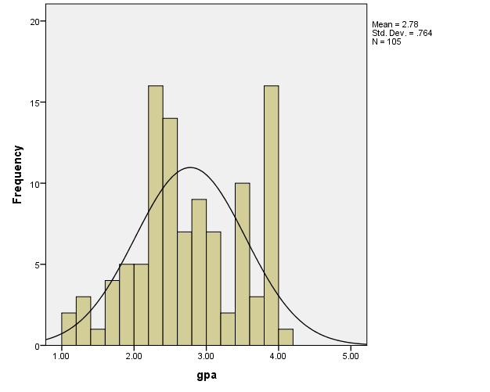

Table 2
Final Scores

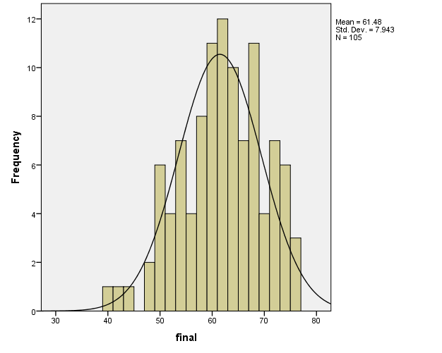

Table 3 provides the descriptive statistics for the above histograms.

Table 3
Descriptive Statistics

Descriptive Statistics
 | N | Mean | Std. Deviation | Skewness |  | Kurtosis
 | Statistic | Statistic | Statistic | Statistic | Std. Error | Statistic | Std. Error
gpa | 105 | 2.7789 | .76380 | -.052 | .236 | -.811 | .467
final | 105 | 61.48 | 7.943 | -.335 | .236 | -.332 | .467
Valid N (listwise) | 105

The mean grade point average (GPA) is 2.7789, while the mean final score is 61.48. Those statistics prove that higher GPA’s do not always equal higher test scores. More variables are needed to understand the score differences in conjunction with the GPA’s.
More information needed: Check Unit 5’s introduction that goes over all of the assumptions for the correlation. The assumption of normality is tested using a visual interpretation of the histograms. You are missing that entirely. Describe the histograms in terms of skewness, kurtosis, modality, outlier, etc. Then at least list the other assumptions as well.
Research Question, Hypotheses, and Alpha Level
The null hypothesis for the research is that students with higher grade point averages will score higher on final tests. The alternative hypothesis for the research is that individual factors (i.e. gender), rather than the one variable (GPA), affect final test scores. The following alpha levels apply: 1% and 5%.
You are missing a research question. Remember to frame it in the form of a question with a question mark. Remember that this is a correlation so you may want to word your null and alternative in terms of relationships rather than effects. The alpha is .05

Interpretation
Table 4 provides the scatter plot generated, and Table 5 provides the descriptive statistics/correlations for this research based on Pearson with alpha levels 1% and 5%.

Table 4
Scatter Plot
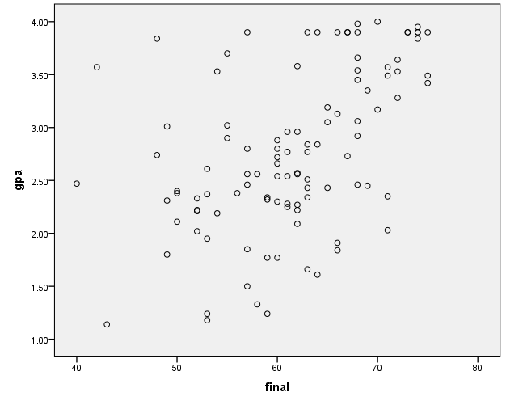

This scatter plot should go in the assumption section. Please move it. You also need to interpret the correlation that you can see in the scatterplot. Also you have the variables in the wrong places. GPA should be on bottom. Final should be on side (y axis).

Table 5
Descriptive Statistics/Correlations

Correlations
 |  | gpa | final | total | gender
gpa | Pearson Correlation | 1 | .498** | .432** | -.194*
 | Sig. (2-tailed) |  | .000 | .000 | .048
 | N | 105 | 105 | 105 | 105
final | Pearson Correlation | .498** | 1 | .883** | -.140
 | Sig. (2-tailed) | .000 |  | .000 | .156
 | N | 105 | 105 | 105 | 105
total | Pearson Correlation | .432** | .883** | 1 | -.120
 | Sig. (2-tailed) | .000 | .000 |  | .224
 | N | 105 | 105 | 105 | 105
gender | Pearson Correlation | -.194* | -.140 | -.120 | 1
 | Sig. (2-tailed) | .048 | .156 | .224
 | N | 105 | 105 | 105 | 105
**. Correlation is significant at the 0.01 level (2-tailed).
*. Correlation is significant at the 0.05 level (2-tailed).

As demonstrated, correlation is significant at the 1% and 5% alpha levels (2-tailed), reinforcing the null hypothesis that higher grade point averages equal higher test scores and rejecting the alternative hypothesis that other variables influence test scores. However, while reviewing Table 4, one may assume that the null hypothesis must be rejected because some students with higher GPA’s scored poorly on the test while some students with lower GPA’s scored higher on the test.
You are missing core information: Highest correlation is between what two variables? Lowest is between what two? What are the correlations and effect sizes? What is the correlation between GPA and Final? Use APA style results reporting.
Conclusion
In conclusion, this experiment is limited to one final test score in comparison with grade point averages. Although statistics indicate that higher GPA’s lead to higher test score, the testing is flawed. Other factors such as the type of test, time limit, physical and mental state of the students, etc. can affect testing scores. To be more accurate, different groups of students’ GPA’s and testing scores can be compared and other variables can be factored. However, to ensure that the null hypothesis is not rejected, alpha levels must remain low. On the other hand, by doing so errors can occur. For example, an Error 1 would be automatically assuming that students with high GPA’s always receive high test scores. Although the experiment and data set shows a strong correlation between the two factors, more research is needed.
Be very clear about strengths and limitations of using correlations in this section.

