DISNEY ITEMS
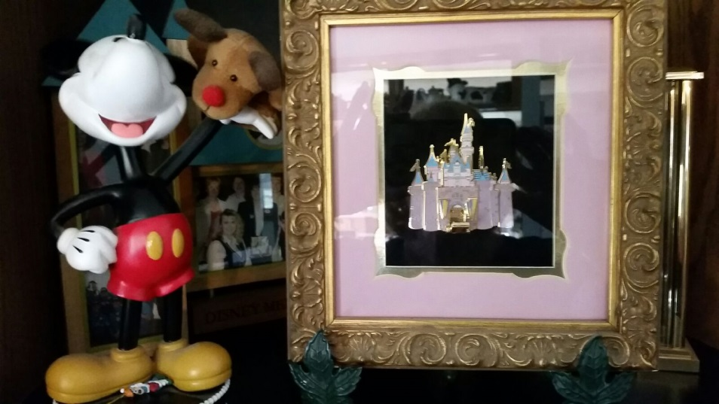Castle Pin framed. $50 This was a Cast member Exclusive limited
Edition pin I did for the Cast Members. I had a few framed and we sold them like that, big hit.

Goofy Large $500
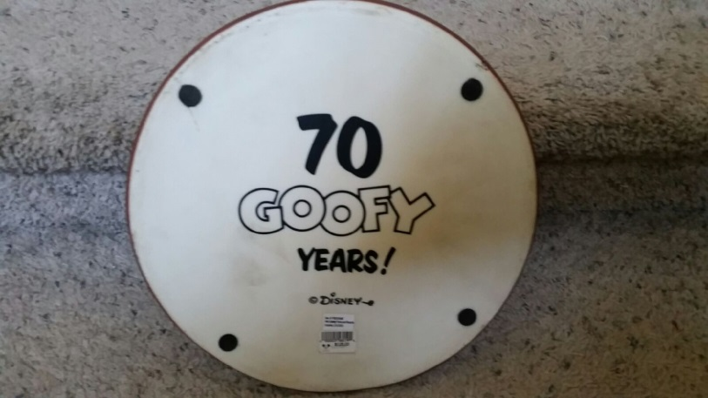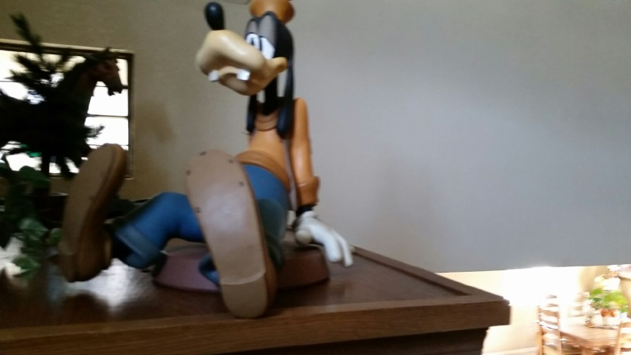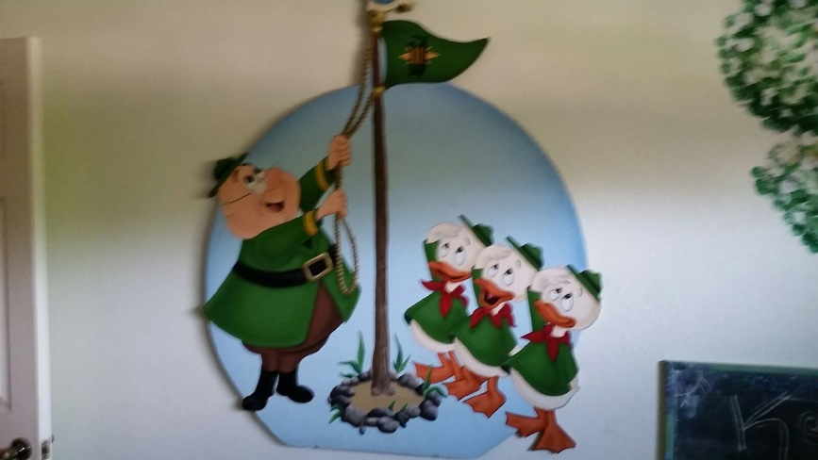Camp Woodlor. $200 This was one of the signs that was up at the
Very short lived Day Camp for Disneyland Employees. It is about 5 x 5 and is on foam core. I also have the original model sheets
And Brouchures about the camp.

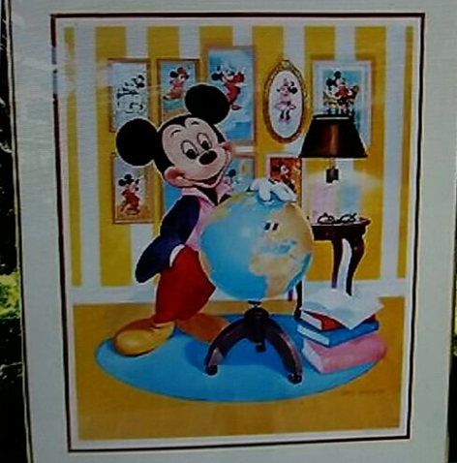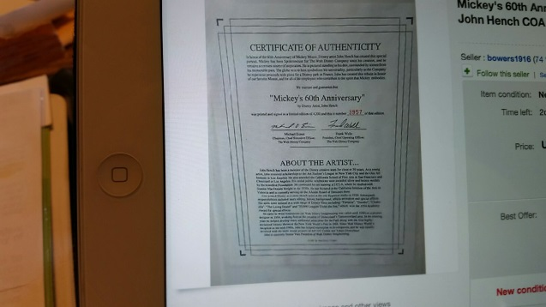
John Hench Mickey’s 60th Anniversary Litho signed and numbered $300

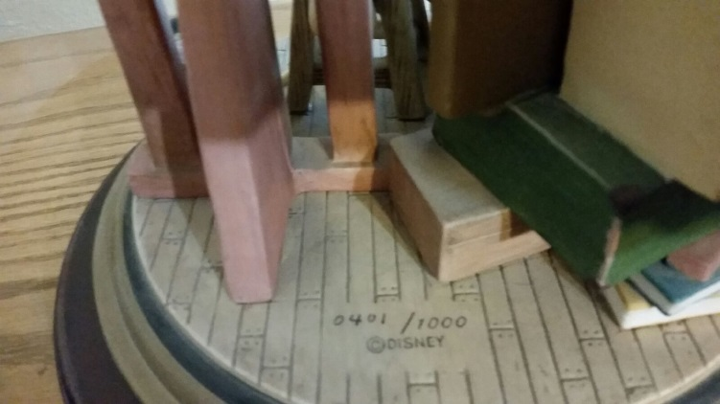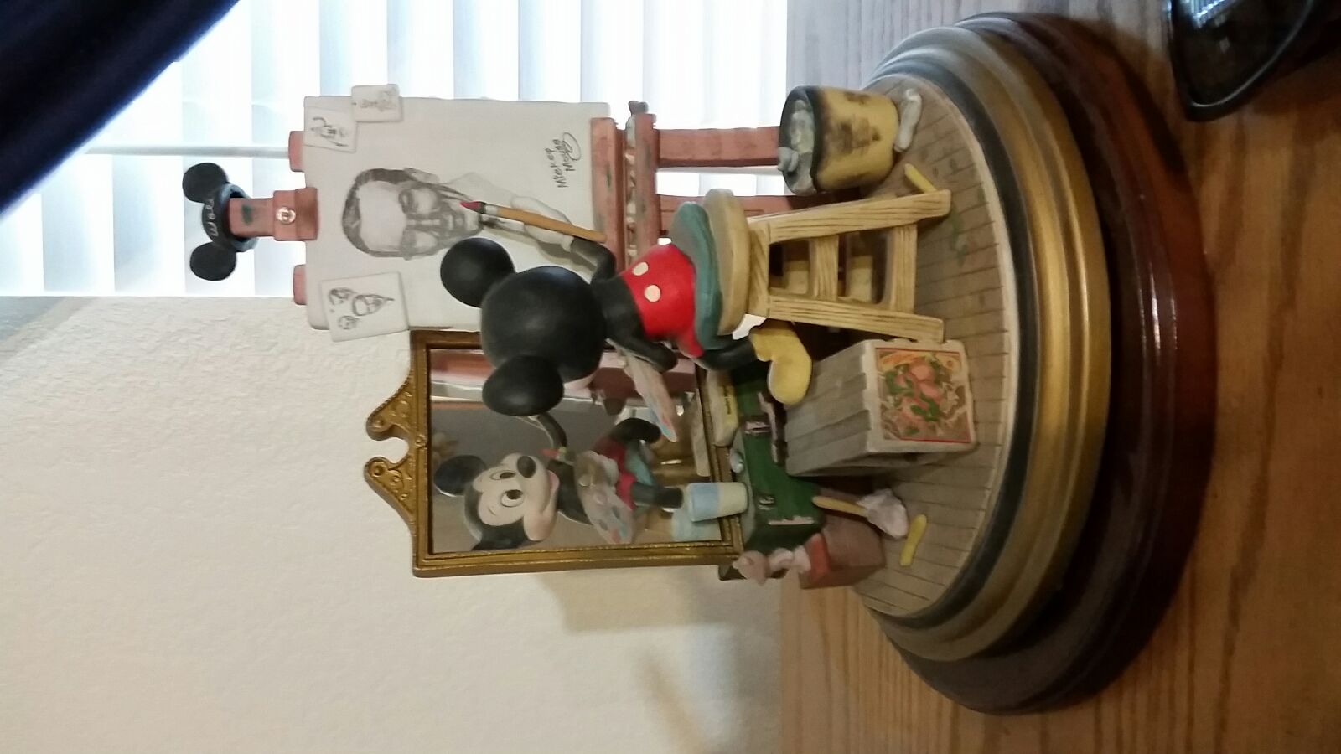$750
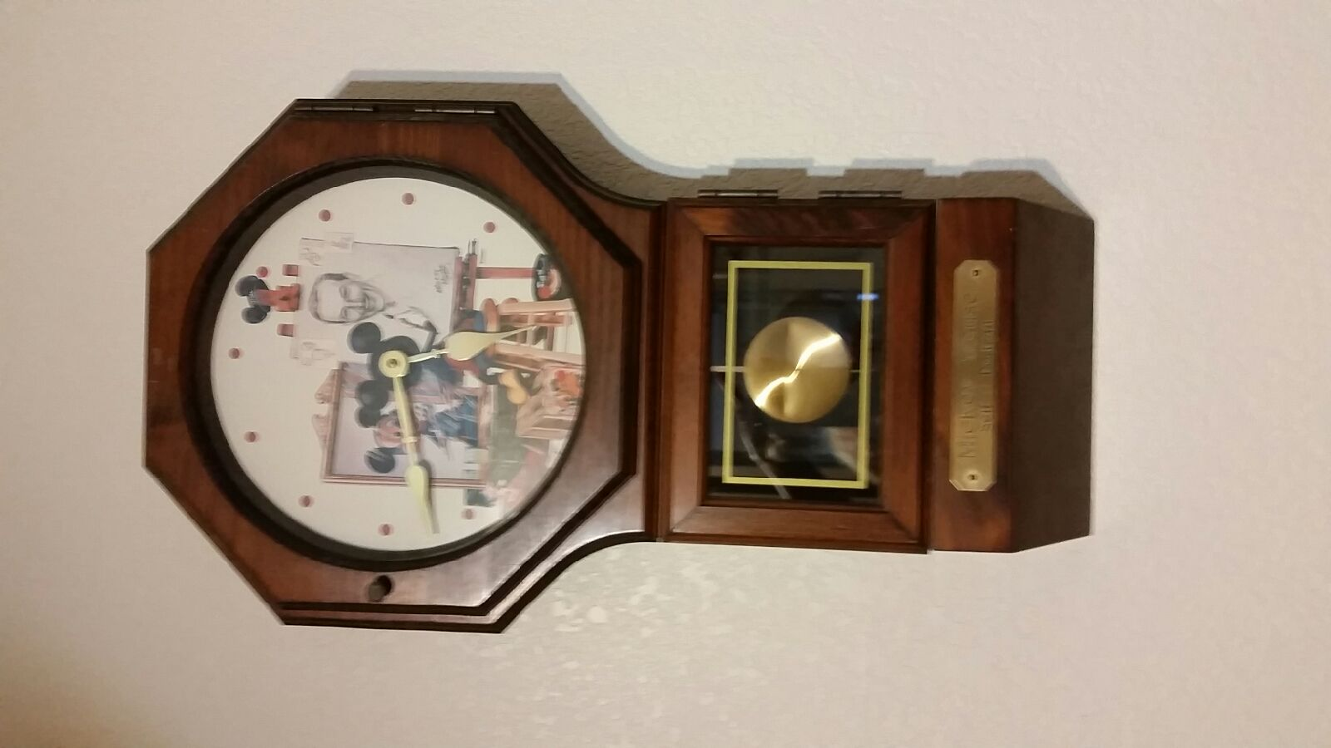Self Portrait, I also have a large table lamp with this art
Clock and Lamp $250

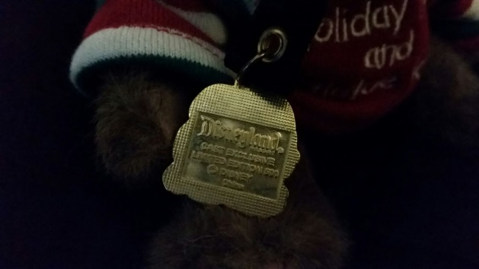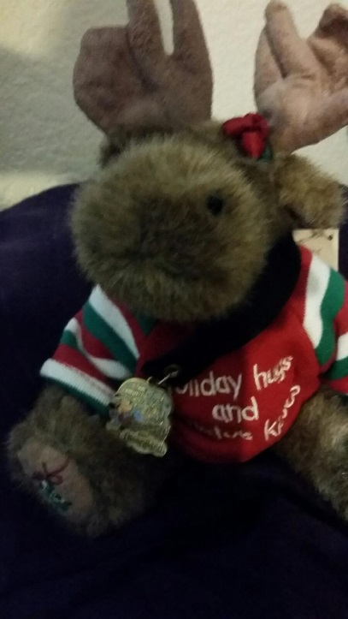Holiday Moose, Cast Exclusive limited edition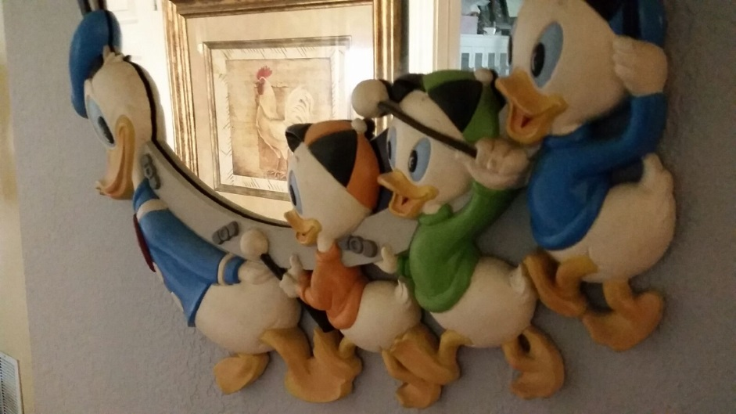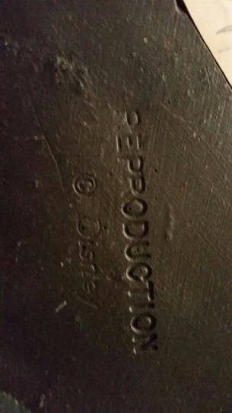
Donald and nephews reproduction Mirror $500
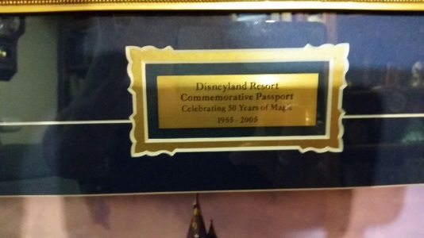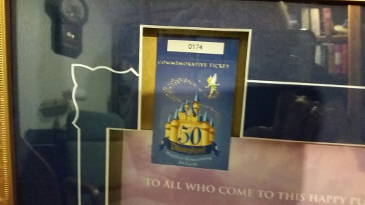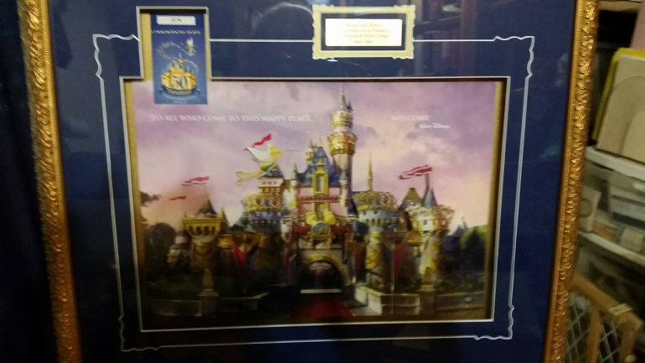
Framed 50th Commemorative Ticket # 174
$300
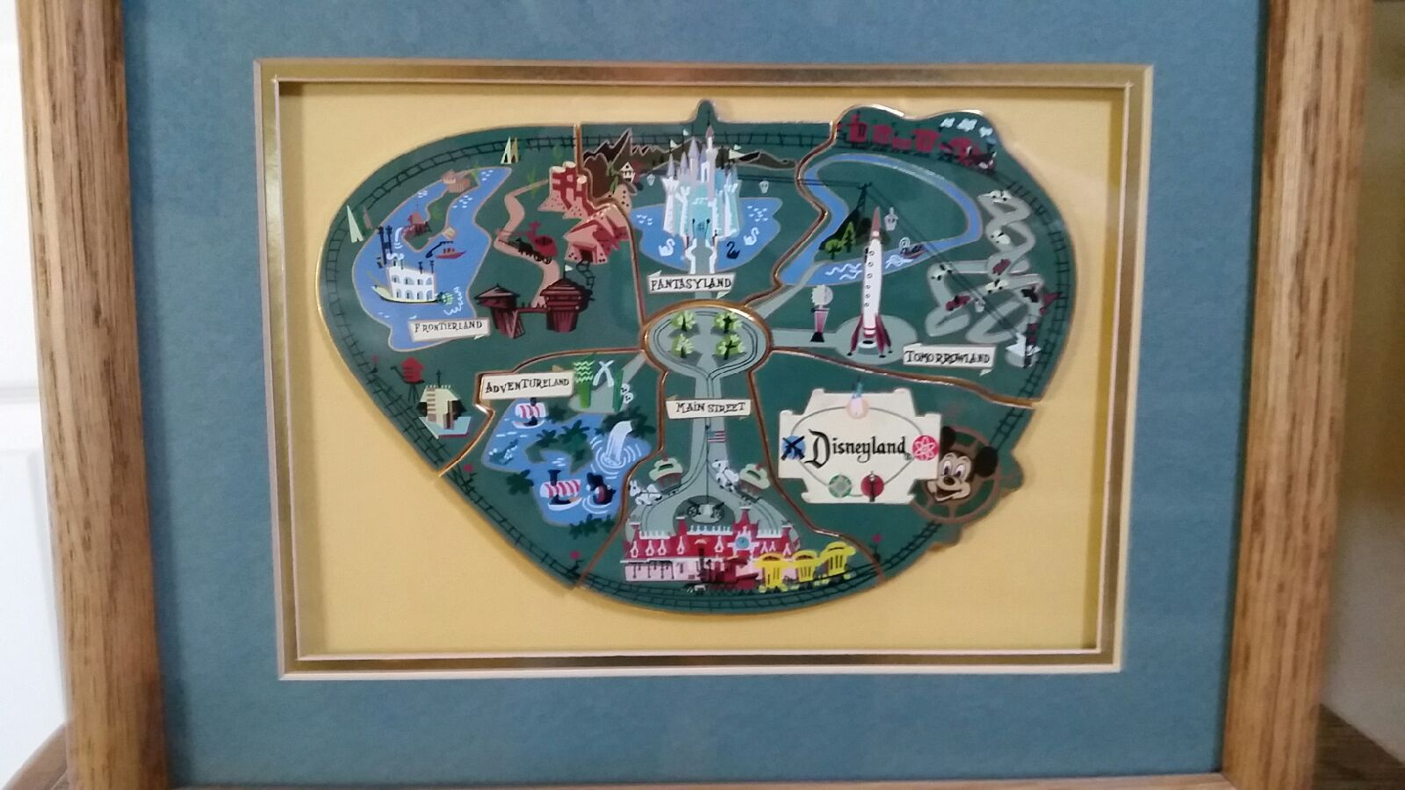
Cast Exclusive – limited edition. Each Pin was sold individually - $150

I have lots more, just have not had time to photo all.

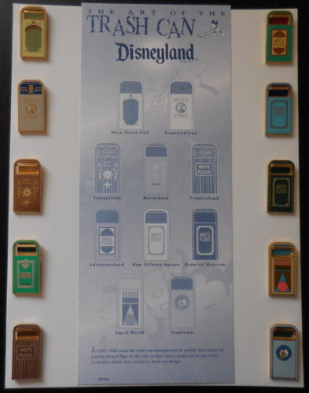$150

