This table will be available on every exam. (It is a Z-table of values of the cdf of N(0, 1), giving values of Φ(z) for –3 < z < 3, in increments of .01.)

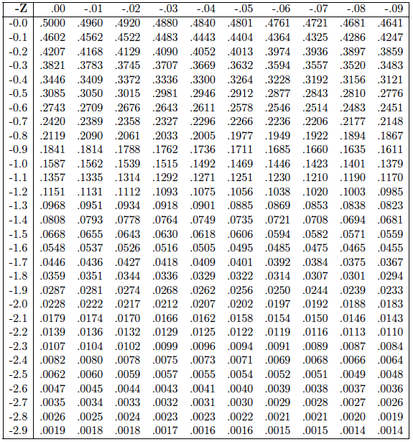 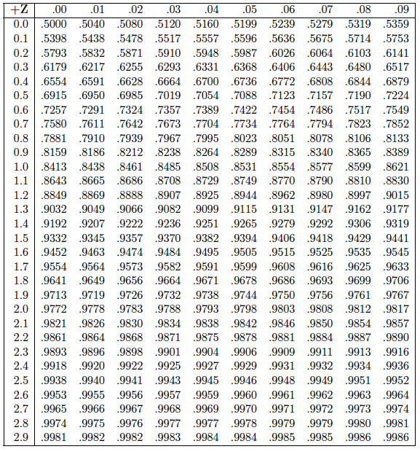

After Exam 1, the following table for the t-distribution (for various df) will also be available. *NOTE:* This table does *not* have the same structure as the Z-table above. For the T-table, the rows are the df ( = n – 1), ranging from df = 4 to df = 47. The columns are just a few probabilities, ranging from .95 to .995. Thus, for a given df within its range, this table is more limited, and has only one row (10 values total) of probabilities. Note also, that because of symmetry about 0, the supplied t-distributions determine *both* the values from .95 - .995, and those from .005 - .05.

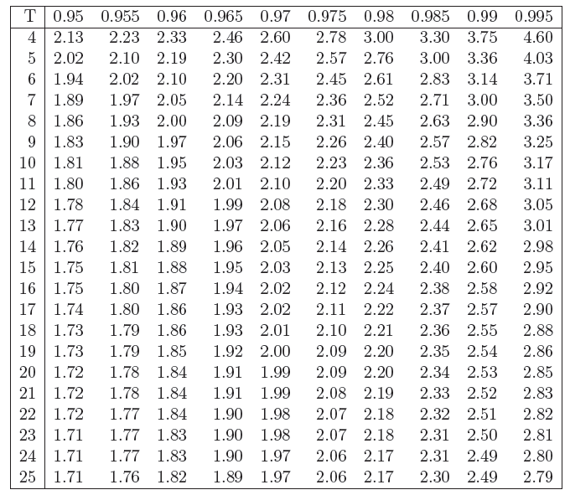 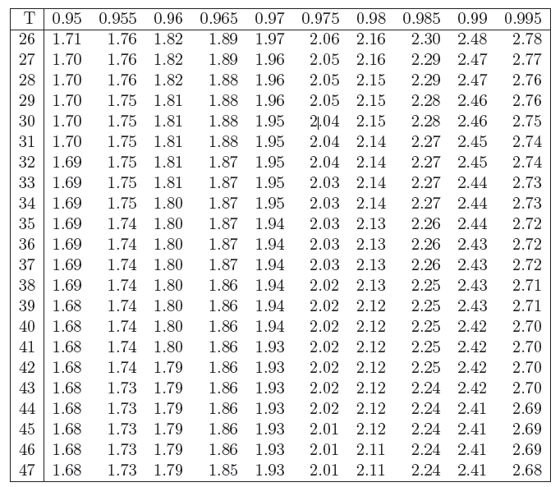

*NOTE:* By definition, an “innermost” or “symmetric” interval is one whose endpoints are equidistant from the mean. (Thus, when μ = 0, these endpoints will have the form –q and q (for some q > 0.)

*NOTE:* If the T-table does not include appropriate values (either because a row with the right df is not included, or because column values corresponding to the cdf between .05 and .95 are needed, simply use the Z-table instead.

**START OF NEED TO KNOWS FOR EXAM 1**

**========================================================**

# Point Estimation

[*Note:* for the point estimation questions, unless noted otherwise, you may assume that the $X_{i}$ s are all i.i.d., with a shared mean and standard deviation of μ and σ, respectively.]

1. Give the definition of a random sample.
2. What does i.i.d. stand for?
3. Write a couple sentences explaining the differences between , , and 
4. What is a point estimate? How is it different from a point estimator and from a population parameter?
5. What is a point estimator? How is it different from a point estimate and from a population parameter?
6. What is a population parameter? How is it different from a point estimate and from a point estimator?
7. Calculate the value of  in terms of the mean  of Xi, (i.e., like we did in class).
8. Calculate the variance of  in terms of the variance 2 of Xi (i.e., like we did in class).
9. Suppose X has a mean μ and standard deviation σ; let . Calculate the mean of Z, using the mean/variance of a linear combination of random variables.
10. Suppose X has a mean μ and standard deviation σ; let . Calculate the standard deviation of Z, using the mean/variance of a linear combination of random variables.
11. Give the definition of a consistent estimator.
12. What is the formula for the Law of Large Numbers?
13. In words, what does the Law of Large Numbers say?
14. Explain (or prove) why the Law of Large Numbers is true. (You don’t need to use Chebyshev’s inequality here, although you can if you wish. Just give the main idea why the law is true.)
15. Is $\overline{X}$ a consistent estimator of μ? Explain/prove your answer.
16. Is  a consistent estimator of μ? Explain/prove your answer.
17. Is  a consistent estimator of μ? Explain/prove your answer.
18. Is  a consistent estimator of μ? Explain/prove your answer.
19. Is S2 a consistent estimator of σ2? Explain/prove your answer.
20. Is  a consistent estimator of σ2? Explain/prove your answer.
21. Give the definition of an estimator’s bias (the mathematical formula will do).
22. Give the definition of a biased estimator (the mathematical formula will do).
23. Give the definition of an unbiased estimator (the mathematical formula will do).

* Describe in words what a biased estimator is.
* Describe in words what an unbiased estimator is.

1. If an estimator is consistent, is it unbiased? Why or why not? (If not, give an example.)
2. If an estimator is unbiased, is it consistent? Why or why not? (If not, give an example.) [*Hint:* consider the estimator: $\hat{Θ}=\frac{1}{3}X_{1}+\frac{1}{3}X_{2}+\frac{1}{3}X_{3}+0X_{4}+0X_{5}+⋯+0X_{n}$.]
3. Show that (i.e., calculate, like we did in class) is an unbiased estimator of .
4. Calculate the bias of as an estimator of μ; show your work in detail.
5. Calculate the bias of as an estimator of μ, where n=21, μ=103; show your work in detail.
6. Calculate the bias of as an estimator of μ; show your work in detail.
7. Calculate the bias of as an estimator of μ, where n=21, μ=103; show your work in detail.
8. Calculate the bias of as an estimator of μ; show your work in detail.
9. Calculate the bias of as an estimator of μ, where n=21, μ=103; show your work in detail.
10. Calculate the bias of as an estimator of σ2; show your work in detail.
11. Calculate the bias of as an estimator of σ2, where n=21, σ2=8.1; show your work in detail.
12. Calculate an unbiased estimate of σ2 using the random sample {2, 1, -3, 1}.
13. Calculate an estimate of σ from the random sample {2, 1, -3, 1} using the estimator.
14. Calculate s2 from the data set {3, -1, 4, 5, 0}.
15. Calculate s from the data set {3, -1, 4, 5, 0}.
16. Calculate $s_{\overline{x}}^{2}$ from the data set {3, -1, 4, 5, 0}.
17. Calculate $s_{\overline{x}}$ from the data set {3, -1, 4, 5, 0}.
18. Do the calculations to show that $σ_{\overline{X}}=\frac{σ}{\sqrt{n}}$.
19. If a random sample of 15 Xs each have a distribution with a variance of 6, then what is the variance of ?
20. If a random sample of 15 Xs each have a distribution with a variance of 6, then what is the standard deviation of ?
21. If a random sample of 15 Xs each have a distribution with a standard deviation of 6, then what is the variance of ?
22. If a random sample of 15 Xs each have a distribution with a standard deviation of 6, then what is the standard deviation of ?
23. In general, if we have a random sample of n Xs from a distribution whose mean and variance is  and σ2, then what is the mean and variance of ?
24. In general, if we have a random sample of n Xs from a distribution whose mean and standard deviation is  and σ, then what is the mean and standard deviation of ?

* [*Comment:* The next five questions break down the proof of that S2 is an unbiased estimator of σ2 found in the slides.] As part of a proof that S2 is an unbiased estimator of σ2, show that: 
* As part of a proof that S2 is an unbiased estimator of σ2, show that: 
* As part of a proof that S2 is an unbiased estimator of σ2, show that: 
* As part of a proof that S2 is an unbiased estimator of σ2, show that: 
* Use the previous four equations to calculate that S2 is an unbiased estimator of σ2.

1. [*Comment:* The next five questions break down the proof that S2 is an unbiased estimator of σ2 that we did in class.] Prove that:. (This is the Lemma from class.)
2. Prove that: .
3. Use the Lemma above to prove that: 
4. Use the Lemma above to prove that: 
5. Use the previous three equations to prove that: E[SS] = (n–1)σ2.
6. Your colleague at work was gathering some data for you, and you noticed that she accidentally estimated the standard deviation as the square root of the average of the sum of the squared deviations from the sample mean (i.e., she "divided by n"). Her estimate was 270 for the 15 observations she collected. You wish to use an unbiased estimate of the sample variance. What is it (show your work)?

* What does “MSE” stand for?
* What is the relationship between the MSE, variance, and bias of an estimator?

1. Give the definition of the mean squared error of an estimator.
2. Show that $MSE\left(\hat{Θ}\right)= Var\left[\hat{Θ}\right]+{\left(Bias\left(\hat{Θ}\right)\right)}^{2}$.
3. The MSE of an estimator looks a lot like a formula for the variance, although it is not. Explain why the MSE is not the variance – *don’t* simply show that the two formulas differ. Explain what the MSE characterizes, and how this differs from the variance of the estimator in question.
4. You are using an estimator  to try to figure out some population parameter . Your estimator is known to have a variance of 6 and a bias of -3. What is the mean squared error of?
5. Give the formula for S2. Why do we use this estimator?

* Write sentence or two about how consistency and bias are similar, and how they are different.
* Write a couple sentences about how consistency and MSE are similar, and how they are different.
* Write a couple sentences about how bias and MSE are similar, and how they are different.

*Comment*: It's natural to think that since S2 is an unbiased estimator of the variance, S must be an unbiased estimator of the standard deviation. However, this is not true. The next couple questions guide you through a proof, using some concepts you may have encountered in other economics courses. (Cf. the worked examples for an explicit analysis of a simple case.)

1. By definition, a function $f\left(x\right)$ is *strictly convex* (in a given interval) iff $f\left(px_{1}+\left(1-p\right)x_{2}\right)<pf\left(x_{1}\right)+\left(1-p\right)f\left(x_{2}\right)$ 
    ,   
   for all $x_{1}, x_{2}$, and all $0≤p≤1$. Notice that $f$ is strictly convex at $x$ if its second derivative at $x$ is positive: $f^{''}\left(x\right)>0$. Show that for every positive value $v>0,$ the function $f\left(v\right)= -\sqrt{v}$ is strictly convex.
2. If $f\left(v\right)= -\sqrt{v}$ is strictly convex, then what do we know about the square root function $\sqrt{v}$?
3. *Jensen's Inequality* is a theorem that states that for any strictly convex function $f, f\left(E\left[X\right]\right)< E[f\left(X\right)]$. Use this inequality and the previous questions to prove that $E\left[S\right]≠σ.$
4. Is the bias of S as an estimator of σ positive, negative, or 0?

# The Normal Distribution and the Central Limit Theorem

1. For Z~N(0,1), use the table above to estimate Pr[Z ≤ 1.8].
2. For Z~N(0,1), use the table above to estimate Pr[Z > 2.2].
3. For Z~N(0,1), use the table above to estimate Pr[-.2 < Z < .8].
4. For X ~ N(25, 182), use the table above to estimate Pr[X ≤ 31].
5. For X ~ N(25, 182), use the table above to estimate Pr[X > 22].
6. For X ~ N(25, 182), use the table above to estimate Pr[22 < X ≤ 30].
7. For Z~N(0,1), what is the *z* such that Pr[Z ≤ *z*] = .93?
8. For Z~N(0,1), what is the *z* such that Pr[Z > *z*] = .94?
9. For Z~N(0,1), what is the *z* such that Pr[Z > *z*] = .03?
10. For Z~N(0,1), what is the *z* such that Pr[Z ≤ *z*] = .04?
11. For Z~N(0,1), what is the *z* such that Pr[-*z* ≤ Z < *z*] = .94?
12. For X~N(4,72), what is the *x* such that Pr[X ≤ *x*] = .93?
13. For X~N(4,72), what is the *x* such that Pr[X > *x*] = .94?
14. For X~N(4,72), what is the *x* such that Pr[X > *x*] = .03?
15. For X~N(4,72), what is the *x* such that Pr[X ≤ *x*] = .04?
16. For X~N(4,72), what are the $x_{L}$ and $x_{U}$ that are equidistant from the mean, and such that $\operatorname{Pr}\left[x_{L}≤X≤x_{U}\right]= .94$?
17. Many test scores are (approximately) normally distributed. Your professor reports that the midterm average was a 78, and that the standard deviation was 8. You got an 88 on the midterm. Approximately what percentile does that put you in? (I.e., what percentage of the students did you score higher than?)
18. Many test scores are (approximately) normally distributed. Your professor reports that the midterm average was a 78, and that the standard deviation was 8. What is the approximate range of scores for the middle 50% of the scores?
19. Many test scores are (approximately) normally distributed. Your professor reports that the midterm average was a 78, and that the standard deviation was 8. What is the approximate range of scores for the top 10% of the scores?
20. Many test scores are (approximately) normally distributed. Your professor reports that the midterm average was a 78, and that the standard deviation was 8. What is the approximate range of scores for the bottom 10% of the scores?
21. There is a stock that, in the past has produced, on average annual return of 3.7%, with a standard deviation of 2.9%. These returns are, you assume, normally distributed. You will invest in this stock for one year. What is the probability that you will lose money (i.e. experience a negative return)?
22. There is a stock that, in the past has produced, on average annual return of 3.7%, with a standard deviation of 2.9%. These returns are, you assume, normally distributed. You will invest $350 in this stock for one year. What is the probability that you will receive a return worth at least $75?
23. Kimmy Schmidt has an investment! Its monthly fluctuation is predicted to be normally distributed! The mean should be $2,000, and it should have about $127 as its standard deviation! Kimmy wants to know what values of her investment will be in the top 5% of this investment! Help her find it! Show your work!

A group of Mexicans have taken the New Black, and decided to try to build a large wall of ice at the border to keep out White Walkers, white wraiths, white horsemen of death, and White Zombie (both the heavy metal band and its fans), hereafter collectively known as “Whities”. (This wall will be the best wall. It’s going to be a big beautiful wall, made out of the best ice. Many people are saying this is the best ice in the world. Many, many people have said this.) However, to do this, they need to raise the capital to cover the construction costs. Thus, the ultimate question of interest is, *Can the Mexicans afford to build a wall at the border to keep out Whities?*

To build the wall, the group will need to raise 175 billion Gold Dragon coins (bGD), and through a wide variety of fundraising schemes, their sum total projected funds is assumed to be distributed as X ∼ N(159, 82). (All units are in bGDs.) However, [Carlos Slim](https://en.wikipedia.org/wiki/Carlos_Slim) has also indicated interest in this project, and may make his own investment in it, which would be *independent* from the primary funds indicated by X. (Carlos Slim is the best investor. He's the best, the smartest. His real estate developments are better than anyone else’s. They're fantastic, simply wonderful, every one of them. And he knows everything about ice, too. A very, very beautiful man.) However, there are several ways he might do this. In each case, assess the probability that the wall will be built.

1. CS0: He decides not to invest.
2. CS1: He invests 10 bGD.
3. CS2: He invests the revenues from a particular telecom company; those funds are distributed as N(10, 62).
4. CS3: He will cover all remaining costs, provided that the other funding sources (i.e. X) reach at least 150 bGD.
5. CS4: He will invest 20 bGD, provided that the other funding sources reach at least 145 bGD.
6. CS5: He will invest the returns from his telecom expansion into the Isle of Pyke. There is a 30% chance that the Ironborn residents will “pay the iron price”, which would only yield 4 bGD; otherwise, they will fully honor the contract, and so the investment would be 19 bGD.

* There are two commonly used names for N(, σ2). What are they?
* Write out the mathematical formula for the pdf for N(, σ2).
* Write out the mathematical formula for the pdf of N(0, 1).
* Write out the mathematical formula for (x).
* **What is the value of (0)?
*   is the pdf for N(0, 1); calculate the value of (1.5).
* *\*\* f* is the pdf for N(3, 162); calculate the value of *f*(5).
* *\*\* f* is the pdf for N(3, 162); calculate the(two) values x for which we have *f*(x) = .01.
* *\*\* f* is the pdf for N(3, σ2) and *f*(5) = .01; calculate the value of σ2.
* *f* is the pdf for N(μ, 162) and *f*(5) = .01; calculate the two possible values of μ.
* What is the value of (0)?

1. Suppose X ~ N(0, 1). Which, if either, is more likely: .3 ≤ X ≤ .4, or .7 ≤ X ≤ .8? Explain your answer (you do *not* need to calculate these values).

* Suppose X ~ N(0, 1). Which, if either, is more likely: .3 < X < .4, or .7 ≤ X ≤ .8? Explain your answer (you do *not* need to calculate these values).

1. Suppose X ~ N(0, 1). Which, if either, is more likely: –1 ≤ X ≤ 1, or 5 ≤ X ≤ 10? Explain your answer (you do *not* need to calculate these values).
2. Draw and label the graphs of the pdf (together, on one set of axes) of N(0,1) and N(-1, 22). Your graphs should display how the different parameters of the two distributions affect the pdfs.
3. Draw and label the graphs of the cdf (together, on one set of axes) of N(0,1) and N(-1, 22). Your graphs should display how the different parameters of the two distributions affect the cdfs.
4. What is the total area under the curve of the pdf of N(0, 1)?
5. What is E[X] if X ~ N(, σ2)?
6. What is E[X] if X ~ N(1, 33)?

* What is the mean of X if X ~ N(, σ2)?
* What is the variance of X if X ~ N(, σ2)?
* What is the standard deviation of X if X ~ N(, σ2)?
* What is the mean of X if X ~ N(1, 32)?
* What is the variance of X if X ~ N(1, 32)?
* What is the standard deviation of X if X ~ N(1, 32)?
* What is  of X if X ~ N(1, 32)?
* What is σ2 of X if X ~ N(1, 32)?
* What is σ of X if X ~ N(1, 32)?

1. What is E[(X – E[X])2] if X ~ N(, σ2)?
2. What is E[(X – E[X])2] if X ~ N(, 2)?

* ** What is α1 if X ~ N(, σ2)?
* ** What is α1 if X ~ N(, 2)?
* ** What is α2 if X ~ N(, σ2)?
* ** What is α2 if X ~ N(, 2)?

1. What is the (standardized) skew of N(, σ2)?
2. What is the (standardized) skew of N( 2)?
3. What is the (standardized) kurtosis of N(, σ2) (or: if your answer to this is 0, then what constant number is subtracted from the formula to yield 0)?
4. What is the (standardized) kurtosis of N( 2) (or: if your answer to this is 0, then what constant number is subtracted from the formula to yield 0)?
5. What is the unstandardized skew of the normal distribution?
6. What is the unstandardized kurtosis of the normal distribution?
7. How much of the probability of an N(, σ2) distribution is within 1.96 standard deviations of the mean?
8. If X ~N(, σ2), what is what is the probability that X ≤ ( + 1.64σ)?

* Why does the normal distribution occur frequently in nature?
* Give two real life examples that are probably (nearly) normally distributed; for each one, write a sentence or two about why they probably are normally distributed.
* For N(, 2), calculate the largest value of its pdf. Show also that any other value – i.e. x = μ+c, (c ≠ 0) – will be less than this number.
* For N(, 2), calculate the largest value of its pdf. Show also that any other value – i.e. x = 40+c, (c ≠ 0) – will be less than this number.
* What command would you use if you wanted Eviews to compute the probability that X < 2, if X~N(0, 1)?
* What command would you use if you wanted Eviews to compute the probability that X > 2, if X~N(0, 1)?
* What command would you use if you wanted Eviews to compute the probability that   
  – 3 < X < 2, if X~N(0, 1)?

1. If X ~ N(0, 1), then what is the distribution of Y = a + bX (b ≠ 0)?
2. If X ~ N(, σ2), how would you transform it so that it is distributed as N(0, 1)?
3. If X ~ N(, σ2), then what is the distribution of Y = a + bX (b ≠ 0)?
4. If X ~ N(0, 1), then what is the distribution of Y = 2 + 3X?
5. If X ~ N(, 2), how would you transform it so that it is distributed as N(0, 1)?
6. If X ~ N(, 2), then what is the distribution of Y = 2 + 3X?

* From a purely mathematical perspective, for what values is the pdf of N(6, 42) greater than 0?

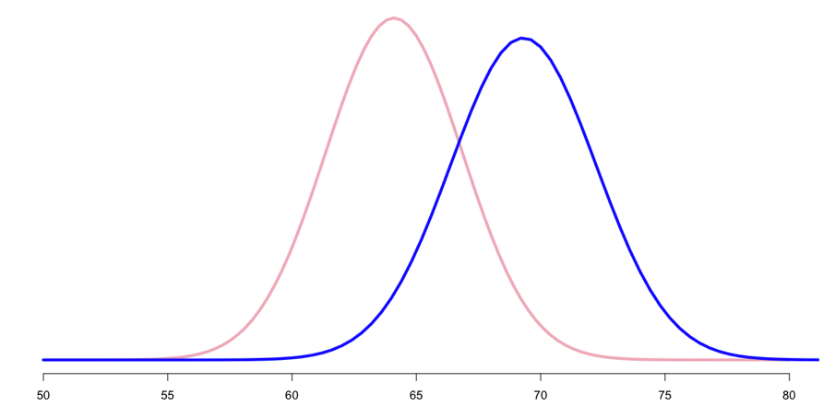

1. *Comment:* According to a recent estimate of US persons in their 20s, Female and Male heights (in inches) are distributed approximately as N(64.1, 2.752), and N(69.3, 2.922), respectively. These are illustrated above, and the next several questions refer to them. (On an exam, the numbers will be changed to artificial ones.)
2. What is the probability that a male is taller than the average female?
3. What is the probability that a male is shorter than the average female?
4. What is the probability that a female is taller than the average male?
5. What is the probability that a female is shorter than the average male?
6. If a woman is taller than (exactly) 90% of women, what percent of men is she taller than?
7. If a man is taller than (exactly) 10% of men, what percent of women is he taller than?
8. How likely is it that a male is within 2 inches of the average (for males)?
9. How likely is it that a female is within 2 inches of the average (for females)?
10. Explain in your own words why the two probabilities just calculated are different.
11. What are the heights of the “innermost” 90% of women (i.e. the 90% closest to the mean)?
12. What are the heights of the “innermost 90% of men (i.e. the 90% closest to the mean)?
13. Among humans, about 49% are female, and 51% are male. What is the average human height?
14. Among humans, about 49% are female, and 51% are male. What is the standard deviation of human heights?

* [The next few questions refer to this scenario.] A disguised thief T breaks into the UCI bookstore one evening. From grainy security camera footage, only T’s height can be discerned. Your “null hypothesis” H0 is that T is female, and you will reject that hypothesis (thus inferring the thief is male) only if T’s height is found only among the tallest 5% of women. How tall must T be in order for you to reject H0? I.e., what is the minimum height that would make you reject H0? (This is sometimes known as a “critical bound”, and the upper 5% of the female’s distribution is a “critical region.)
* Suppose T’s height is 68 inches. Do you reject H0?
* Suppose T’s height is 68 inches. What is the probability that a female would be 68 inches or taller? (This is known as a “p-value”.)
* Let *x* be the critical bound mentioned above. What is the probability that a male would be *x* inches tall or taller? (This is known as the “power” of the test.)
* Let *x* be the critical bound mentioned above. What is the probability that a male would be less than *x* inches tall? (This is known as the probability of a “type II” error.)

## Central Limit Theorem

1. Your friend/relative is interested in what you’re doing, but has no background in statistics. Write a sentence or two that explains to her/him in ordinary language what the Central Limit Theorem says.
2. What background conditions were given for the version of the Central Limit Theorem that we have examined?
3. Give the formula for the Central Limit Theorem in terms of $n, X_{i}, μ$, and σ (be sure to include the limit notation).
4. Give the formula for the Central Limit Theorem in terms of $\overline{X}, μ$, and $σ_{\overline{X}}$ (be sure to include the limit notation).

* Give the formula for the Central Limit Theorem in terms of n and Zi (be sure to include the limit notation).
* Give the formula for the Central Limit Theorem in terms of n and ZX̅  (be sure to include the limit notation).

1. Show that two common forms of the Central Limit Theorem are equivalent by calculating that: $\frac{1}{\sqrt{n }}\sum_{i=1}^{n}{\left(\frac{X_{i}-μ}{σ}\right)}=\frac{\overline{X}-μ}{σ_{\overline{X}}}$.

* The slides list two roles the Central Limit Theorem plays in statistics; what are they?

1. The host probability distribution (e.g., wages of individuals) whose mean you wish to estimate is not normally distributed, and yet your analysis of the mean of a random sample involves the normal distribution. Explain why.

*Comment:* Below are typical examples of distributions with positive skew (blue), negative skew (red), large kurtosis (aka “overly fat tails”) (green), and small kurtosis (aka “overly broad shoulders”) (purple). For comparison, a normal distribution is below them in black. The normal distribution has a skew of 0 and a kurtosis of 3. I.e., it has no skew and neither overly fat tails nor overly broad shoulders.

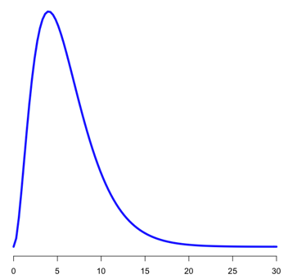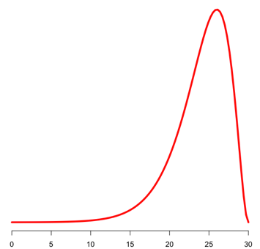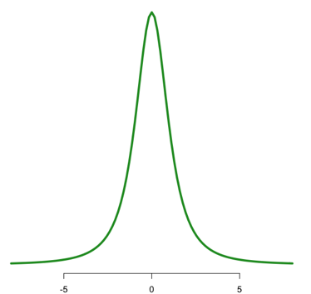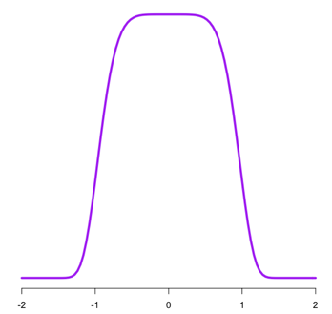

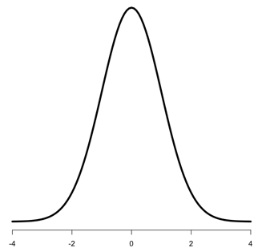

1. You have a random sample from a distribution whose skew is -3. In general, do you expect the skew of X̅ to be larger, smaller, or the same as this? Explain. [*Comment:* Skew and kurtosis here refer to the (standardized) forms that we have referred to in class, on the slides, and on Eviews.]
2. You have a random sample from a distribution whose skew is 6. In general, do you expect the skew of X̅ to be larger, smaller, or the same as this? Explain.
3. You have a random sample from a distribution whose kurtosis is 6. In general, do you expect the kurtosis of X̅ to be larger, smaller, or the same as this? Explain.
4. You have a random sample from a distribution whose kurtosis is 1. In general, do you expect the skew of X̅ to be larger, smaller, or the same as this? Explain.
5. You have a random sample from a distribution with a positive skew. On one set of axes, sketch a curve that might represent this distribution, and one that plausibly represents that of $\overline{X}$; be sure to show how $\overline{X}$ has a different skew and variance.
6. You have a random sample from a distribution with a negative skew. On one set of axes, sketch a curve that might represent this distribution, and one that plausibly represents that of $\overline{X}$; be sure to show how $\overline{X}$ has a different skew and variance.
7. You have a random sample from a distribution with an unusually large kurtosis. On one set of axes, sketch a curve that might represent this distribution, and one that plausibly represents that of $\overline{X}$; be sure to show how $\overline{X}$ has a different kurtosis and variance.
8. You have a random sample from a distribution with an unusually small kurtosis. On one set of axes, sketch a curve that might represent this distribution, and one that plausibly represents that of $\overline{X}$; be sure to show how has a different kurtosis and variance.
9. If = 10,  = 4, σ = 2.2, and n = 11, what is the z-score for ?

* If = 10,  = 4, σ2= 5, and n = 11, what is the z-score for $\overline{x}$?

1. If a data set {1, 2, 5, 7, 2} is a random sample from a distribution where  = 4, and σ = 3, what is the z-score for $\overline{x}$?

* If a data set {1, 2, 5, 7, 2} is a random sample from a distribution where  = 4, and σ2 = 7, what is the z-score for $\overline{x}$?

# Basic Confidence Intervals (Exam 1: assume s2 = σ2 is known)

* How do confidence intervals help us to interpret point estimates?

1. Describe what the quantile function does (i.e, it takes you from what to what?).

* What is the relation between the quantile function and the cdf?

1. Suppose X ~ N(0, 1). Explain how we use the quantile function to translate our choice of a confidence level into a confidence interval for X.
2. Give the formula for the margin of error (when the variance is known).
3. Give the formula for a confidence interval in terms of the point estimate and the margin of error.
4. What is the formula for the lower bound of a confidence interval when the variance is known? Label the parts (do *not* just give the m.o.e. as a single part).
5. What is the formula for the upper bound of a confidence interval when the variance is known? Label the parts (do *not* just give the m.o.e. as a single part).
6. When the variance is known, what probability distribution do we refer to when constructing a confidence interval for the mean?
7. In constructing confidence intervals, it is crucial that the event $–q≤\frac{\overline{X}-μ}{σ_{\overline{X}}}≤q$ is the same thing as $\overline{X}-qσ\frac{1}{\sqrt{n}}≤μ≤\overline{X}+qσ\frac{1}{\sqrt{n}}$ Do the calculations to show that these two events are indeed the same (like we did in class).

* What are the boundaries of a confidence interval at the .99 confidence level if the 14 samples comes from a distribution with a known variance of 6, and the sample mean was 8?
* Calculate a 99% confidence interval for a data set of 14 observations, whose mean is 6.2, if the underlying probability distribution has a known variance of 7.

1. Calculate a 99% confidence interval for a data set of 14 observations, whose mean is 6.2, if the underlying probability distribution has a known standard deviation of 7.