{1-888-701-2736 csem@csem.com} Note: This INFO will be in every slider where the statement about a fish & bird are. These pictures sliders will be of the same type as seen on www.safetytrainingclassescourses.com but different ones purchased from I-Stock to freshen up the site.
HOME Social Media’s Privacy Policy Get Quote Site Search Bar Contact Us
This space seen below is where “topic photo sliders” will go on auto rotation.
On-Line or Instructor Led (at your location w/5 0r more)
Note: when on-line is chosen an under construction page flashes but does not allow for the user to go anywhere! When quote form is clicked on it becomes the entire page
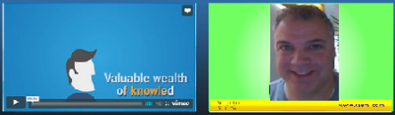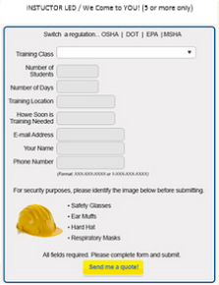
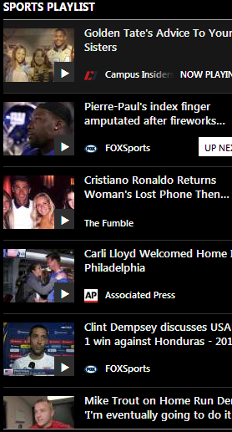
These video Stacks will be on sliders a manual slider well. When the user clicks upon the slider more CSEM classes will come in to view. The video that is clicked upon will immediately place you upon that page with the video of Robyn thanking the viewer for choosing the Center for Safety and Environmental Management for your “TOPIC” training provider. “Sentence about Subject matter and diversity actor edification”, A quick note about our Instant Quote Tool and how to use video to her right on the scene and back to “Diversity Speaker about the “TOPIC”. These video stacks must be CLEAN and ready to roll, we have a contract with Website talking heads to build the videos for us. The regulatory agency and the CODE# will be located within the space to the right of each photo. The back ground will be very clean and crisp not grey bar.
A careful note as to the requirements of a PPC site will be here such as GEO map links. Perhaps a footer that has all other information critical for PPC I know we will be pushing on down load speed but we will be functional and that’s what counts.

