Ernest Radicke

in the Australia, Marriage Index, 1788-1950
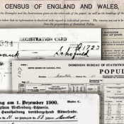No Image
Text-only collection
- Add Alternative Information
- Report issue
Name: | Ernest Radicke
Spouse Name: | Anna Pauline Schodel
Marriage Date: | 08 May 1920
Marriage Place: | Queensland
Registration Place: | Queensland
Registration Year: | 1920
Registration Number: | B025304
Page Number: | 3126

