Section I

Use the diagram below answer the questions in this section. Assume all activities require the same type of resource (e.g. a programmer) and that there is a maximum of only 6 resources available for this project. Also assume the project starts at time zero and each duration unit equals one day. Use the scheduling heuristics provided to develop a resource-constrained schedule.

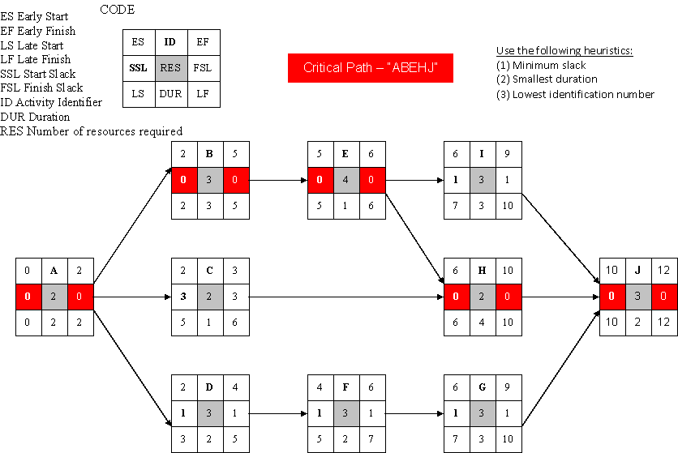

- What is the project duration for the resource-constrained schedule? (Write only the number; do not write units, such as weeks.) (10 pts.)
- How many working days (duration units) will pass in the schedule before activity D is completed in the resource-constrained schedule? (5 pts.)
- How many working days (duration units) will pass in the schedule before activity G is completed in the resource-constrained schedule? (5 pts.)
- Which activities are impacted (i.e. require a change to the activity’s start or finish time) by the resource constraints? (10 pts.)

Section II

Use the table below answers the questions in this section. Assume only 1 carpenter and 1 painter is available.

Activity | Duration (days) | Predecessor | Required Resource
A* | 3 | None | 1 carpenter
B | 4 | A | 1 carpenter
C | 3 | B | 1 carpenter
D | 4 | B | 1 carpenter
E | 5 | C, D | 1 painter
F | 2 | D | 1 painter
G | 5 | E, F | 1 carpenter
H | 3 | G | 1 carpenter
*Assume zero as the early start (ES) time for activity A

- Which activities are on the critical path in the unconstrained project? (5 pts.)
- What is the duration of the unconstrained project? (Write only the number; do not write units, such as days.) (5 pts.)
- What is the project duration for the resource-constrained schedule? (Write only the number; do not write units, such as days.) (10 pts.)
- Which activities are impacted (i.e. require a change to the activity’s start or finish time) by the resource-constrains? (10 pts.)

Section III
Use the time-phased work packages and network provided below to answer the questions in this section. Assume the project starts at time zero and each duration unit equals one day.

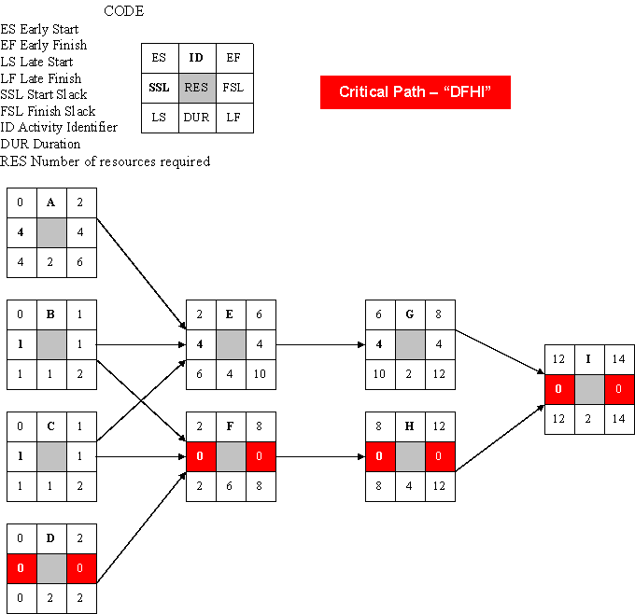

 | Cost by Day
ID | 1 | 2 | 3 | 4 | 5 | 6
A | 25 | 25
B | 100
C | 50
D | 75 | 25
E | 100 | 200 | 300 | 400
F | 100 | 200 | 300 | 300 | 200 | 100
G | 150 | 150
H | 200 | 200 | 100 | 100
I | 50 | 50

- Scheduling all activities based on their ES and EF times, what is the cumulative budget for day 3 of the project? (10 pts.)
- Scheduling all activities based on their ES and EF times, what is the dollar amount budgeted for only day 7 of the project? (10 pts.)
- Scheduling all activities based on their LS and LF times, what is the cumulative budget for day 5 of the project? (10 pts.)
- Scheduling all activities based on their LS and LF times, what is the dollar amount budgeted for only day 10 of the project? (10 pts.)

