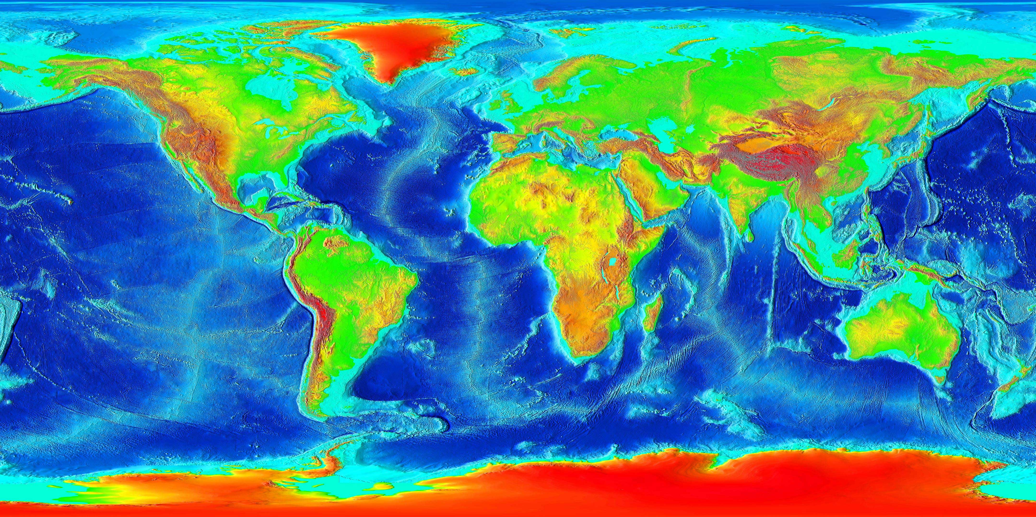

★

★

**∞**

TC

★

FJ

PI

KI

PE

ET

ST

HI

AL

AN

D

C

HM

RK

AS

SH

SS

AZ

IL

TR

HS

SM

AP

SL

SF

TF