1.
A Dutch person travels, on average, 35 km/day divided over traveling by
  - Car (75%)
  - Train (8,8%)
  - Bus (4,9%)
We neglect the other ways of transportation, like transport by bicycle and walking.
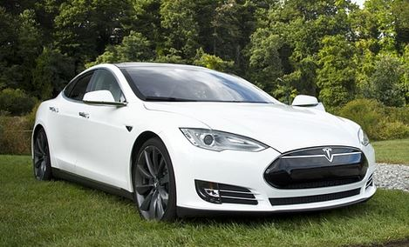

Car
(1 point possible)
On average, a car uses 80 kWh/100 km. Round your answer to the nearest whole number.
How much energy in kWh is required for car transportation per day per person?
Not yet answered.

CHECKYOUR ANSWER SAVEYOUR ANSWER
You have used 0 of 3 submissions

Train
(1 point possible)
On average, a train uses 10 kWh/100 km. Give your answer with two decimals.
How much energy in kWh is required for train transportation per day per person?
Not yet answered.

CHECKYOUR ANSWER SAVEYOUR ANSWER
You have used 0 of 3 submissions

Bus
(1 point possible)
On average, a bus uses 32 kWh/100 km. Give your answer with two decimals.
How much energy in kWh is required for bus transportation per day per person?
Not yet answered.

CHECKYOUR ANSWER SAVE YOUR ANSWER
You have used 0 of 3 submissions

2.
The transportation of goods requires a lot of energy.
To transport kiwis from Chile to the port of Rotterdam in the Netherlands, 50 tons (1 ton = 1000 kg) of fuel per day is used. The sea freight time from Chile to the Netherlands is approximately 24 days. Bunker fuel used has an energy content of 40 MJ/kg.
A cargo ship can carry 1500 containers, each with 17 000 kgs of kiwi. One kilogram of kiwis is approximately 12 kiwis.
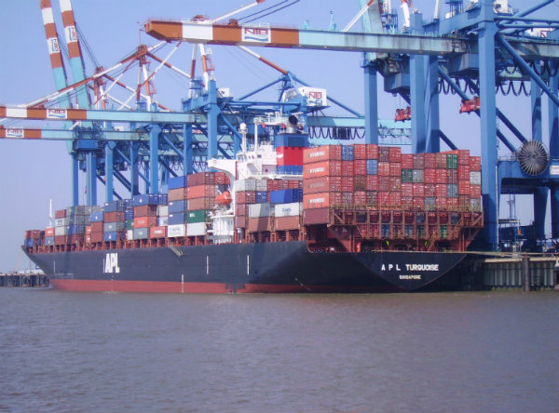

Kiwis from Chile
(1 point possible)
If all of the containers on the cargo ship are packed with kiwis, calculate the amount of energy needed for the transport of fruit from Chile to Rotterdam, in kWh per kilogram of kiwi. Give your answer with one decimal point.
Not yet answered.
CHECKYOUR ANSWER SAVEYOUR ANSWER
You have used 0 of 3 submissions

Kiwis from Chile
(1 point possible)
If we were to calculate the energy requirement per kiwi fruit transported, what is the energy consumption inkJ/kiwi? Round your answer to the nearest whole number.
Not yet answered.
CHECKYOUR ANSWER SAVEYOUR ANSWER
You have used 0 of 3 submissions

3.
Steel production is an energy intensive industry. Shandong Iron and Steel Group, from China, is the 12th producer of steel in the world.
In 2014 they produced 23.3 million tonnes of steel. Most of the energy required for the production of steel is used in the blast furnace.
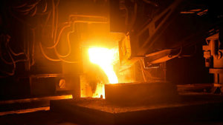
In the blast furnace, steel has to heat up to 1000∘C. If the initial temperature is 25∘C, and the heating capacity of steel is approximately 0.49 kJkg∘C.

Numerical Input
(1 point possible)
How much energy, in petajoules (PJ), is needed as thermal energy, for the total production of Shandong Iron and Steel Group from 2014. Round the answer to one decimal.
Not yet answered.

