- Perform an analysis of the current XYZ network, using the current network diagram and the NMap report below.

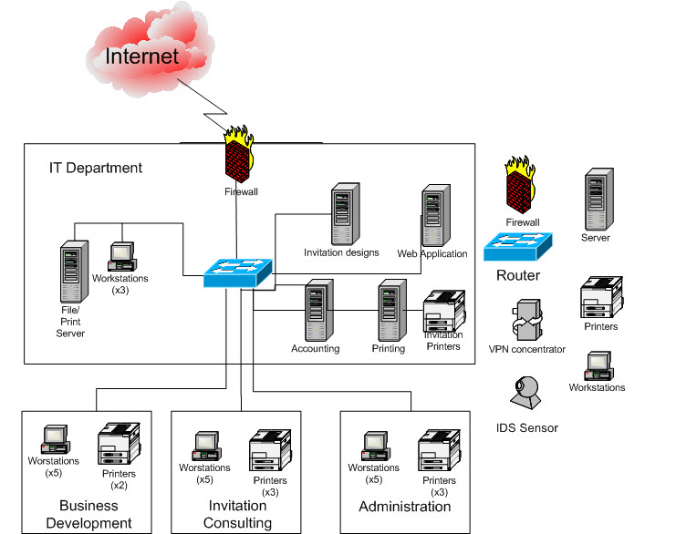

Results of NMAP Scan
Above is the official network diagram of XYZ (premerger with ABC). All servers are supposed to be Windows 2008. XYZ uses a private IP internally of 192.168.x.x. Below are the results of the NMAP scan done as part of the consulting agreement with infosecwizards.
Starting Nmap 5.00 (http://nmap.org) at 2009-MM-DD 23:12 UTC Interesting ports on XYZDomainController at (192.168.0.1): Not shown: 997 filtered ports
Port | State | Service | Product | Version | Extra info
135 | tcp | open | msrpc
139 | tcp | open | netbios-ssn
427 | tcp | open | svrloc
445 | tcp | open | microsoft-ds
Service Info: OS: Microsoft Windows 2008 Server or Windows 7 Interesting ports on XYZInviteDesign at (192.168.0.2): Not shown: 997 filtered ports

Port | State | Service | Product | Version | Extra info
135 | tcp | open | msrpc
139 | tcp | open | netbios-ssn
427 | tcp | open | svrloc
445 | tcp | open | microsoft-ds
Service Info: OS: Microsoft Windows 2008 Server or Windows 7 Interesting ports on XYZAcct at (192.168.0.3): Not shown: 997 filtered ports
Port | State | Service | Product | Version | Extra info
135 | tcp | open | msrpc
139 | tcp | open | netbios-ssn
427 | tcp | open | svrloc
445 | tcp | open | microsoft-ds
Service Info: OS: Microsoft Windows 2008 Server or Windows 7 Interesting ports on XYZprinting at (192.168.0.4): Not shown: 997 filtered ports
Port | State | Service | Product | Version | Extra info
135 | tcp | open | msrpc
139 | tcp | open | netbios-ssn
427 | tcp | open | svrloc
Service Info: OS: Microsoft Windows 2008 Server or Windows 7 Interesting ports on XYZwebsrv at (192.168.0.5): Not shown: 997 filtered ports
Port | State | Service | Product | Version | Extra info
135 | tcp | open | msrpc
139 | tcp | open | netbios-ssn
427 | tcp | open | svrloc
1025 | tcp | open | NFS-or-IIS
Service Info: OS: Microsoft Windows 2008 Server or Windows 7 (The 1656 ports scanned but not shown below are in state: closed) Interesting ports on XYZChat at (192.168.0.6):
Port | State | Service | Product | Version | Extra info
22 | tcp | open | ssh
80 | tcp | open | Apache
111 | tcp | open | rpcbind
6000 | tcp | open | X11
32771 | tcp | open | sometimes-rpc5
Service info: OS: Linux 2.5.25 - 2.6.3 or Gentoo 1.2 Linux 2.4.19 rc1-rc7) Service detection performed. Please report any incorrect results at http://nmap.org/submit/. Nmap done: 6 IP address (6 hosts up) scanned in 64.27 seconds

