Network Design Paper

The University has recently leased a building in Adelphi, Maryland. The building will house some offices, classrooms, library, and computer labs.

Building dimensions: Length: 240 Feet, Width: 95 Feet, Height: 30 Feet

The 50-year-old two-story building has the following layout:
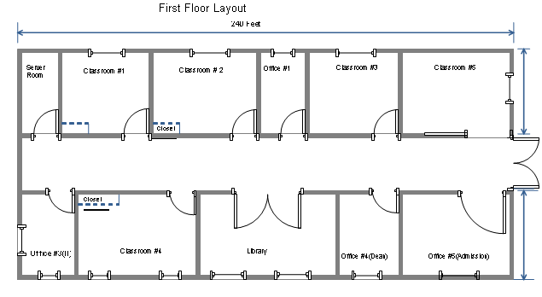
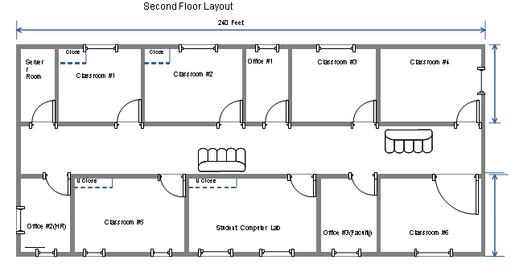

There will be six computer labs (in the building diagram above, these labs are the classroom with closet in them) that will be used for instruction. Each of these labs will have 21 computers (20 student computers and 1 instructor computer). Each of these labs will also have a server in the closet located inside the lab.

In addition to the six computer labs, there will also be a Student Computer Lab that will provide computer access to students to do their homework. There will be 30 computers in this lab and a server in the closet.

The library will also have some computers to allow students access to the library resources. There will be 10 computers for student’s use in the library, and 3 computers for Library staff.

There are five lecture classrooms in the building. Each of this room will have a computer for instructor’s use.

Finally, there are various offices in the building. Each of these offices will have one computer for staff use, with the exception of the Admission office that will have 5 computers for staff use.

Equipment Inventory
Workstation  Placement | Number of  Computers | Users | Total Computers
6 Instructional  Computer labs | 21 | Student and  Faculty | 126
Student Computer Lab | 30 | Student | 30
6 various offices | 6 | Staff/Faculty | 6
Admission office | 5 | Staff | 5
Library | 10 | Student | 10
Library | 3 | Staff | 3
5 classrooms | 1 | Faculty | 5
Server |  | Staff | To be determined by students
Network Connecting Devices |  | IT Staff | To be determined by students
Printers |  |  | To be determined by student

Two server rooms have been allocated, one on the first floor and one on the second floor.

Your task is to design the network for this new building with the following criteria:
- Student-accessed computers should be on separate network from the staff-accessed computers.
- The whole building will share one Internet access connection (T-1 link from Verizon). This connection will come into the Server Room on the first floor.
- Security is very important for UMUC as we have to protect students and employee’s data as well as any intellectual property that UMUC has on the servers and computers.
- The network has been assigned the 10.11.0.0/16 network address for all computers and devices. For Internet routing use 151.1.1.1 IP address.
- The network should use physical cable (not wireless), but do provide wireless access in the Student Lobby area.

Submission should include (in no more than ten pages, excluding diagrams and references):
Network Addressing:
- Define the subnet (based on: rooms, floor, department, or other criteria).
- For each subnet, explain which devices/groups/users/rooms will be on this subnet, define the network address, subnet mask, and available IP addresses to be used by computers or devices.

Network Design:
- Define the topology that will be used.
- Select the appropriate network media to use.
- Select the appropriate network connecting devices to use.
- Physical layout of the computers on the floor plan.
- List of additional servers, network devices, or network services needed to implement the network.
- Justifications for your network design (number 1 – 5 above)

You will be evaluated on your ability to
- Implement appropriate IP addressing scheme (LabSim 5.0)
- select and justify appropriate cable media that includes the length of each cable segment and number of nodes on each segment (LabSim 2.0)
- select and justify appropriate topology such as star, bus, or ring for your network (LabSim 1.0)
- select and justify of your selected network equipments (LabSim 2.0, 3.0, 4.0, 5.0, 6.0, 7.0, 8.0, 9.0)
- select and justify appropriate network services to meet network requirements (LabSim 5.0, 6.0, 7.0, 8.0, 9.0)
- select and justify security implementation for the network (LabSim 8.0)
- use proper grammar, formatting, network terminology, and reference citations

