1.
Value:10.00 points
The following frequency distribution analyzes the scores on a math test. Find the class midpoint of scores interval 95-99.
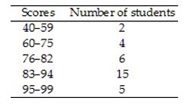
97.598.097.096.5

2.
Value:10.00 points
The histogram below represents the number of television sets per household for a sample of U.S. households. What is the maximum number of households having the same number of television sets?
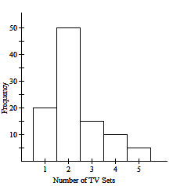
502510020

3.
Value:10.00 points
The students in Hugh Logan's math class took the Scholastic Aptitude Test. Their math scores are shown below.
Find the Mean score, Median score, Mode score
356, 525, 356, 496, 350, 482, 525, 496, 608, 349, 352, 496, 470, 516
Mean 455.5, Median 489, Mode 496Mean 489, Median 496, Mode 455.5Mean 455.5, Median 496, Mode 489Mean 496, Median 455.5, Mode 489

4.
Value:10.00 points
Find the mean of the data summarized in the given frequency distribution. The heights of a group of professional basketball players are summarized in the frequency distribution below. Find the mean height. Round your answer to one decimal place.
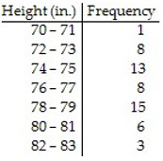
78.1 in.75.3 in.13.5 in.76.6 in.

5.
Value:10.00 points
A class of sixth grade students kept accurate records on the amount of time they spent playing video games during a one-week period. The times (in hours) are listed below: Find the Range, Variance, and Standard Deviation for the given sample data.
25.7 13.6 9.2 14.2 18.6 30.4 19.8 14.0 24.6 24.1

Range: 44.9, Variance: 21.2, Standard Deviation: 6.7Range: 21.2, Variance: 6.7, Standard Deviation: 44.9Range: 21.2, Variance: 44.9, Standard Deviation: 6.7Range: 6.7, Variance: 44.9, Standard Deviation: 21.2

6.
Value:10.00 points
The test scores of 32 students are listed below. Find.
32 37 41 44 46 48 53 55 56 57 59 63 65 66 68 69
70 71 74 74 75 77 78 79 80 82 83 86 89 92 95 99

79.5792480

7.
Value:10.00 points
A class consists of 27 women and 32 men. If a student is randomly selected, what is the probability that the student is a woman?
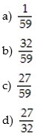
abcd

8.
Value:10.00 points
The following table contains data from a study of two airlines which fly to Small Town, USA. Find the indicated probability. Express your answer as a simplified fraction unless otherwise noted. If one of the 87 flights is randomly selected, find the probability that the flight selected arrived on time.
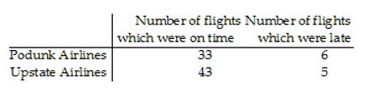
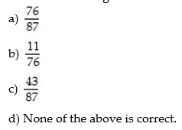

abcd

9.
Value:15.00 points
A psychologist claims that more than 5.8 percent of the population suffers from professional problems due to extreme shyness. Use p, the true percentage of the population that suffers from extreme shyness.
H0: p < 5.8% : p = 5.8%H0: p > 5.8% : p = 5.8%H0: p = 5.8% : p < 5.8%H0: p = 5.8% : p > 5.8%

10.
Value:15.00 points
Use the given information to find the P-value. Also, use a 0.05 significance level and state the conclusion about the null hypothesis (reject the null hypothesis or fail to reject the null hypothesis).
The test statistic in a two-tailed test is z = 1.95.
0.9744; fail to reject the null hypothesis0.0512; fail to reject the null hypothesis0.0512; reject the null hypothesis0.0256; reject the null hypothesis

11.
Value:10.00 points
Evaluate the expression. 13!
-134,790,016,0001696,227,020,800

12.
Value:10.00 points
The differences between two sets of dependent data are : 84, 85, 83, 63, 61, 100, 98. Find sd. Round to the nearest tenth.
13.116.215.315.7

13.
Value:10.00 points
Assume that a procedure yields a binomial distribution with a trial repeated n times. Use the binomial probability formula to find the probability of x successes given the probability p of success on a single trial. Round to three decimal places.
n =12, x = 5, p = 0.25
0.1030.0910.0270.082

14.
Value:10.00 points
The two data sets are dependent. Find to the nearest tenth.
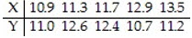
0.30.60.70.5

15.
Value:10.00 points
Assume that the data has a normal distribution and the number of observations is greater than fifty. Find the critical z value used to test a null hypothesis. α = 0.1 for a two-tailed test.
±2.33±2.052±1.645±1.4805

16.
Value:10.00 points
Find the indicated critical z value. Find the value of 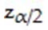 that corresponds to a confidence level of 95%.
.051.6451.962.575

17.
Value:10.00 points
The scores on a certain test are normally distributed with a mean score of 60 and a standard deviation of 5.
What is the probability that a sample of 90 students will have a mean score of at least 60.527?
0.84130.15870.31740.3413

18.
Value:10.00 points
Find the area of the shaded region. The graph depicts the standard normal distribution with mean 0 and standard deviation 1.
