MIS2502 – Project
Due date:
The project is due at noon on Friday 6/10.
Scenario:
In this project you will analyze data provided to Temple University by QVC. In case you are not familiar with QVC, it is a multinational corporation specializing in televised home shopping. QVC was founded in 1986 by Joseph Segel in West Chester, Pennsylvania. QVC is short for Quality, Value, and Convenience.
The senior management at QVC understands that the media viewing habits of consumers are evolving rapidly. Their vision is to re-imagine the customer experience by merging shopping, entertainment, and social media. Your goal is to analyze QVC’s data to identify new market possibilities. The QVC data includes information about campaigns, on-air personalities, on-air broadcast, and social networking. The company wants to gain insight into how these components drive product sales. Your analysis could address one or more of the following questions:
- What are the products and product categories that sell best in the US market? What can we learn from these categories?
- How effective are QVC’s campaigns in driving product sales?
- How effective are QVC’s on-air broadcast and on-air personalities in driving product sales?
- What is the impact of QVC’s social networking presence on driving product sales?
- Does this data contain information what could make QVC more innovative and profitable?
Directions:
You are to work in teams of two or three. No more, no less.
You will be provided with the QVC data in a MySQL database. You will also be provided with a data dictionary. In this data you are to find one or more facts that are relevant to one or more of the questions above. Use SQL queries we have learned in class to dig though the data. Use Excel (or other software) to create at least one chart or graph. You will then use Picktochart (see https://piktochart.com/ ) to create an infographic that illustrates your interesting discovery to QVC management.
Deliverables:
You are to provide the following items.
- A word document. The document should clearly indicate the names of the persons on your team. The document should also contain a short description of your project. The description should clearly state the problem you were trying to solve, how you chose to approach the problem, and why you think your insight would be useful to QVC management. It should be convincing. One or two paragraphs is fine. Anything more than a page is too much.
- Your infographic, saved as an image (.png or .jpg). Be sure that your infographic has a text at the very bottom that indicates the names of your team members, and cites any references used.
- A text file ( .txt or .sql ) that contains a list of the SQL queries you used to analyze the data. It should be very clear how the queries were used to drive your conclusions. The queries should all run. That is, if I copy and paste them into MySQL workbench they should run without error or warning, and produce accurate results.
Attach all three items and email them to your instructor (jeremy@temple.edu) by the project due date with the subject “MIS2502 Project”. Kindly cc your teammates when you do this. Only one email per team, please.
Evaluation:
Your work will be evaluated, on a scale of 0 to 4, on each of the following six factors. The 0-4 scale is translated as follows:
0 – Didn’t do it.
1 – Did it, but with serious errors in accuracy or presentation
2 – Did it, but only in superficial way in order to meet the requirement
3 – Did it, with satisfactory proficiency
4 – Did it, with above average proficiency

Factors:
- Utility - Does the project provide a meaningful insight that was not immediately obvious to QVC management? Do the project insights suggest a way for QVC to be more competitive/innovative than it is today?
- Clarity - How well are your thoughts expressed in the infographic? Are the ideas and/or insights clear without extensive explanation? Do the ideas expressed in the infographic match the word document provided?
- Creativity – Is the infographic presented in a way that is appealing and engaging?
- Accuracy – Are the conclusions, and the evidence used to reach them, valid?
- Technical Proficiency – Do the queries provided run? Are they correct? Do they illustrate a working knowledge of material covered in class? (for example, join statements, group by statements, where clauses, order by clauses)
- Project submission – These should be the easiest points you will earn on the project. Basically, did you email the instructor everything required? In the right format? Did you cc: your teammates, and use the right subject line in your message? Did you re-read this document and make sure you have done everything required of you?
MIS Professional Achievement Points:
MIS majors can earn professional achievement points for their work on this project. All team members receive the same number of points.
- Teams earning a score between 70% and 79% will be awarded 30 MIS points each.
- Teams earning a score between 80% and 89% will be awarded 40 MIS points each.
- Teams earning a score between 90% and 100% and a Utility factor of 3 or less will be awarded 40 MIS points each.
- Teams earning a score between 90% and 100% and a Utility factor of 4 be awarded 50 MIS points each.
Suggestions, warnings, etc.:
- Be creative! Keep your audience in mind… QVC management. If what you are presenting would not be interesting to a QVC executive, you should re-think what you are doing. Some suggestions: consider the impact of on-air personalities and campaigns. Look at the tables and see if you find any data columns that could be used in an interesting way.
- You may wish to consider information outside of the data-set in order to come up with an interesting presentation. That is most certainly acceptable, but not required. If you choose to do this, document your source(s) by mentioning them at the very end of your infographic.
- Here are some tips on making a good infographic: http://www.coolinfographics.com/blog/2010/4/27/10-tips-for-journalists-designing-infographics.html
- Do not ask me to suggest innovative ideas to you. Coming up with your own innovative approach to the problem is part of the assignment.
- Do not submit to me a project that does nothing more that inform me that the top selling QVC product categories are Apparel, Home Decor, and Health/Beauty. I know this. QVC management knows this. Do not attempt to convince me that this is an extraordinary insight that QVC management needs to know. If you do this, and nothing else, you and your teammate(s) will receive a failing grade on the project.
- You will receive a 10% penalty for each day that the project is late. If the project is over three calendar days late, then you and your teammates will receive a score of zero.

Data
Here is a schema diagram of the data provided to you.

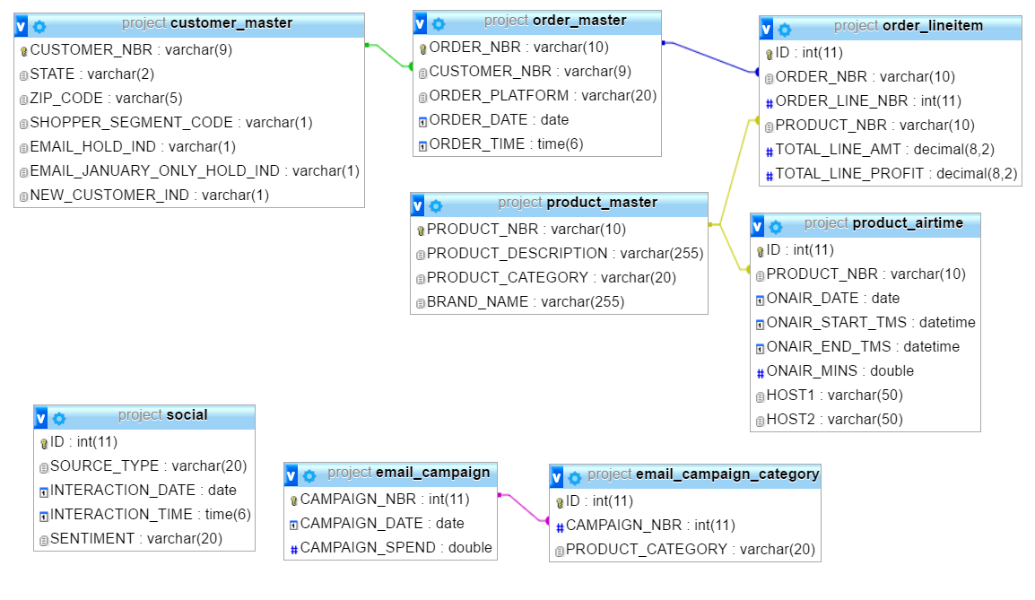

QVC Data Dictionary – For MIS2502 class project

Table | Records | Original Records | Notes
customer_master | 4,722 | 749,859 | Took a 0.1% sample
order_master | 4,794 |  | Took a 0.1% sample
order_lineitem | 4,798 | 4,725,771 | Took a 0.1% sample
product_master | 2,779 | 48,780 | Took a 0.1% sample
product_airtime | 31,596 | 63,468 | Airtime records for sampled products
email_campaign | 61 | 61 | Unchanged
email_campaign_category | 77 | 77 | Unchanged
social | 10,071 | 100,622 | Took a 10% sample

customer_master
Field | Definition
CUSTOMER_ NBR | Identifier for a QVC customer
STATE | The state code of the customer address
ZIP_CODE | The zip code of the customer address
SHOPPER_SEGMENT_CODE | Code that represents a grouping/classification of a customer
EMAIL_HOLD_IND | Indicates that the customer has never been sent marketing emails
EMAIL_JANUARAY_ONLY_HOLD_IND | Indicates that the customer was withheld from emails in the month of January
NEW_CUSTOMER_IND | Indicates that the customer became a customer of QVC between 01-2015 and 03-2015

order_master
Field | Definition
ORDER_NBR | Identifier for an order placed by a customer
CUSTOMER_NBR | Identifier for a QVC customer
ORDER_PLATFORM | The platform in which the customer placed the order
ORDER_DATE | The date the order was placed
ORDER_TIME | The time the order was placed (24-HR)

order_lineitem
Field | Definition
ID | Unique identifier
ORDER_NBR | Identifier for an order placed by a customer
ORDER_LINE_NBR | Line number for an order
PRODUCT_NBR | Identifier for a product sold by QVC
TOTAL_LINE_AMT | The total amount charged to the customer for the order line
TOTAL_LINE_PROFIT | The profit margin on the amount charged to the customer for the order line. (Calculated. Assumed 30%)

product_master
Field | Definition
PRODUCT_NBR | Identifier for a product sold by QVC
PRODUCT_DESCRIPTION | The description about the product sold by QVC
PRODUCT_CATEGORY | The merchandising category the product is assigned
BRAND_NAME | The Brand name of the product

product_airtime
Field | Definition
ID | Unique identifier
PRODUCT_NBR | Identifier for a product sold by QVC
ONAIR_DATE | The date the product was on air
ONAIR_START_TMS | The start time interval of the product on air
ONAIR_END_TMS | The end time interval of the product on air
ONAIR_MINS | The number of minutes during the time interval that the product was on air
HOST1 | The host that was on air during the time interval
HOST2 | The host that was on air during the time interval

email_campaign
Fields | Definition
CAMPAIGN_NBR | Campaign Identifier
CAMPAIGN_DATE | The date the email campaign occurred
CAMPAIGN_SPEND | The amount in dollars that was spent on the campaign.

email_campaign_category
Fields | Definition
ID | Unique Identifier
CAMPAIGN_NBR | Identifier referencing the campaign
PRODUCT_CATEGORY | The product category for which the campaign is for. This table supports multiple categories per campaign.

Social
Field | Definition
ID | Technical key
SOURCE_TYPE | The source of the social data
INTERACTION_DATE | The date and time the person interacted with the social platform
POST | The post/text that the person submitted to the social media platform
SENTIMENT | The view or attitude that was inferred from the post.

