Example Calculation – Flat Plate Fin
Air Properties
$$\left(T\right) Temperature (K)$$ | $$300$$
$$\left(C_{p}\right) Specific Heat (\frac{kJ}{kgK})$$ | $$1.0049$$
$$\left(μ\right) Dynamic Viscosity (\frac{kg}{ms})$$ | $$1.846 × {10}^{-5}$$
$$\left(k_{air}\right) Thermal Conductivity (\frac{W}{mK})$$ | $$2.624 × {10}^{-2}$$
$$\left(ρ\right) Density (\frac{kg}{m^{3}})$$ | $$1.177$$
$$\left(Pr\right) Prandtl Number$$ | $$0.707$$

Flat Plate Fin – Example Calculation
$$Fin Length \left(l\right)-103mm$$
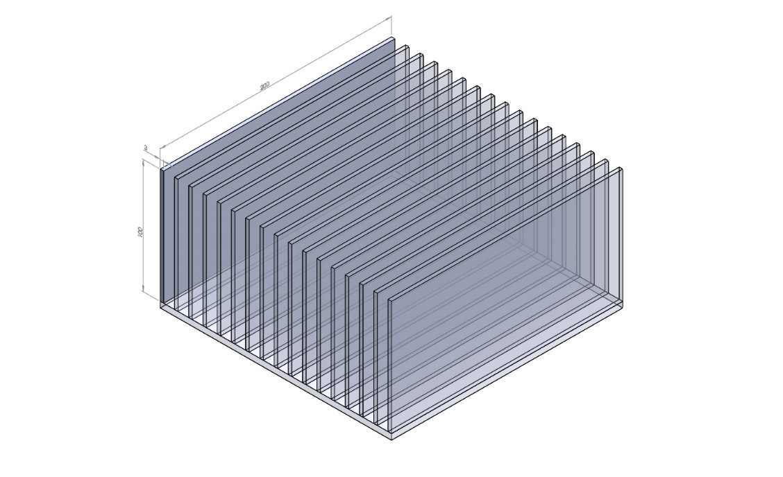
$$Plate Length \left(x\right)-200mm$$

$$Fin Thickness \left(t\right)-2.1mm$$

$$Number of Fins \left(n_{fin}\right)-17$$

$$Fin Mass-0.116802 kg$$

$$Gap Size-10.27 mm$$

$$Air Velocity \left(u\right)-1\frac{m}{s}$$
$$Thermal Conductivity (k_{Al)}-239\frac{W}{mK}$$

$$Wall Temperature (T_{w})-380K$$

$$Air Temperature \left(T_{∞}\right)-300K$$

Formula | Calculation | Answer
Corrected Velocity
Step 1 – Using Bernoulli’s Principle, calculate correct velocity due to area reduction.
$$u_{2}=\frac{u_{1}×A_{1}}{A_{2}}$$ | $$u_{2}=\frac{0.2×0.103×1}{\begin{aligned}\left(0.2×0.103\right)-(17×90.0021× \\ 0.103))\end{aligned}}$$ | $$1.217\frac{m}{s}$$
Finding the Heat Transfer Coefficient
Step 2 – Calculate Reynolds number of Air at 300 K
$$Re= \frac{ρ.u.S}{μ}$$ | $$Re= \frac{1.177× 1.217×0.2}{1.846×{10}^{-5}}$$ | $$15522.697$$
Step 3 – Calculate Prandtl Number of Air at 300k
$$\operatorname{Pr}{= \frac{C_{p}.μ}{k_{air}}}$$ | $$\operatorname{Pr}{= \frac{1.0049×1.846×{10}^{-5}}{2.624×{10}^{-5}}}$$ | $$0.707$$
Step 4 – Calculate Nusselt Number by referring to Chapter 5 of Holman (Heat Transfer, McGraw-Hill). The appropriate Nusselt equation has been selected on the following restrictions.
$$T_{w}=Constant$$
$${Re}_{x}= <5×{10}^{5}$$
$$0.6<Pr<50$$
$${Nu}_{x}=0.332{Pr}^{1/3}{R_{e}}^{1/2}$$ | $${Nu}_{x}=0.332×{0.707}^{1/3}×{15522}^{1/2}$$ | $$36.848$$
Step 5 – Rearrange the standard Nusselt Number equation to make $h$ the subject, with $x$ representing the characteristic length of the fin (0.1). Standard equation is as follows:
$$Nu=\frac{h.x}{k_{air}}$$
$$h=\frac{Nu.k_{air}}{x}$$ | $$h=\frac{36.848×2.624×{10}^{-2}}{0.2}$$ | $$4.835 W/m^{2}K$$
Step 6 – Calculate average heat transfer co-efficient $(\overline{h}$) to be used in heat dissipation calculations
$$\overline{h}=2h_{x}$$ | $$\overline{h}=2×4.835$$ | $$9.669 W/m^{2}K$$
Find Out What Type of Fin it is & Calculate Heat Dissipation
Step 7 – Calculate Perimeter $(P)$ of Fin
$$2t+2x$$ | $$(2×0.0021)+(2×0.2)$$ | $$0.4042 m$$
Step 8 – Calculate Cross-sectional Area $(A)$ of Fin
$$t×x$$ | $$0.003×0.2$$ | $$4.2×{10}^{-4 }m^{2}$$
Step 9 – Calculate $TanH(ml)$
$$TanH(\sqrt{\frac{(\overline{h}.P)}{(k.A)}}.l)$$ | $$TanH(\sqrt{\frac{(9.669×0.4042)}{(239×4.2×{10}^{-4})}}×0.103)$$ | $$0.567 (Type 2 Fin)$$
Step 10 – Convert Type 2 Fin to Type 3 using the correct length $(l_{c})$
$$l_{c}=l+l^{'}$$  $$l^{'}=\frac{t}{2}$$ | $$l_{c}=0.103+\frac{0.0021}{2}$$ | $$0.1041 m$$
$$TanH(\sqrt{\frac{(\overline{h}.P)}{(k.A)}}.l_{c})$$ | $$TanH(\sqrt{\frac{(9.669×0.4042)}{(239×4.2×{10}^{-4})}}×0.1041)$$ | $$0.571$$
Step 11 – Calculate Heat Dissipated $(Q)$ from Fin
$Q=\sqrt{\overline{h}.P.k.A}×θ_{0}×TanH(m.l_{c})$ | $$Q=\sqrt{(9.669×0.406×239×4.2×{10}^{-4})}×80×0.571$$ | $$28.619 W$$
Heat Dissipation for Base Plate Section
Step 12 – Using the same $h$ value, calculate single section of exposed base plate
$$Q=\overline{h}.A.δT$$ | $$Q=9.669×(0.2×0.01027)×(380-300)$$ | $$1.589 W$$
Total Heat Dissipation
Step 13 – Multiply fin $Q$ value by number of fins
$$n_{fin}×Q_{fin}$$ | $$17×28.619$$ | $$486.531 W$$
Step 14 – Multiply flat plate $Q$ value by number of flat plate sections
$${(n}_{fin}-1)×Q_{gap}$$ | $$(17-1)×1.589$$ | $$25.418 W$$
Step 15 – Calculate total heat dissipation for heat sink
$$Q_{gap total}+Q_{fin total}$$ | $$25.418+486.531$$ | $$511.949 W$$

