iLab 6 of 6: Swing and Database Connection

iLAB OVERVIEW

Scenario/Summary
Develop one application using JTabbedPanes and JFrames and another application that connects to a MySQL database.

Deliverables
- JavaPizza
- ContactList
At the beginning of all your programs, put a comment box that includes the program name, your name, and a brief description of the program.

Example:
/***********************************************************************
Program Name: ProgramName.java
Programmer's Name: Student Name
Program Description: Describe here what this program will do
***********************************************************************/

How to submit your assignment:
- The programs must have the same names as the assignment title.
- Each Java source file (*.java) must include a corresponding class file (*.class) program as evidence of success.
- In addition to the program source code files and byte code files, put all your program source code files and screen shots of your program output files into a Word document.
- You must use a zipped folder to send your weekly assignment to the Dropbox. Do not send subfolders within your zipped folder. Place all of the .java and .class files for the week into the one zipped folder. The zip folder should be named CIS355A_YourLastName_iLab_Week6, and this zip folder will contain all the weekly
- programming assignments.

Required Software

Eclipse

Step 1: JavaPizza
Develop an application using a JTabbedPane to order a pizza. You will need to ask the customer for their name and phone number. You will ask for the size (choose one) and toppings (choose many) and compute the total. After computing the total, provide a button to display the order summary, which includes the name, phone number, size, toppings, and total. The prices are listed below. Screenshots of a possible solution are included. Your application must include four tabs and open a new window when the button is clicked.
Small: 8.00
Medium: 10.00
Large: 12.00
Each topping is 2.00 extra.

*** See below for a screen shot of how the program should look like ***
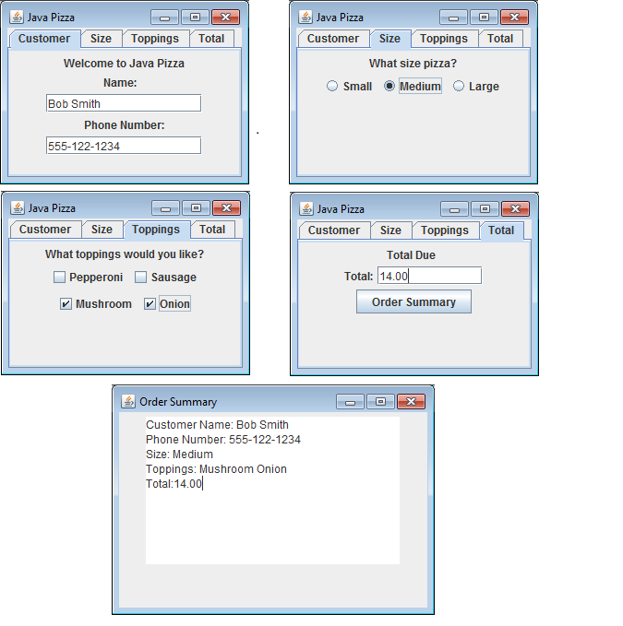

JavaPizza | Points | Description
Standard header included | 1 | Must contain program's name, student name, and description of the program
Program compiles | 1 | Program does not have any error
Program executes | 1 | Program runs without any error
Created the JTabbedPane with four tabs | 4 | The JTabbedPane is displayed with the four required tabs and components on each tab
Total is calculated correctly | 5 | The total on the last tab is calculated correctly based on information supplied.
Order summary window displayed correctly | 8 | The order summary window is displayed with a JTextArea, including all information from the four tabs.
Subtotal | 20

Step 2: Contact List

Develop a Java application to add a contact into the contact table, and display all contacts in the contact table. The contact table contains two columns, FullName, and PhoneNumber. Both values are text data. Use JOptionPanes to ask for the contact data, and display a confirmation message when the contact is added. Display the list of contacts in the console. Screenshots of a possible solution are included. *** SEE SCREEN SHOTS BELOW TO SEE HOW THE PROGRAM SHOULD LOOK ***
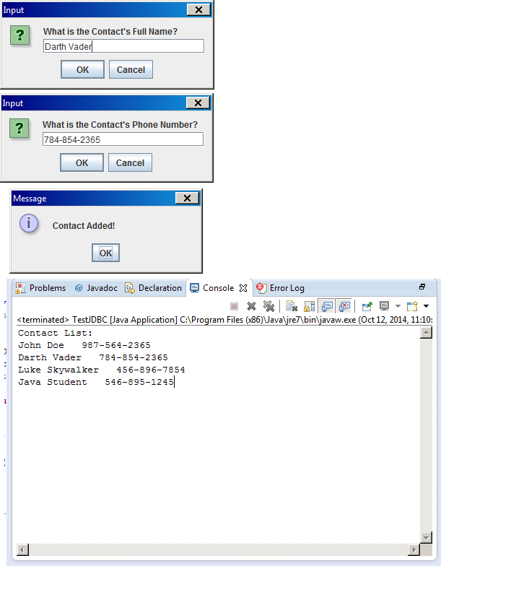
ContactList | Points | Description
Standard header included | 1 | Must contain program's name, student name, and description of the program
Program compiles | 1 | Program does not have any error
Program executes | 1 | Program runs without any error
Created the JOptionPanes for input | 6 | Two JOptionPanes are displayed to retrieve input
JOptionPane displayed upon insert | 4 | A JOptionPane is display to confirm the contact was added
ContactList shown in console | 7 | The list of contacts is displayed in the console under a heading contact list .
Subtotal | 20

