Design Procedure
- Load DesignCase1 into PowerWorld Simulator. This case contains the initial system power flow case, and the disconnected KWW gener- ator and its interconnection bus. Perform an initial power-flow solu- tion to determine the initial system operating point. From this solution you should find that all the line flows and bus voltage magnitudes are within their limits. Assume all line MVA flows must be at or below 100% of their limit values, and all voltages must be between 0.95 and 1.10 per unit.
- Repeat the above analysis considering the impact of any single transmission line or transformer outage. This is known as n-1 con- tingency analysis. To simplify this analysis, PowerWorld Simulator has the ability to automatically perform a contingency analysis study. Select Tools, Contingency Analysis to show the Contingency Analysis display. Note that the 57 single line/transformer con- tingencies are already defined. Select Start Run (toward the bottom right corner of the display) to automatically see the impact of re- moving any single element. Without the KWW generation the sys- tem has no contingency (n-1) violations.
- Using the available rights-of-ways and the transmission line parame- ters/costs given in the table, iteratively determine the least expensive system additions so that the base case and all the contingences result in reliable operation points with the KWW generation connected with an output of 200 MW. The parameters of the new transmission lines(s) need to be derived using the tower configurations and conductor types provided by the instructor. In addition, the transmission changes you propose will modify the total system losses, indicated by the yellow field on the one-line. While the system losses are not KWW’s respon- sibility, your supervisor has asked you to consider the impact your de- sign changes will have on the total system losses assuming the system operates in the studied condition for the next five years. Hence, you should minimize the total construction costs minus the savings asso- ciated with any decrease in system losses over the next five years.
- Write a detailed report including the justification for your final recommendation.
Simplifying Assumptions
To simplify the analysis, several assumptions are made:
1. You need only consider the base case loading level given in Design- Case1. In a real design, typically a number of di¤erent operating points/loading levels must be considered.
- You should consider all the generator real power outputs, including that of the new KWW generation, as fixed values. The change in the total system generation due to the addition of the 200 MW in KWW generation and any changes in the system losses are always picked up by the system slack.
- You should not modify the status of the capacitors or the trans- former taps.
- You should assume that the system losses remain constant over the five-year period, and you need only consider the impact and new de- sign has on the base case losses. The price for losses can be assumed to be $50/MWh.
- You do not need to consider contingencies involving the new trans- mission lines and possibly any transformers you may be adding.

I need a Electrical or Computer Engineer who can help me with a report/project using powerworld or whatever program they are comfortable with. I can upload the lengthy prompt. This project is long and time consuming but I just need to get it done, I will tip very well. Please let me know if you can take on a design project and writing a report and screenshotting images of the process throughout. Everything needed is in this detailed prompt. In the prompt it tells you what is asked for and then some guidance about how to go about completing what is asked for.
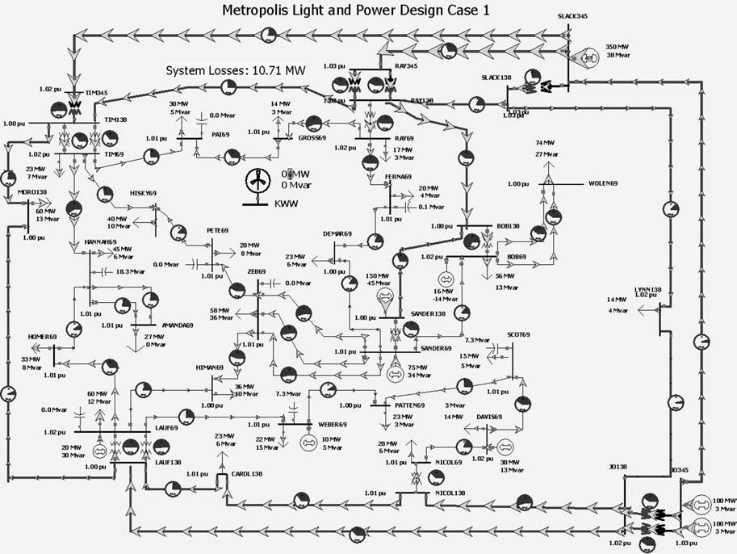
FIGURE 6.20
Design Case 1 System One-line Diagram
6. While an appropriate control response to a contingency might be to decrease the KWW wind farm output (by changing the pitch on the wind turbine blades), your supervisor has specifically asked you not to consider this possibility. Therefore the KWW generator should always be assumed to have a 200 MW output.
Available New Rights-of-Ways for Design Case 1
Right-of-Way/Substation KWW to PAI KWW to PETE KKWW to DEMAR KKWW to GROSS KKWW to HISKY KKWW to TIM KKWW to RAY
KWW to ZEB
Right-of-Way Mileage(miles) 6.0
7.4 12.0 4.5 11.2 13.0 15.0 11.0
DESIGN PROJECT 2: SYSTEM PLANNING FOR GENERATION RETIREMENT
After more than 70 years of supplying downtown Metropolis with electricity it is time to retire the SANDERS69 power plant. The city’s downtown revi- talization plan, coupled with a desire for more green space, make it impossi- ble to build new generation in the downtown area. At the same time, a booming local economy means that the city-wide electric demand is still as high as ever, so this impending plant retirement is going to have some ad- verse impacts on the electric grid. As a planning engineer for the local utility, Metropolis Light and Power (MLP), your job is to make recommendations on the construction of new lines and transformers to ensure that the trans- mission system in the MLP system is adequate for any base case or first con- tingency loading situation. The below table shows the right-of-way distances that are available for the construction of new 69 kV and/or new 138 kV lines. All existing 69 kV only substations are large enough to accommodate 138 kV as well.
Design Procedure
1. Load DesignCase2 into PowerWorld Simulator which contains the system dispatch without the SANDERS69 generator. Perform an initial power flow solution to determine the initial system operating point. From this solution you should find that all the line flows and bus voltage magnitudes are within their limits. Assume all line MVA
flows must be at or below 100% of their limit values, and all voltages must be between 0.95 and 1.10 per unit.
- Repeat the above analysis considering the impact of any single transmission line or transformer outage. This is known as n-1 con- tingency analysis. To simplify this analysis, PowerWorld Simulator has the ability to automatically perform a contingency analysis study. Select Tools, Contingency Analysis to show the Contingency Analysis display. Note that the 57 single line/transformer con- tingencies are already defined. Select Start Run (towards the bottom right corner of the display) to automatically see the impact of re- moving any single element. Without the SANDERS69 generation this system is insecure for several contingencies, including at least one that has nothing to do with the power plant retirement (but it still needs to be fixed).
- Using the rights-of-way and the transmission line parameters/costs given in the table, iteratively determine the least expensive system additions so that the base case and all the contingences result in se- cure operation points. The parameters of the new transmission lines(s) need to be derived using the tower configurations and con- ductor types provided by the instructor. The total cost of an addition is defined as the construction costs minus the savings associated with any decrease in system losses over the next five years.
- Write a detailed report discussing the initial system problems, your approach to optimally solving the system problems and the justifica- tion for your final recommendation.
Simplifying Assumptions
To simplify the analysis, several assumptions are made:
- You need only consider the base case loading level given in Design- Case2. In a real design, typically a number of di¤erent operating points/loading levels must be considered.
- You should consider the generator outputs as fixed values; any changes in the losses are always picked up by the system slack.
- You should not modify the status of the capacitors or the trans- former taps.
- You should assume that the system losses remain constant over the five-year period and need only consider the impact and new design has on the base case losses. The price for losses can be assumed to be $50/MWh.
Available New Rights-of-Ways
Right-of-Way/Substation BOB to SCOT BOB to WOLEN FERNA to RAY LYNN to SCOT
LYNN to WOLEN SANDER to SCOTT SLACK to WOLEN JO to SCOT
Right-of-Way Mileage (miles) 8.5
4.8
6.0 12.0 15.0 6.0 11.5 15.0
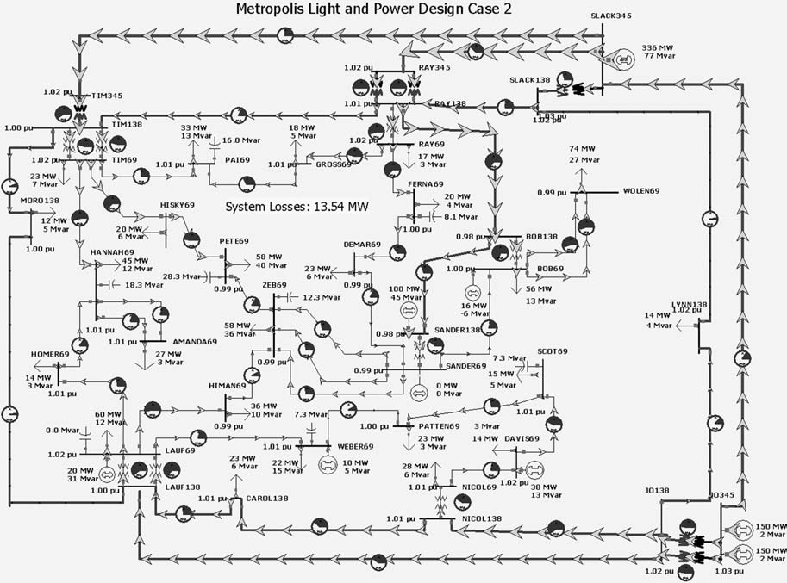
FIGURE 6.21
Design Case 2 System One-line Diagram
DESIGN PROJECTS 1 AND 2: SAMPLE TRANSMISSION SYSTEM DESIGN COSTS
Transmission lines (69 kV and 138 kV) New transmission lines include a fixed cost and a variable cost. The fixed cost is for the design work, the purchase/ installation of the three-phase circuit breakers, associated relays, and changes to the substation bus structure. The fixed costs are $200,000 for a 138-kV line and $125,000 for a 69-kV line.
The variable costs depend on the type of conductor and the length of the line. The assumed cost in $/mile are given here.
Conductor Type
Rook Crow Condor Cardinal
Current Rating (Amps)
770 830 900 1110
138-kV Lines
$250,000/mi $270,000/mi $290,000/mi $310,000/mi
69-kV Lines
$200,000/mi $220,000/mi $240,000/mi
Lined impedance data and MVA ratings are determined based on the conductor type and tower configuration. The conductor characteristics are given in Table A.4 of the book. For these design problems assume a symmetric tower configurations with the spacing between the conductors student specific. To find your specific value consult the table at the end of this design project.
Transformers (138 kV/69 kV) Transformer costs include associated cir- cuit breakers, relaying and installation.
101 MVA $950,000
187 MVA $1,200,000
Assume any new 138/69 kV transformer has 0.0025 per unit resistance and 0.04 per unit reactance on a 100-MVA base.
Bus work
Upgrade 69-kV substation to 138/69 kV $200,000
DESIGN PROJECT 3: SYSTEM PLANNING*
CASE STUDY QUESTIONS 373
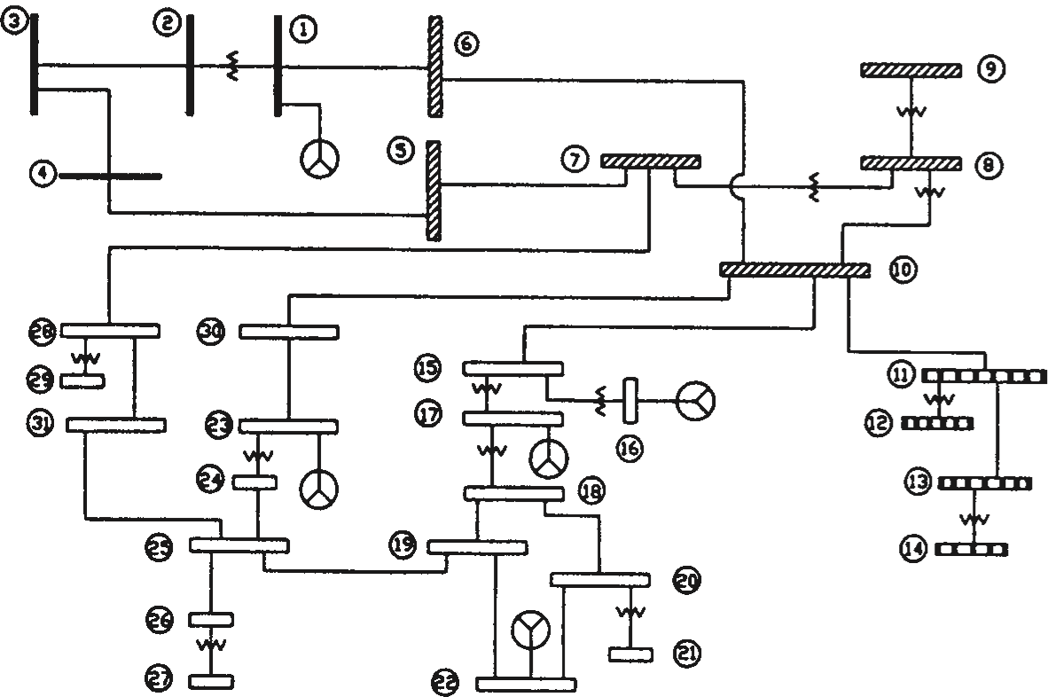
FIGURE 6.22
Design Project 3: Single-line diagram for 31-bus interconnected power system
Figure 6.22 shows a single-line diagram of four interconnected power systems identified by di¤erent graphic bus designations. The following data are given:
- There are 31 buses, 21 lines, and 13 transformers.
- Generation is present at buses 1, 16, 17, 22, and 23.
- Total load of the four systems is 400 MW.
- Bus 1 is the swing bus.
- The system base is 100 MVA.
- Allocate the total 400-MW system load among the four systems.
- For each system, allocate the load to buses that you want to repre- sent as load buses. Select reasonable load power factors.
- Taking into consideration the load you allocated above, select appropriate transmission-line voltage ratings, MVA ratings, and distances necessary to supply these loads. Then determine per-unit transmission-line impedances for the lines shown on the single-line diagram (show your calculations).
- Also select appropriate transformer voltage and MVA ratings, and determine per-unit transformer leakage impedances for the trans- formers shown on the single-line diagram.
- Develop a generation schedule for the 5 generator buses.
- Show on a copy of the single-line diagram per-unit line impedances, transformer impedances, generator outputs, and loads that you se- lected above.
- Using PowerWorld Simulator, run a base case power flow. In addi- tion to the printed input/output data files, show on a separate copy of the single-line diagram per-unit bus voltages as well as real and reactive line flows, generator outputs, and loads. Flag any high/low bus voltages for which 0:95aVa1:05 per unit and any line or transformer flows that exceed normal ratings.
- If the base case shows any high/low voltages or ratings exceeded, then correct the base case by making changes. Explain the changes you have made.
- Repeat (7). Rerun the power-flow program and show your changes on a separate copy of the single-line diagram.
- Provide a typed summary of your results along with your above calculations, printed power-flow input/output data files, and copies of the single-line diagram.
DESIGN PROJECT 4: POWER FLOW/SHORT CIRCUITS
assign one of the single-line diagrams shown in Figures 6.23 and 6.24.
Assignment 1: Power-Flow Preparation
For the single-line diagram that you have been assigned (Figure 6.23 or 6.24), convert all positive-sequence impedance, load, and voltage data to per unit using the given system base quantities. Then using PowerWorld Simulator, create three input data files: bus input data, line input data, and transformer input data. Note that bus 1 is the swing bus. Your output for this assignment consists of three power-flow input data files.
The purpose of this assignment is to get started and to correct errors before going to the next assignment. It requires a knowledge of the per-unit system, which was covered in Chapter 3, but may need review.
Assignment 2: Power Flow
Case 1. Run the power flow program and obtain the bus, line, and trans- former input/output data files that you prepared in Assignment 1.

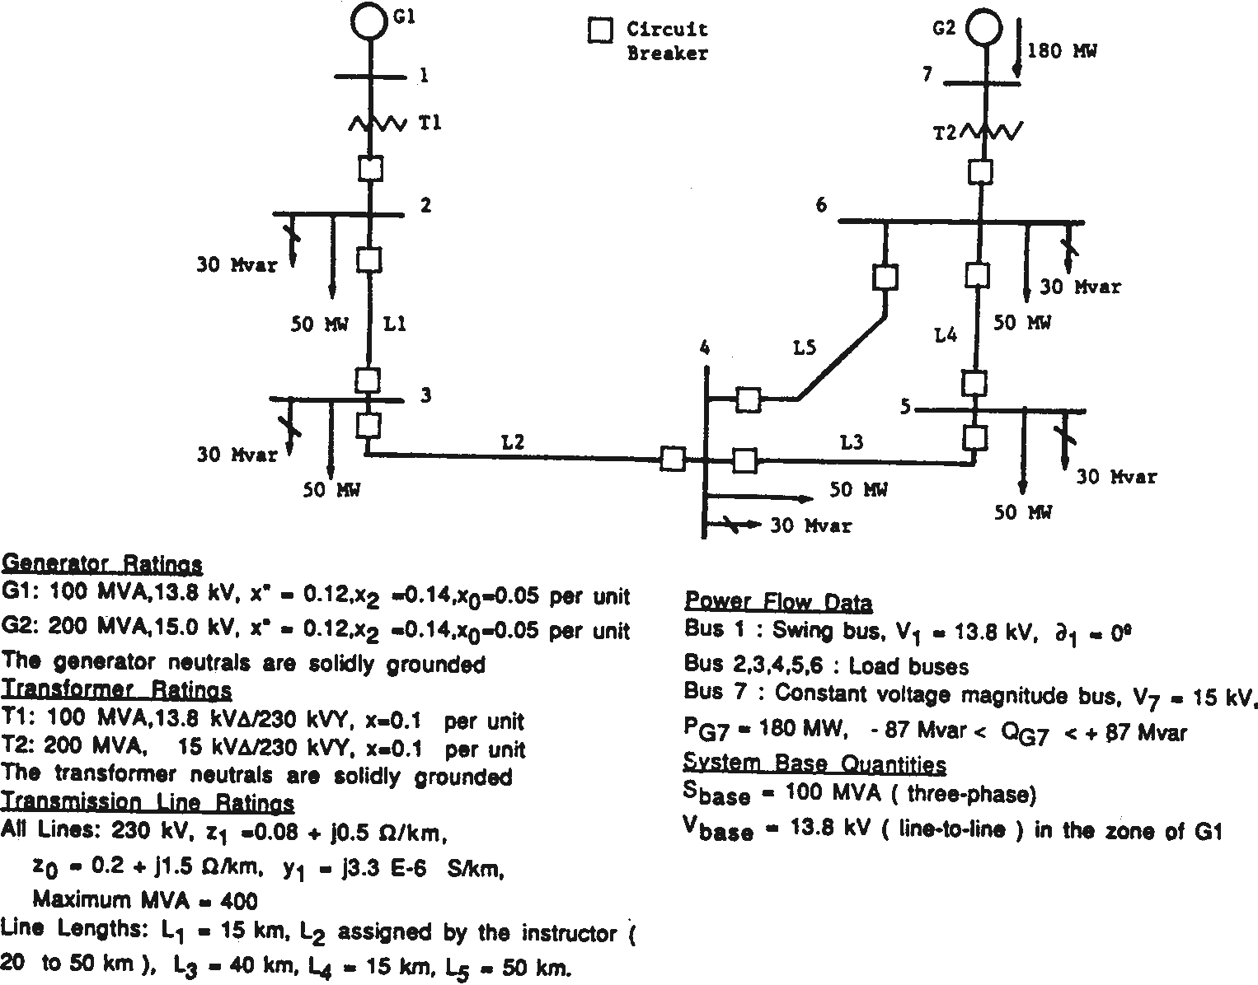
FIGURE 6.23
Single-line diagram for Design Project 4—transmission loop
Case 2. Suggest one method of increasing the voltage magnitude at bus 4 by 5%. Demonstrate the e¤ectiveness of your method by making appropriate changes to the input data of case 1 and by running the power flow program.
Your output for this assignment consists of 12 data files, 3 input and 3 output data files for each case, along with a one-paragraph explanation of your method for increasing the voltage at bus 4 by 5%.
During this assignment, course material contains voltage control methods, including use of generator excitation control, tap changing and regulating trans- formers, static capacitors, static var systems, and parallel transmission lines.
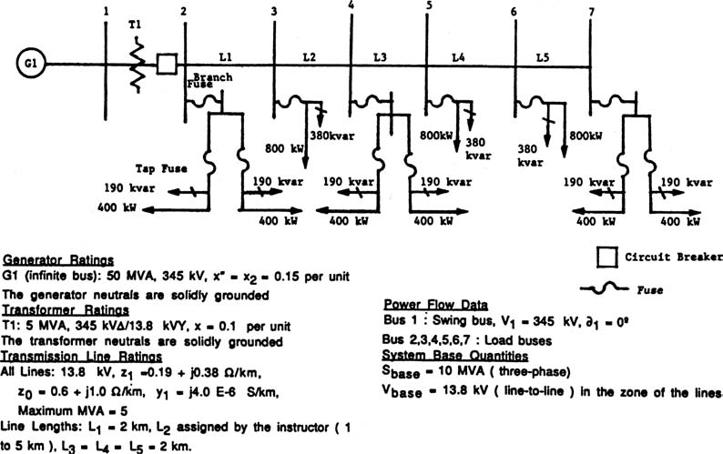
FIGURE 6.24

