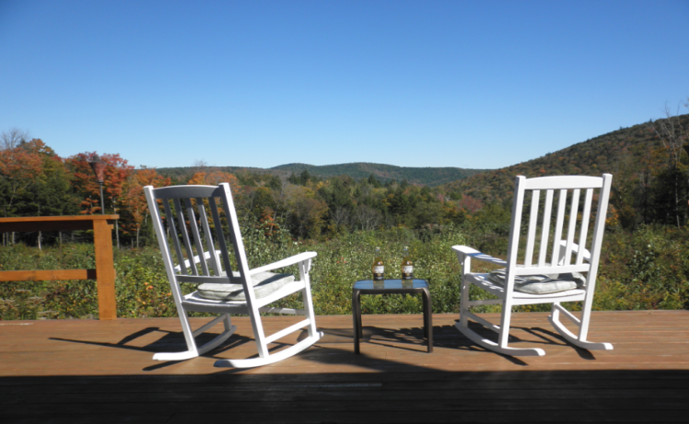
From: Mark DePonte
Moosenuts Junction Productions, _{LLC}
P.O. Box 177 – East Dover, VT 05341
e-mail: mdeponte@moosenutsjunction.com

Home: (802) 451-6410 Cell: (203) 530-7752

To: L.L.Bean Inc.
15 Casco Street – Freeport, ME 04033-0001

Phone: (800) 441-5713 Fax: (207) 552-3080
www.moosenutsjunction.com
REF: Need Guests & Products for Show

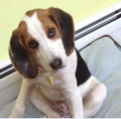
Dear Sir/Madam:
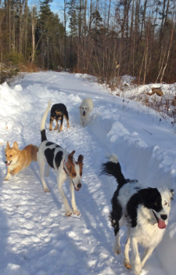
I am working on a simple New TV show called "Walkie"
Like the name implies, the "basic" concept is to simply take a walk
with today’s Celebrities, Newsmakers, and Business Leaders
(with links to animal charity organizations) and their pets, and interview them.
We would discuss what makes them “tick”. Their views of the world, life, and of
course, their pets. The “walk” would take place on the trails of my property in VT.
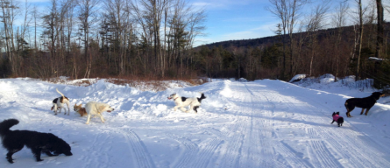
Filming is slated for May through October.
(Won’t be snowing then.)

My reason with contacting you is 2-fold.
1: I would like to have one of your team (or P.R. Reps) as a Guest on the show.
We would talk about LL Bean products and show clips of the products you make in use around the world.
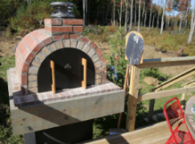
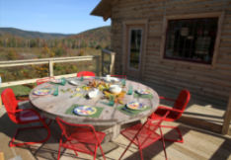
And of course, dogs, cats, horse, life in the woods, etc.
I’ll cook them a pizza at the spinning cabin when we are done.
(You can check it out at National Geographic–Spinning Cabin)

2: Since ALL of my guests will be taking a "walk" (more like a hike) through the woods on my property,
I would like to outfit them with LL Bean gear. (Shoes, Hats, etc.)
We have a short segment on each episode when we show everybody suiting up before the walk.
(ie: Dogs getting cameras and Tracking collars put on. Guests putting on gear, etc.)
So we could highlight your gear for at that time.

Even if you can’t commit to being a guest on the show this year, perhaps you can still commit with this 2nd aspect.
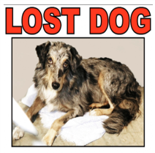

FYI: Another part of the show is where we call old "lost animal" ads to see if the owners ever found their missing loved ones. There are many, many other aspects of the show that go beyond just the walk in the woods, but I don't want to bombard you with details.

Hopefully I will hear from you soon.
In the meantime, you can visit the website for more information: www.MoosenutsJunction.com

Mark DePonte
Owner/Producer

