Press Enter to boot system from CD
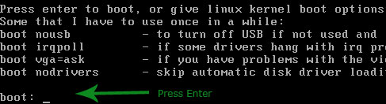
Script will make a quick scan of hard disk and return with all available window installation. Usually there will be only one, unless you have dual operating system installed. Type the disk number (Most probably one, or see the returned result for appropriate number) and press Enter
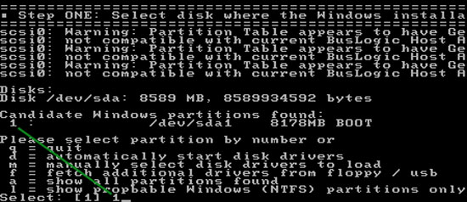
We need to provide registry files path. Usually script will automatically find the path, all you need to do is just press Enter and go with default selected path
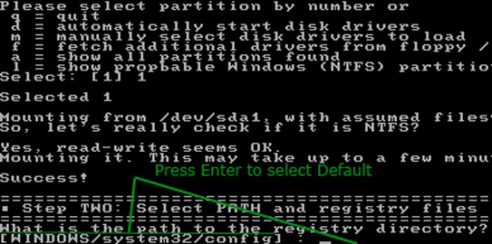
Our primary goal is to reset the password, Type 1 and press Enter
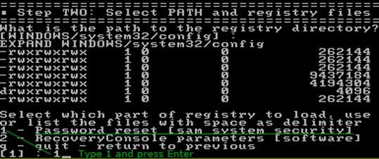
We will first disable the Syskey, Type 2 and press Enter
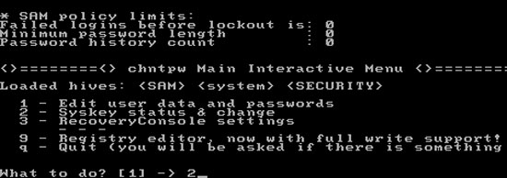
Type y and press Enter to confirm the Syskey disable.
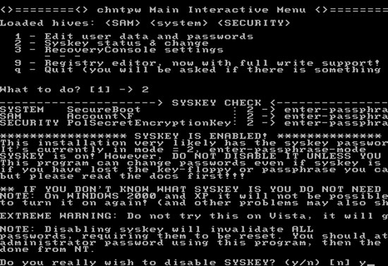
When you disable Syskey, this script will also invalidate (set to blank) all users passwords from system. You need to reset them as well. From this point you can save change to disk and return to window. Type q and press Enter to return previous menu
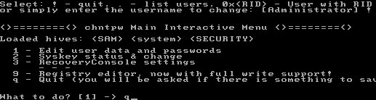
Type y and press Enter so script can write the change to disk
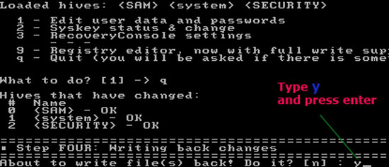

If you want, you can run the script again. Type n and press enter.
