This is the resolution I am able to set without the monitor by using the laptop’s screen:
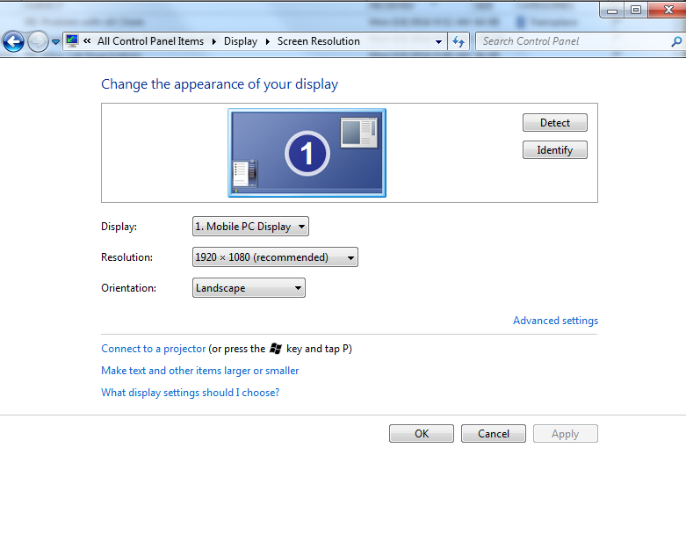

This is the highest resolution I am able to set with the monitor (and switch:
