Information Systems and their Relationship to the Organization
- Definition
- Components

What is an Information System?
[Public Domain via Pixabay]
According to Dessler and Phillips (2007) it is "interrelated components working together to collect, process, store and disseminate information to support decision making, coordination, analysis and visualization in an organization." (p. 23)
Notice that the above definition does not explicitly mention computers. In fact, before the introduction of computers into our society, many organizations had elaborate information systems. The pre-computer information systems were very labor-intensive operations. However, these systems mainly involved the storage and retrieval of hard copy documents. Their only reporting function was to provide the accountants enough information to take care of the balance sheets. Managers relied more on intuition than information to make decisions.
As firms became larger and the global economy developed, manual information systems became too costly to operate. More information was needed to operate a firm in the global marketplace. Thus, computer-based systems were developed to fulfill management's needs for more information at a lower cost.
As we approached the 1980's, four powerful changes took place in the business environment:
- The emergence and strengthening of the global economy; Firms that used to compete in a limited geographical area now have to compete with firms from around the globe. Customers can obtain goods from anywhere in the world, 24 hours a day, seven days a week.
- The metamorphosis of industrial societies into knowledge-based service economies; Manufacturing has moved into geographic areas where labor costs are low. The new economy for major industrial nations is moving more towards the design of goods and the distribution of goods. In such an economy, workers need modern information technology to remain competitive and productive.
- The transformation of the business enterprise; Today, as in the past, most firms can be described as hierarchical, centralized, and structured, relying on a formal rules, plans and division of labor to operate. The modern firm, while remaining hierarchical, has had its structure flattened by using information systems as a replacement for middle management. With fewer specialized middle managers, a new breed of managers with more generalized skills and responsibilities have emerged.
- The emerging digital firm; A new type of firm has emerged. The digital firm (otherwise known as a "dot com" company) deemphisizes brick and mortar buildings. This type of firm uses technology to replace buildings, people and other types of physical infrastructure.
Other significant changes have taken place in the business environment that impacted the work force. Starting around 1925, the number of blue collar workers surpassed the number of farm workers. It is around this time that we can say our economy changed from agrarian to industrial. Then, around 1972, the number of white collar workers exceeded blue collar workers. This event signaled the beginning of the information age.

What are the components of an Information System?

We have already defined what an information system is. What are its components?

Data is streams of raw facts. It is generally unorganized and not useful for people. An example would be the date of a single transaction.
Information is the result of organizing bits of data into a form that is useful to humans. An example would be a report of all transactions that occurred for a single week.
Input is the capture of raw data from within an organization or from its environment.
Processing is the conversion of the raw data into meaningful information.
Output is the distribution of information.
Feedback is when processed information is returned to a point in the organization before where the processing takes place. It is used to evaluate or correct input.
People are the creators and users of information. They are just as much apart of the system as a keyboard. One of the most dangerous errors that information system designers make is forgetting to consider the users' capabilities and needs.

It is necessary to note that information systems are not machines or processes operating in a vacuum. Information systems are meant to be a solution, using information technology, to a challenge posed by the organization's environment. To implement the solutions made possible by computer-based information systems, a manager must go beyond being computer literate. Such challenges require the manager to be information systems literate. That manager must understand the organizational, management and technological dimensions involved in information systems.
Organizations

The key elements of an organization are:

People
Management
Knowledge workers create knowledge for the organization. (Engineers, scientists)
Data workers process the organization.s paperwork. (Clerks, bookkeepers)
Production workers actually produce the product or service the company offers.
Structure
Standard Operating Procedures (SOP) are formal rules for accomplishing tasks within the organization.
Politics
Culture
Business Functions

Management:

Managers have many functions. They exercise leadership, perceive business challenges and allocate human and financial resources. They must also create new products and services, and re-create the organization when needed. There are three categories of managers:

Senior Managers - The big cheeses. They are responsible for making long range decisions. They also decide what products and services to produce.
Middle managers - These managers carry out the programs and plans of senior management.
Operational Managers - The bottom rung. They carry out the day-to-day activities of the organization.

We will learn more about the relationship between Information Systems and Organizations later.

Technology

Information systems use various types of technology. The four types of technology available to organizations are:

[Public Domain via Pixabay]
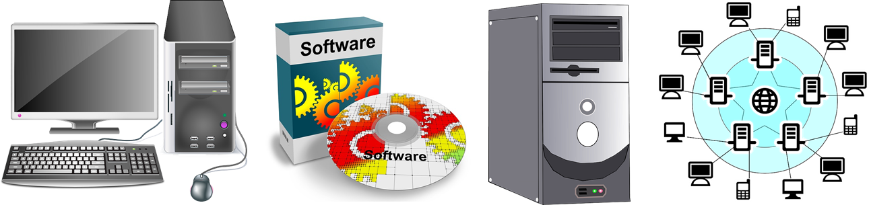

Computer hardware - The stuff you plug in. Examples of hardware are printers, computers, routers, monitors, etc.
Computer software - The detailed set of instructions that tells the hardware what to do. Software usually comes on floppy disks, compact disks or from across a network.
Storage technology - Keeps the information (programs and data) for later retrieval.
Telecommunications technology - Hardware and software for transferring data between physical locations. This includes networks, including the Internet.

Together, these technologies represent the firm's IT infrastructure.

Networks

Source: University of Lincoln, “Map of the Entire Internet 2014" [CC BY-SA 2.0 UK via UL]

Perhaps nothing has affected the way our society does business more than the increasing use of computer networks. From the small office to large corporations, companies are bringing their employees, vendors, customers, and even competitors together. A transaction that took days to complete 20 years ago may now take only 0.00002 seconds. We will cover networks more extensively later in the course..

The big daddy of all networks is the Internet. The Internet is a worldwide network of networks. When using the Internet, geography is irrelevant. I could be teaching this class from Sydney, Australia and you would never know it. In fact, do you really know where I am right now?

The World Wide Web (WWW) is one aspect of the Internet. When you linked to this page, you used the WWW to obtain information. One of the more interesting computer-related Web sites is ZDNet. (Please note that whenever you see blue, underlined text, that is a link I want you to click on and explore.) The Web can be used to exchange information, conduct business and for entertainment.

The basic entity on the WWW is a web page. Right now, you are looking at a web page. This page is part of a web site which is a collection of web pages sharing a common theme. A web site is defined as all of the web pages maintained by an organization or an individual. Using modern technology, a single high-end computer (called a server) can contain several separate web sites.

The Colorado Community College System is made up of several independent institutions spread throughout the state. All institutions use a common academic information system named D2L and a common administrative system named BANNER. We are increasingly becoming a virtual organization. Much of our business is transacted using e-mail and online chat sessions. As time goes on, other technologies will be added to make our operation more efficient.

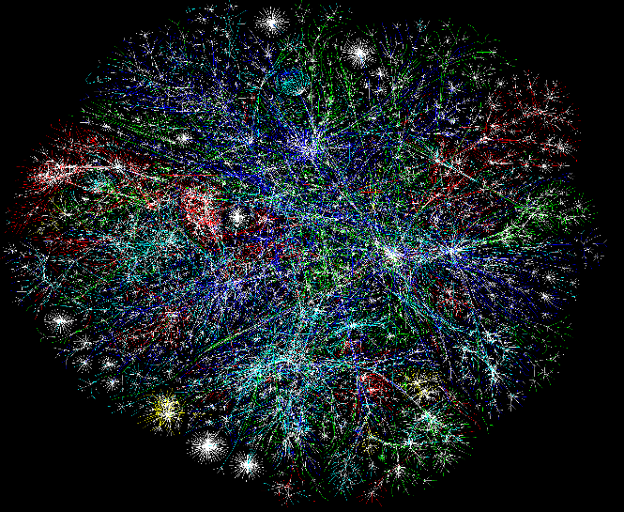
Other networks link companies with their suppliers. These are called interorganizational systems. When you purchase an item at Wal Mart, the transaction is noted in their information system. The system promptly reorders the item from a supplier. Did you also know that you can order merchandise from WalMart over the Internet?

Networks have given rise to electronic commerce. This is where goods are bought and sold electronically. Want to buy a computer? Simply click here, and you will be linked with Dell Computers. You will be able to configure a computer system, tell them where to send it, give them your credit card number, and sit back and wait for your new computer. You can do all this without ever speaking to a human being. This is a good example of Electronic Commerce.

Organizational Implications of Networked Firms

Flattened Organizations: As we have seen earlier, organizations can become flatter after the application of information systems. This is because it is possible for management to control more functions with information systems, thus reducing the need for middle managers. As more firms increase the capability of their systems, more middle managers will find themselves out of a job. This is why is it very important for managers and potential managers to obtain the highest level of information systems literacy possible.

[Public Domain via Pixabay]
Geographical Implications: The Internet, as well as corporate networks, can make geography irrelevant. With Colorado Community Colleges, the administrative computing system can be used by extended campus workers 900 miles away. To them, the corporate servers could be next door. When you purchase an item at Wal Mart, the transaction is recorded at a central office that could be thousands of miles away.
Reorganizing Work flows: With improved work flow, a company can reduce costs because the number of people required to complete an operation is reduced. For instance, in the past when a company had to order a widget, they needed a purchase order that was sent to a central purchasing department. That department contacted the supplier, ordered the part, and arranged for the bill to be paid. With a modern information system, the order can be placed on a computer and electronically transmitted to the supplier. The information system takes care of the payment. Transaction costs are reduced because no human was needed to obtain the parts ordered (in some systems, even the person ordering the part can be eliminated). In another example, there are credit cards you can apply for over the Internet. You receive an answer to your application within 60 seconds. There are no human transactions costs in the application phase because humans have been eliminated from the process.
Organizational Flexibility: When you see a company's web site, do you know if it is large or small? Unless you know the organization some other way, there is no way to tell. On the Internet, large companies can appear to be small and responsive. Small companies can appear to have unlimited resources. The Internet is a great equalizer in many ways. This same concept allows companies to change their strategy to accommodate changes in the environment. For instance, if a new product is developed that Wal Mart wants to sell, it does not have to wait until the items are all shipped to its stores and stocked. Wal Mart can advertise the item immediately as being available on its web site. Another way companies can use information systems to increase flexibility is using mass customization. This is where the manufacturing process is able to produce small runs of specially ordered merchandise with no additional cost to the consumer. A good example of mass customization is Dell Computers. You can use their web site to configure a computer that exactly meets your needs. This order is transmitted to the production line where your computer is assembled and shipped the cost of each unit is not increased and the advantages of scale economics are retained.
Changing the Management Process: More information is available to the manager with modern information systems. As a result,management can base decisions on facts and numbers rather than intuition. The increased communications capabilities of information systems can allow managers to communicate with workers more frequently, regardless of geography. An example is that before the Colorado Community College System began to extensively use e-mail and other communication technologies, its telephone bill was outrageous. Management could not afford to communicate with the outlying campuses on a daily basis. After the adaptation of e-mail and other communication technologies, management could freely communicate with the centers. Real-time discussions were made possible on a weekly basis. The additional communications capabilities allowed the organization to become more efficient and cohesive. They also saved several hundred dollars each month in telephone costs.
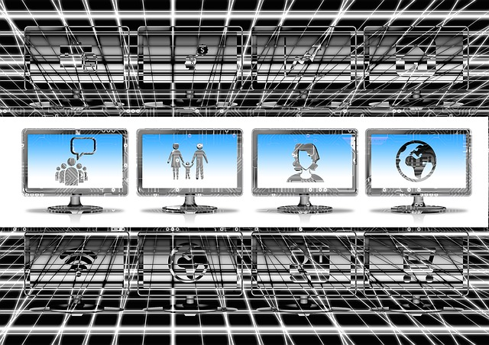
Defining Organizational Boundaries: As mentioned in the section on work flow improvements, firms can extend their information systems to customers and suppliers. This is done though the use of interorganizational systems. Before the use of these systems if a manufacturer wanted to reduce transaction costs (the cost of executing a purchase), it had to acquire the supplier. Now, transaction costs can be reduced without acquisition using interorganizational systems. Later in the course, we will study complex interorganizational systems called industrial networks.

Common Features

Information Systems (IS) do not exist in a vacuum. They are part of an organization dedicated to a purpose. The structure and contents of an organization will affect the structure and contents of an information system. Likewise, an information system will have an effect on the organization. It is important to understand organizational issues regarding information systems.

All organizations have three common features:

Standard Operating Procedures (SOP): procedures that govern the day-to-day functioning of the firm.
Organizational Politics: the method by which competition and conflict occur in the organization.
Organizational Culture: assumptions about how the organization is run

Although you will find the above features in all organizations, the characteristics of each feature vary from organization to organization. For instance, smaller companies are able to quickly change their SOPs to address environmental changes. Larger organizations are often slow to change SOPs. All of the above are powerful barriers to change within the organization. All three will influence how information systems are built and operated in the organization.

Organizations and Information Systems

What is an organization? According to Max Weber, there are five different types of organizations:

[Public Domain via Pixabay]

Entrepreneurial: A small, simple organization dominated by a single person, often the owner.

Machine Bureaucracy: A large company organized into functional divisions.

Professional Bureaucracy: A system for professional organizations with weak central control.

Divisionalized Bureaucracy: A combination of multiple machine bureaucracies.

Adhocracy: A temporary task force used in research oriented organizations.

Information systems and the organizations they serve should form a Gestalt. One connotation of Gestalt is, "The whole is greater than the sum of the parts." In this context, let's say that the potential of the organization is X. Let us also assign the potential for the information systems to Y. Finally, let Z equal the integrated combination of X and Y. The word Gestalt would imply that Z > X+Y.

Using another example if one purchased all the parts it would take to build a 1996 Ford Mustang, there would have a lot of parts, but not a car. One could not go anywhere using the parts. They would be useless. However, when the parts are assembled into their intended form, a vehicle is created. the owner will be able to drive it, show it off or race it. Hopefully you can see that the whole (assembled) car is greater in its utility than the sum of it's parts.

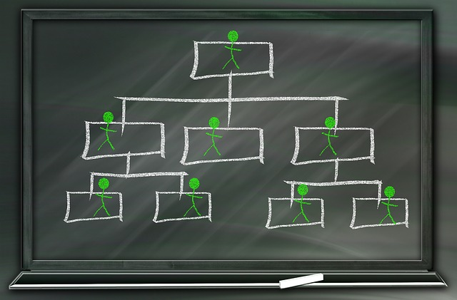
Thus, we seek to create a Gestalt when we introduce an information system into an organization. In doing so, we have to also understand that the organization and the information system are not the only parts we have to consider. The environment, culture, politics and chance also have to be factored in.

Every organization must operate within the constraints of its environment. The environment is not stable. Businesses come and go. Most do not survive much more than 5 years. The reason for this is that they are not able to adapt to the environment. Government regulations, changing technology, new products, customer preference and economic variations all contribute to the environment with which an organization must deal with.

Each organization has internal functional levels. The levels may go by different names depending on the specific organization. The following graphic lists each level and the information system normally used to support them.

Organizational Levels
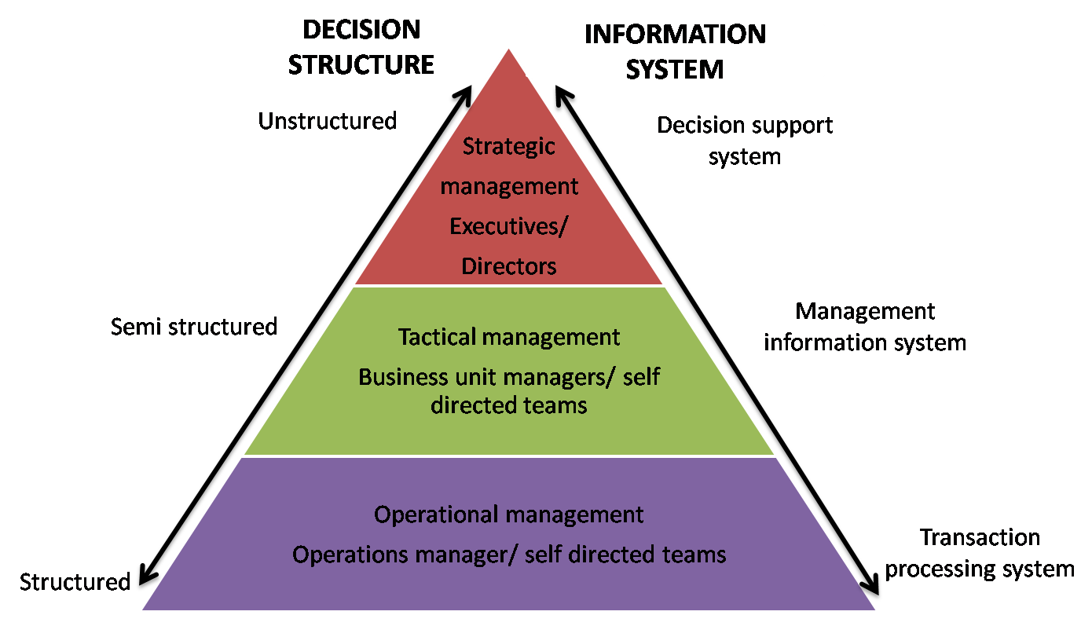

How Organizations Affect Information Systems

Because we seek to create a Gestalt, we must discover how each part affects the other. When information systems are designed, the effect it will have on an organization is what we usually focus on. However, we must also seek to understand how the organization affects the information system.

The organization affects information systems through the decisions made by managers and other employees. Managers decide who uses the systems and how the systems are used. They also decide who designs the systems. Many larger firms have a information systems department. This department is responsible for running the organization's systems. However, the IS department does not, or rather should not, have the primary responsibility for designing the systems. We will discuss reasons for that later in the course.

Managers must justify most decisions they make. Thus, the decision to adopt an information system must be justified. Why adopt an information system? Here is the "top five" list:

5. To become more efficient

4. To gain and hold competitive advantage

3. To save money

2. To reduce the work force

And the #1 reason - To stay in business.

As stated before in this lesson, there are 5 different types of organizations we will cover:

Entrepreneurial:

This is a structure usually found in small companies which are led by one person, usually the owner. These types of companies may not have an IS department. The information systems are usually not well planned or properly financed. This type of organization usually exists in a fast moving environment. Since it does not have some of the administrative overhead other types of organizations have, it is well suited to compete in a changing environment.

Machine Bureaucracy:

This is a large, classical organizational structure. It is dominated by senior management, none of which usually have a majority stake in the ownership. Work is divided into functional divisions such as finance, accounting, sales, manufacturing, etc. Information systems are usually planned very carefully. The information is centralized in one or two mainframe (large) computers.

Professional Bureaucracy:

Professional bureaucracies are knowledge-based companies such as universities, hospitals, law offices and engineering companies. The central authority is usually weak. These firms are dominated by functional department heads. Such companies may have a simple TPS, and a large, sophisticated KWS.

Divisionalized Bureaucracy:

This type of company is very large, with more than one product line. The divisions are usually based on the product lines. Each division has the characteristics of a Machine Bureaucracy. The information systems must allow each division to accomplish its mission, but still meet the reporting requirements of the central headquarters. General Motors is a classic example of a divisionalized bureaucracy.

Adhocracy:

In an adhocracy, employees are usually divided into "task forces". Each task force is created to meet a new need (such as a government contract or a research problem). The central information system may be weak and unorganized. The task force computers are normally organized and very focused on the task at hand. Once the problem or issue is dealt with, this type of organization either transforms into another organizational type or dissolves.

Matrix Organization

This type of organization is sometimes not recognized as a legitimate type, but it is becoming increasingly popular. A matrix organization is created by overlaying product-based departmentalization onto a functional structure . A matrix design is typically used for portions of an organization. Each member of a matrix organization has a functional 'home' but may be assigned at any given time to one or more groups working on special projects. Here is an example of a Matrix Organization:

Matric Organization Structure
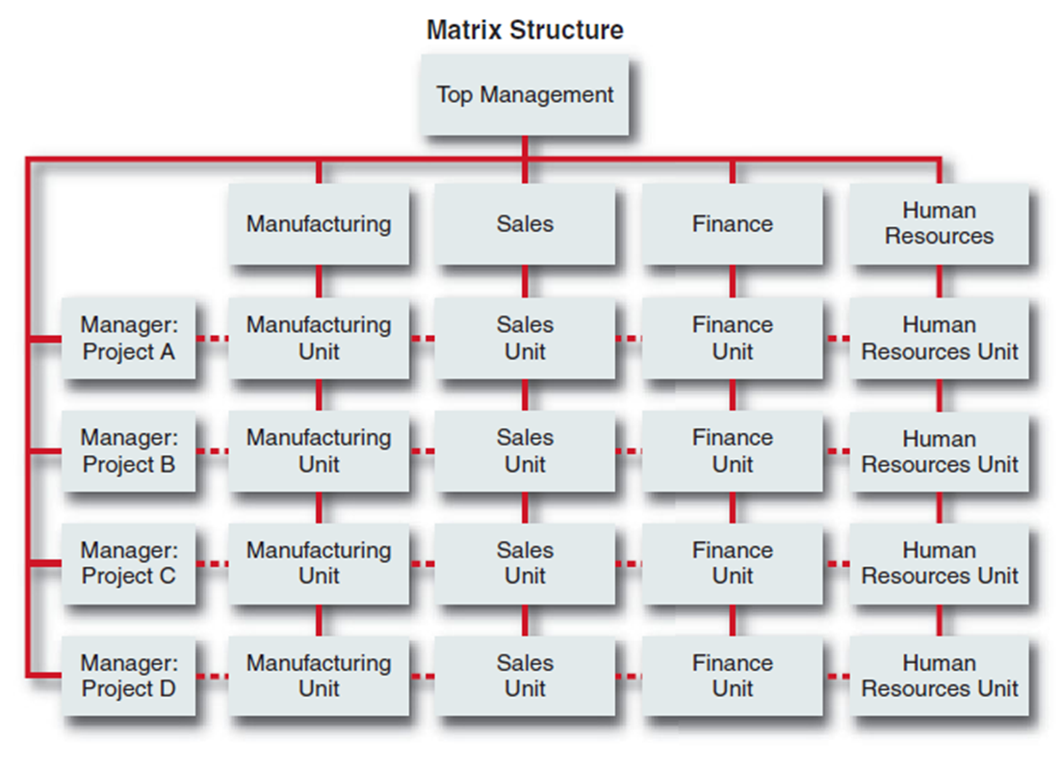
MGMT450, "Generic Matrix Org Chart" [(c) MGMT450 via EduBlogs]

The advantages and drawbacks of the matrix organization are:

IOSH,"Advantage/Disadvantage" [(c)IOSH.co.uk ]

Advantage:

The organization is able to capitalize on the advantages of both functional and product departmentalization.

Drawbacks:

The organization lacks a clear chain of command.

Project groups may take longer to finish work and be prone to conflict.

The organization has to devote more resources to coordination

Roles Within Information Systems

Within the organization, there are different IS roles. For instance, the programmer is charged with developing and maintaining the system from a technical point of view. They write program code, and little else. Programmers usually do not have significant contact with members of the organization outside the IS department.

The systems analyst is a person with some business knowledge and some programming knowledge. This person is the liason between the IS department and the rest of the organization. The analyst will take the firm's business needs, translate then into requirements for the IS, and communicate those requirements to the programmers.

The Information Systems Manager heads a part of the IS department. IS department teams include:

Telecommunications
Programmers
Office Systems
Facilities
Data Entry

The Chief Information Officer (CIO) is a relatively new title in organizations. The position has become necessary because all IS efforts should be managed by senior officials. The CIO is usually a person at the Vice President level who oversees the company's IS efforts.

End users encompass all the people who use the systems on a regular basis. They should usually (but not always) be a part of IS development teams

How Information Systems Affect Organizations

Organizations determine the design of their information systems. Conversely, Information systems affect the organization. There are eight generally accepted theories that try to describe how IS affect organizations.
Economic Theories

Microeconomic Model

Information technology is a factor of production that can be freely substituted for capitol and labor. Put another way, computers can replace people and equipment needed to produce the firm's goods and/or services.

Transaction Cost Theory

Information technology can reduce the firm's costs of acquiring items not made internally. By decreasing the cost of labor formerly required to complete transactions, a firm do the same amount of business with substantially fewer employees. We will discuss more about how this is done when we discuss Electronic Data Interchange (EDI) later in the course.

Agency Theory

If left unsupervised, employees will pursue their own interests rather than the interests of the firm. Information systems allow companies to supervise the activities of their employees using fewer middle managers.
Behavioral Theory

Decision and Control Theory

Organizations make decisions under varying degrees of uncertainty. The pyramid structure of organizations, with senior managers at the top, middle managers in the middle and functional managers and production employees at the bottom, serves as a conduit for information flow within the firm. Information systems can bring information directly to senior managers from the operating units. It can also distribute information from top management to the operating units. Thus, the need for many middle managers is eliminated.
Sociological Theories

Oligarchies and Routines

Information systems have, on their own, little or no power to influence organizations. Their utility is as a better way to implement Standard Operating Procedures (SOPs). Information systems are rejected if they threaten existing SOPs. Change occurs when a new organizational structure forms around an information system.

Post-Industrial Theory

In post-industrial organizations, authority should be based more on knowledge and competence, not formal position. Professional workers are usually self-managed. Therefore, task forces within the organization made up of professionals can be formed to tackle a specific problem. Information systems allow for these professionals to be directed by senior management, eliminating the need for middle management. Also, since the new professional can maintain their offices in the form of a personal computer (in the form of a laptop, desktop or both), a smaller clerical staff.

Cultural Theories

Information systems must fit into the firm's culture of it is unlikely they will be adopted. If members of the firm propose ideas that are not a part of the culture, they are ostracized. Changes to the culture are usually accompanied by changes to senior management.

Political Theories

Information systems are the result of political competition and conflict within the organization. Influence over the policies and procedures of the firm is the goal of the many groups involved.

It is best if you do not subscribe exclusively to any one of the above theories. Each theory has its own truth. However, each theory is also is inadequate to explain all the effects IS has on the organization. Reviewing them serves to illustrate the different concerns you, as a system designer, should pay attention to when designing and/or building an information system.

Organizations and Management

A study done by Mitzburg (1971), indicated that managers:

Perform work at a fast pace with most activities lasting less than nine minutes.
Tend to engage in a wide range of brief activities.
Prefer current, specific and speculative information.
Maintain a large, diverse network of contacts.
Prefer verbal forms of contact.

Managerial Models

There are three major schools of management theory:

Technical-Rational

This is also known as the classical perspective. Managers that use this perspective see the organization as a machine. They try to fine-tune the machine to achieve the highest efficiency possible. As in an actual machine, they see an organization as having individual parts which are crafted, then integrated into the whole.

Behavioral

One problem with the Technical-Rational approach is that it fails to take into account the fact that the workers are human beings. The behavior of individuals by themselves and in groups of differing sizes was not taken into account.

A good example of this was the Chevy Vega. Does anyone remember the Vega? The plant where the Vega was manufactured was a classic one, run using the rational-technical approach. Each person on the assembly line had a job that averaged 15 seconds in length.

One day, a person bought a Vega and took it home. After getting a few blocks from the dealer, he noticed a rattle in the door. After he took the car back three times to fix the door, the dealer finally took the door apart. Inside, there was a soda bottle hanging from a string. Inside the bottle was a note that said, "Noisy, isn't it?" The workers in the plant were so bored, they pulled pranks on the customers. The work was done so poorly that the cars soon fell apart.

Cognitive Perspective

The cognitive perspective sees the organization as a living entity. The organization can learn, behave, remember and know. Have you ever heard the term, "institutional memory?" In this type of organization, the managers job consists of decision making.
Decision Making

Decisions can be:

Strategic: This is where the manager decides the objectives, resources and policies of the organization. It involved predicting the future of the organization as well as matching it's objectives to the environment.
Management control: This is where managers deal with how effectively an organization's resources are used and how units are performing.
Knowledge-level: Managers dealing with this type of decision find new products, better ways to communicate knowledge throughout the organization.
Operational control: This level of management is charged with implementing the tasks specified by the other three levels.

In the Information systems above, the operational and knowledge system levels are designed, to some degree, to help managers make and carry out decisions. Before we deal with specific systems, there are some concepts we must learn. There are three classifications of decisions:

Unstructured decisions: Non-routine decisions with no pre-existing guidelines
Semistructured decisions: Where only part of the problem is routine with guidelines.
Structured decisions: Repetitive, routine decisions with set guidelines.

The figure below was first displayed in the second section of this lesson. It shows the different information systems that are designed for the different decision types described above.
Organizational Levels

Parul Batra,"Types of Information Systems" [© Parul Batra]

Now that we have some idea about the types of decisions managers are faced with, we need to review the steps they take in the decision making process. The four steps of decision making listed in the book were developed by Dr. Herbert Simon. Dr. Simon won the Nobel Prize in economics in 1978 for his work in bounded rationality. The four stages of decision making he described are:

Intelligence Gathering: information needed to make the decision.
Design Planning: possible solutions to the problem.
Choice Choosing: one of the alternatives available.
Implementation Putting: the chosen solution into effect and measuring its progress.

The decision making process is not always linear. Managers may have to backtrack to and repeat a prior stage.

Decision making is not easy. Managers seem to be right as often as they are wrong. When managers are incorrect in the decisions they make, the organization can be come extinct. Every day we see empty stores where businesses once operated. Our bankruptcy courts are busy with companies which have failed.

Information systems can help a company stay in business. They help provide information to managers that is timely and useful. For an information system to do it's job, it must be designed so that:

It is flexible.
It can support a wide range of styles, skills, knowledge and decision making processes.
It is powerful enough to support multiple data models and track many alternatives.
It reflects the political and social interests of the organization.
It reflects an understanding that information systems have limitations.

Understanding how managers make decisions and what types of decisions are made will help a system designer to develop a system that will provide all of the information needed. Without adequate information, managers have a lower likelyhood of making correct decisions.The next section of this lesson will discuss how information is used to manage an organization and to create competitive advantage.

Information Requirements of an Organization

Information is a strategic resource. What does that mean? It is the fact that information can be used to create a competitive advantage for a firm. When a computer system is developed to create and take advantage of this type of information, it can be termed a strategic information system

The strategic system of a single company can alter the structure of the entire industry. For instance, if a manufacturing company developed an IS that streamlined its entire supply chain, it would reduce many costs and could enhance customer relations. The result could be that other firms in that industry could no longer compete. Some would say that the only true competitive advantage is obtained when a company's entire industry is altered. Otherwise, any advantage would be fleeting.
How information can be used for competitive advantage

The Value Chain

The Value Chain Model separates the activities that create value (primary activities) for the customer from support activities that make delivery of the primary activity possible. The model states that firms can create competitive advantage by providing products or services with greater value than its competitors, or the same services at a lower price. Information Systems can provide this type of advantage at either the support or primary activity level.

There are four strategies that firms can use to create a niche in the marketplace:

Product differentiation: When a firm creates unique products and services that cannot easily be duplicated by competitors.
Focused differentiation: When a firm narrowly defines a target market, then creates a product or service that serves that market in a superior manner.
Developing linkages to customers and suppliers: This can help a company by raising the switching cost for the other firm to switch to another product. We will cover this more when we study Electronic Data Interchange.
Becoming a low cost producer: This way, a firm can prevent potential competitors from entering the market by making their expected revenue low. Most prospective competition must deal with high initial costs. If they cannot recoup their costs within a reasonable amount of time, they may refrain from entering the market. However, low cost must be attained without sacrificing quality.

Supply Chain Services

Information Systems can link an organization to its customers or suppliers. An example is Baxter International's stockless hospital inventory system. Baxter puts its terminals in client hospitals. To order merchandise, a hospital simply enters the order into one of the terminals. Orders are filled within hours of being placed. Hospitals may be willing to pay a little more for the items it purchases this way because they do not have to maintain a large inventory. That saves them a considerable amount of money. In essence, many hospitals turn a majority of their inventory management over to Baxter. This is known as vendor-managed inventory. Vendors are usually product experts, able to make sure that products needed are always available. In Baxter's case, the supplies needed are usually delivered directly to the unit within the hospital that ordered them. Once this type of relationship is established, it is very difficult (and costly) for a hospital to change vendors due to increased switching costs.

Interorganizational systems carry the customer-supplier link even further. It allows the information systems of two or more organizations to interconnect, automating the flow of information. American Airlines SABRE system is an example. It links travel agents around the country directly to the airlines they serve.

Wal-Mart has an interorganizational system that helps it not only save money by maintaining a very small inventory, but also insures that it has plenty of merchandise on hand. When a Wal-Mart customer pays for his/her merchandise, the company's IS instantaneously sends an order for replacement directly to its supplier.

Businesses develop information services mostly to either introduce new products and services or to increase the quality of their existing products and services. A firm may have an information system based on older technology that provides services that meet its goals. In this case, the introduction of new technology may not be desired.

Information Partnerships

Firms can share information from each other's information systems for mutual advantage without a merger. For instance, auto rental companies, hotel chains and credit cards offer frequent flier miles to its customers. Each of the firms involved in this relationship benefits from the arrangement.

Network Economics

In the Network Economics model, adding an additional customer to the network costs near zero. To a certain extent, this is true. Once a system is designed and deployed, that system costs the same whether there are 100 customers or 100,000 customers (assuming that the system capacity remains unchanged.)

There are potential hidden costs when network economics appear to apply. For instance, adding 100,000 people to your television viewing audience may appear to be zero. If you look more closely, you will find that doing so could increase certain costs, such as clerical (more people to answer phones), utilities (more phone lines to handle the increased call volume), IS (new systems to track incoming calls), etc.

A few years ago, AOL decided it would not cost them much money to add thousands of new subscribers. They changed their access fee to a flat rate and embarked on a major ad campaign. The response exceeded their expectations. As a result, they had to dramatically (and quickly) increase the number of phone lines and network resources available. In AOL's case, network economics did not apply because there was an increased cost to add customers.

Management of IS Development

The level at which information systems are developed and managed has a substantial influence on its success or failure. Managers at the highest level must take an active role in these areas to make sure the IS they manage help the firm realize its goal. Technicians (programmers) cannot deal effectively with the issues and barriers IS causes within the organization in response to the inevitable change that usually occurs. Employees in the IS department do not have sufficient organizational vision or clout to address all the issues. Senior management must take a leadership role in IS development.

