Windows 10 installed.
Open Visual Studio. Not responding.
I had to use Task Manager to close it.
Attempt 2
This time I could open and close/ OK
Made a copy pf 3.5.2 and updated it to 3.5.3
Rebuild man project. OK
Rebuild installer msi. Failed
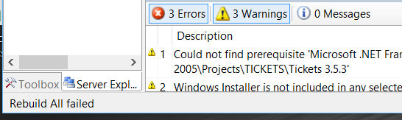
Here are the messages:
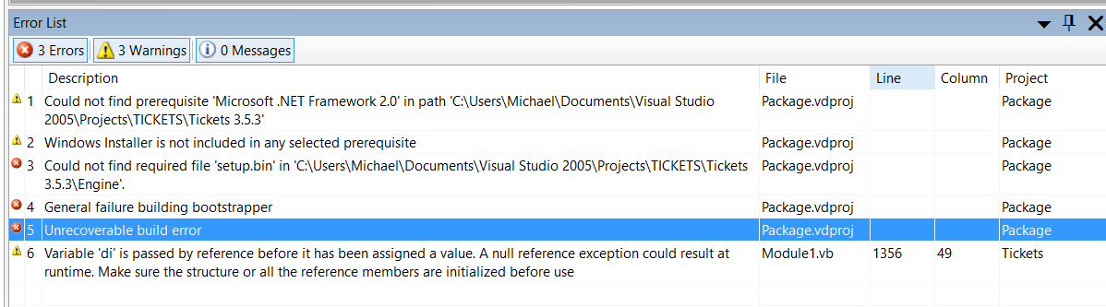
You can ignore the Warnings (in yellow). They are always there and make no difference.
The Errors are in red.
- Cannot find setup.bin in ***\Tickets 3.5.3\Engine
This is because the folder Engine does not exist. Nor setup.exe. These objects appear in NO folder structure of earlier versions of my program environment, all run under Windows 8 or lower.
- The other two Errors will be a consequence of this.
General failure building bootstrapper and Unrecoverable build error.
So it comes to this. Why does the VS2005 compiler running under Windows 10 expect there to be a new sub-folder ***/Engine containing file setup.exe when under Windows 8 and earlier this folder and file were not expected and not required?
If you can find someone who knows the Visual Studio environment and how it works under different versions of Windows then we are in business!

