If you forgot your Apple ID password
If you're having issues signing in with your Apple ID password, use these steps to reset it and regain access to your account.
Your Apple ID is the account you use for everything you do with Apple, like shopping the iTunes Store, signing in to iCloud, buying an app, and more. To reset your password, you'll need to know the email address for your Apple ID. If you're not sure which email address it is, there are a few ways you can find your Apple ID.

Reset your password
You can reset your password when you go to your Apple ID account page and click Forgot Apple ID or password.
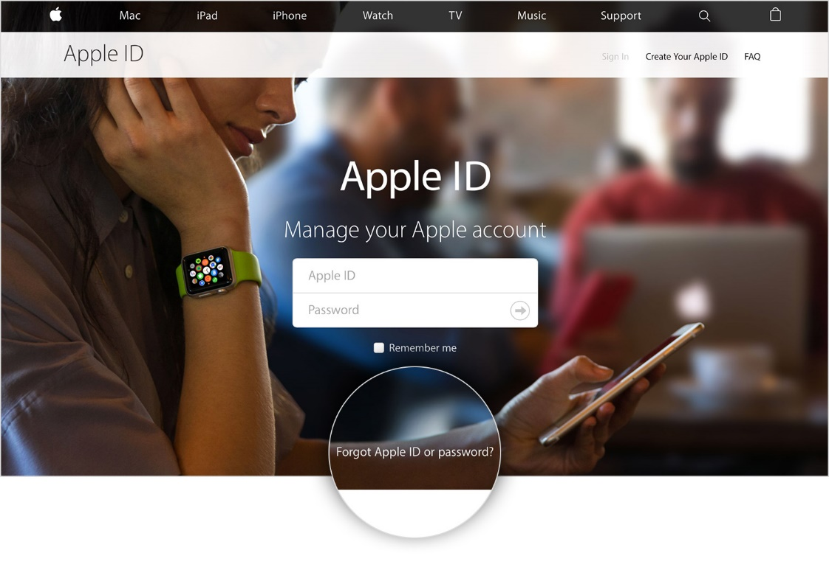
Enter your Apple ID, then click Continue.
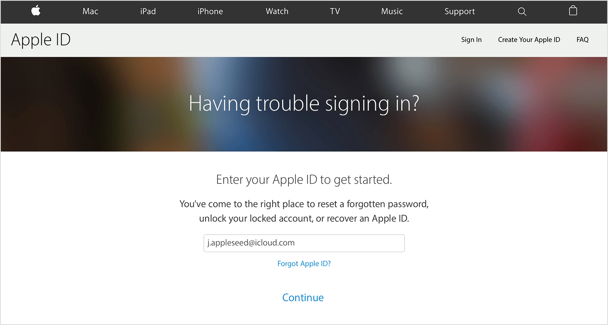
After you enter your Apple ID, you can see how to reset your password depending on the security features that you're using with your account. For example, if you set up two-factor authentication, your steps will be different than if your account uses security questions.
Answer your security questions Get an email

If you use Two-Factor authentication If you use two-step verification

Answer your security questions
If you know the answers to your security questions, select "Answer security questions" and follow the steps to reset your password.
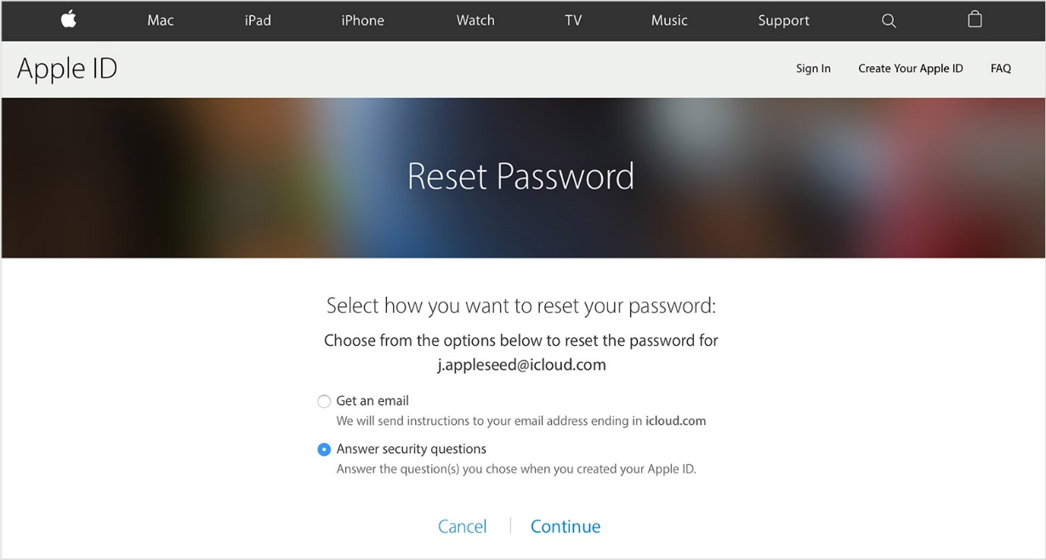

Get an email
If you select "Get an email," we'll send an email to your primary or rescue email address that you can use to reset your password. Didn't get the email?
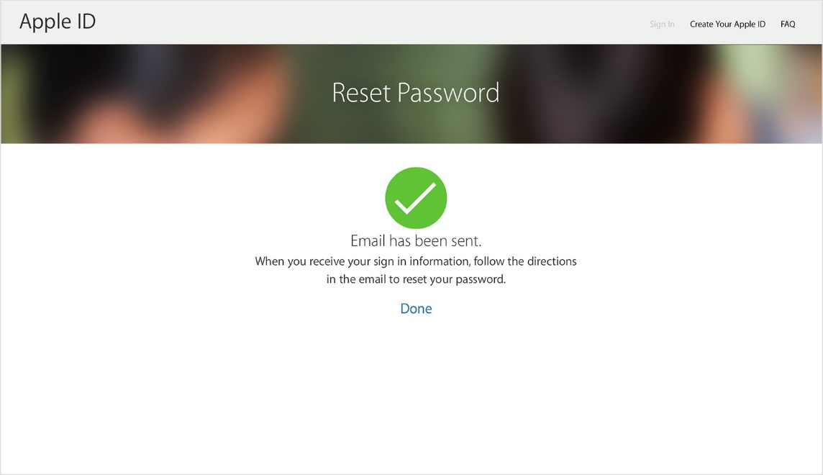

If you use two-factor authentication
If you have two-factor authentication enabled for your Apple ID, you can reset or change your password directly from your trusted iPhone, iPad, or iPod touch or on iforgot.apple.com. These steps will work only from a trusted device with a device passcode enabled.
Use these steps after you enter your Apple ID on iforgot.apple.com:
- Enter your trusted phone number and choose Continue to send a notification to your trusted device.
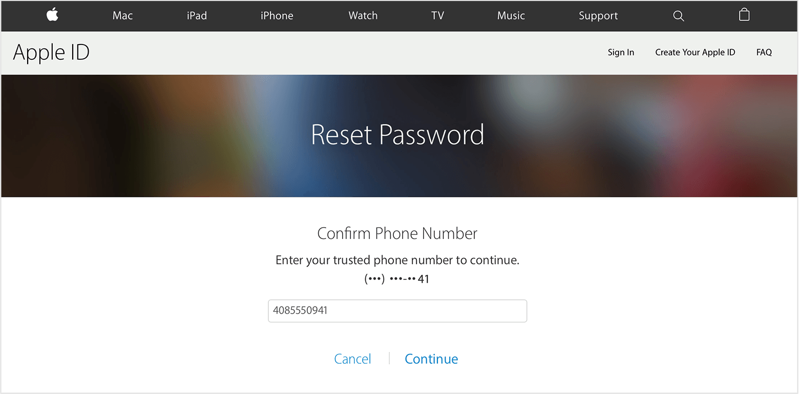
- Wait for the notification to appear on your trusted device and tap Allow.
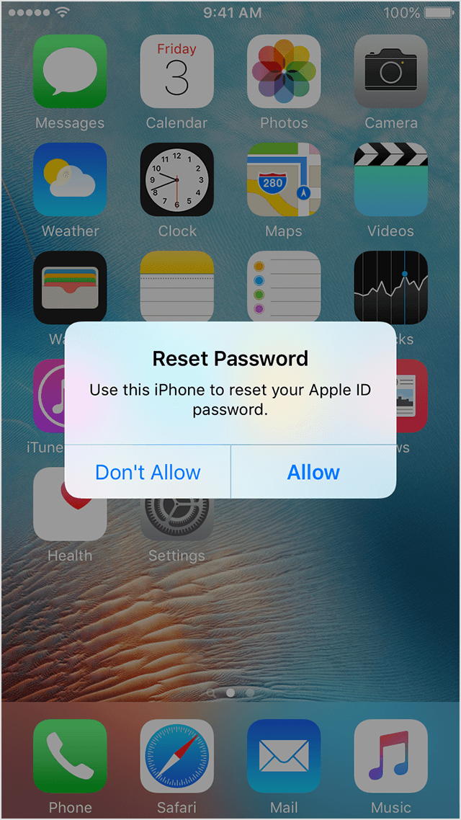
- Follow the steps to enter your device passcode and reset your password.
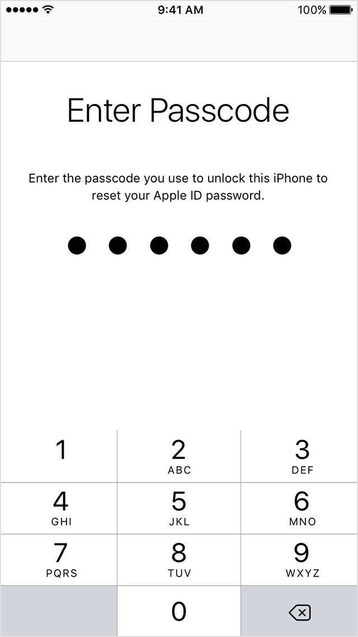
You can also reset your password from your trusted iOS device at any time:
- Go to Settings > iCloud.
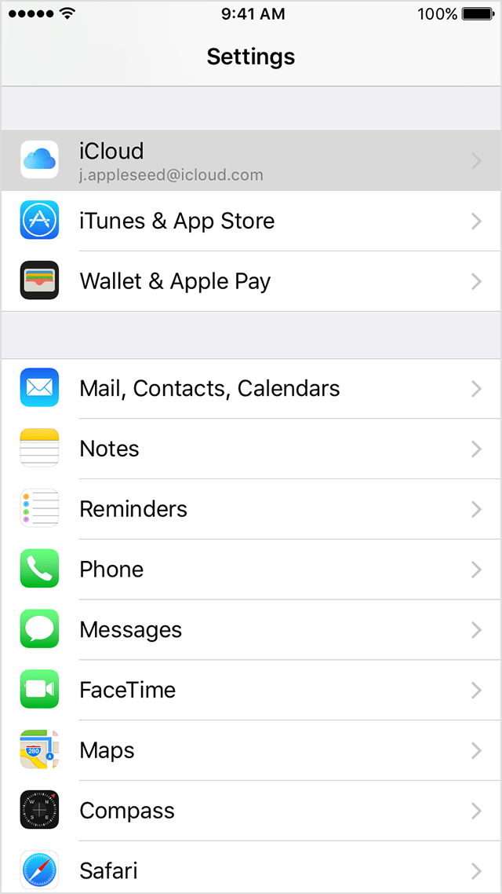
- Tap your name.
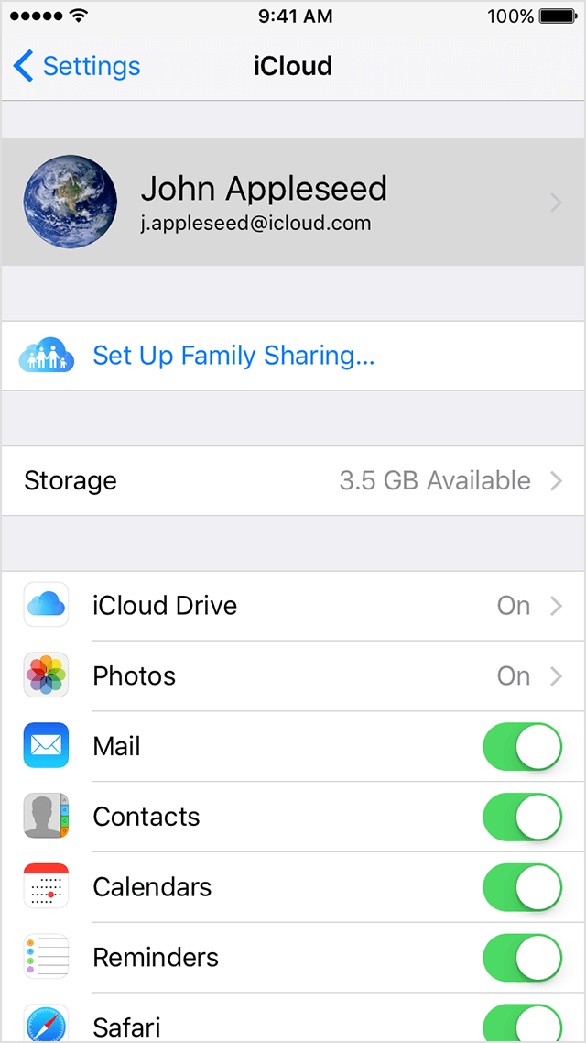
- Tap Password & Security.
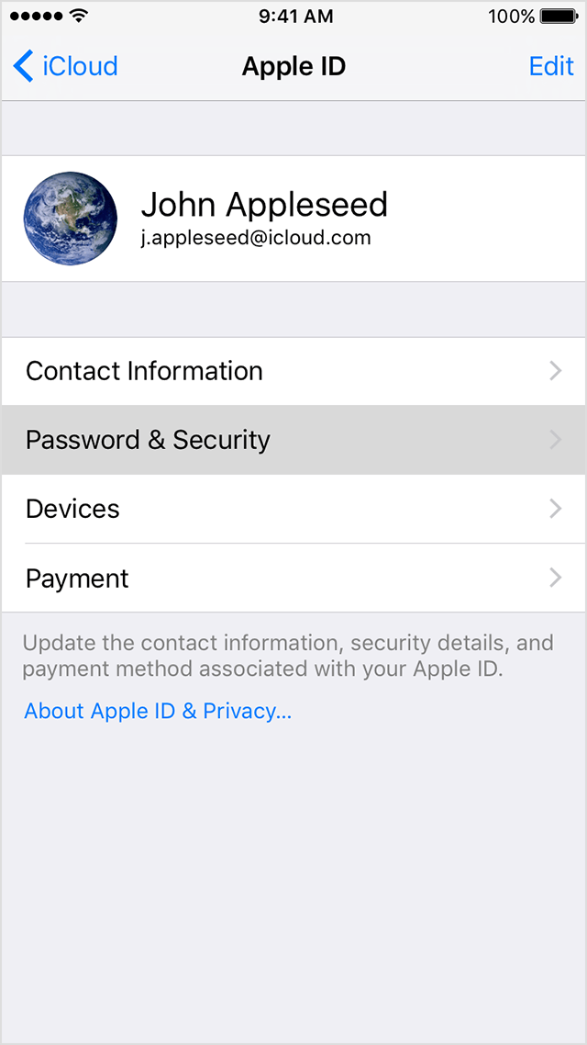
- Tap Change Password.
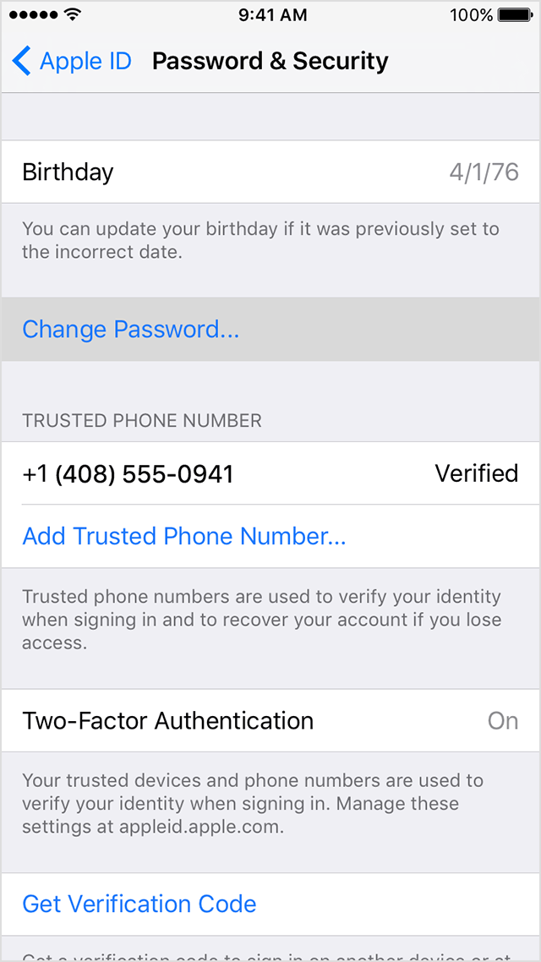
- Enter a new password.
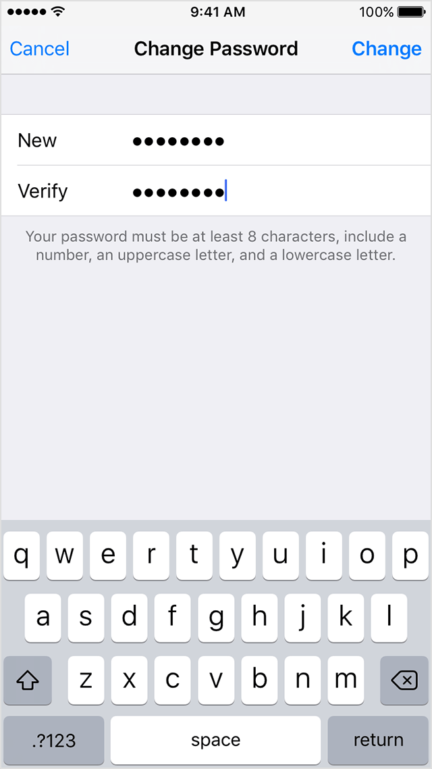
If you don’t have access to a trusted device, you can still reset your password and regain access to your account with account recovery. Account recovery is designed to get you back into your account as quickly as possible while denying access to anyone who might be pretending to be you. It might take a few days—or longer—depending on the account information you can provide to verify your identity.

If you use two-step verification
If you set up two-step verification, you will need your recovery key and a trusted device to reset your password. Follow these steps after you enter your Apple ID on iforgot.apple.com:
- Enter your Recovery Key.
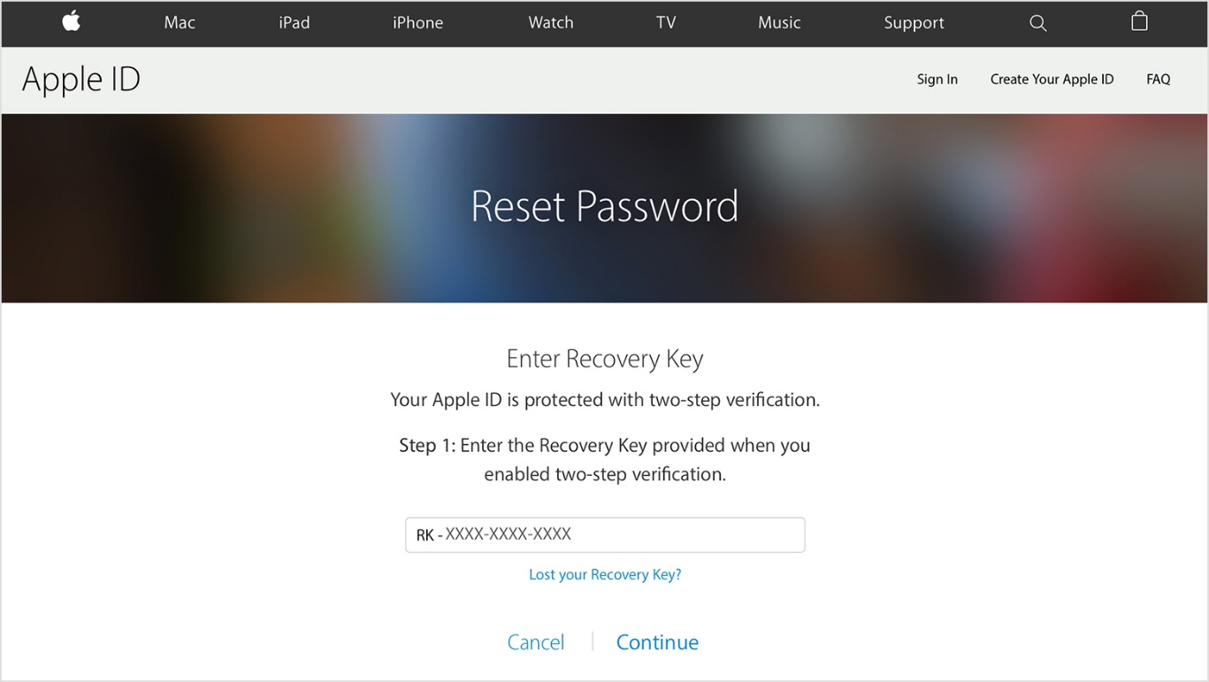
- Choose a trusted device. We'll send your device a verification code.
- Enter the verification code.
- Set a new password and select Reset Password.
If you permanently lost your recovery key or access to your trusted device, you can't change your password.

After you reset your password
After you reset your password, you'll be prompted to sign in again with your new password. You also might need to update your password in Apple services and on your devices.

Get more help
If you're still having issues signing in with your Apple ID and password, make sure that you're entering the correct Apple ID. In most cases, your Apple ID is also the primary email address of your Apple ID account. If these steps didn't help you change your password, contact Apple Support.

