Program in Java on Android Studio algorithm Discrete wavelet transform (DWT)

Our project follows descrption (TBStego) :

4.1.2.1 Home:
When the user runs TBStego, it the home page appears, which contains a description about the proposed tool. Also, it has a help icon, which provides help and explanations about the tool,Embed and Extract button as shown in figure[4-3].

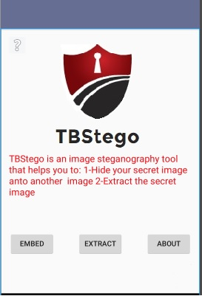
Figure [4-3] TBStego home screen.

4.1.2.2 Embed:
In this button the DWT embedding algorithm is performed by taking cover image and secret image as input to produce a stego-image that contains a secret image as output. Figure [4-4] and Figure [4-5] shows how the "Embed" button will look like.
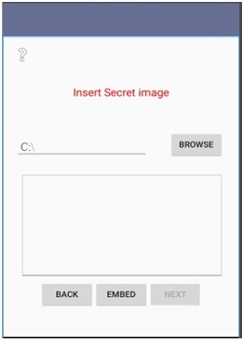
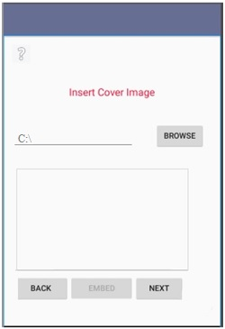
Figure [4-5]Embed screen.
Figure [4-4]Embed screen.

4.1.2.3 Extract:
In this process taking the Stego-image and cover image as an input to produce the secret image as output, see figure [4-6].
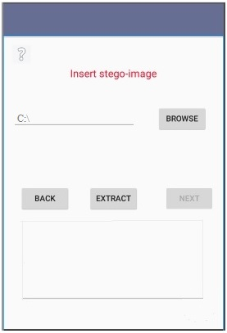
Figure [4-6] Extract screen.

4.1.2.4 About:
In this page more information about the tool will be provided to the user as shown in Figure [4-7].
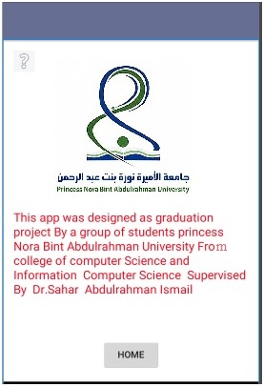
Figure [4-7] About screen.

4.3 User Interface Design:
1-When TBStego app is opened, the home page appears as shown in figure [4-8].
This screen has four buttons: Hide(Embed), Extract, About and Help.
Figure [4-8] Home screen.

2-The " help" button in the home page will provideageneral description about the proposed tool ,See figure [4-9].
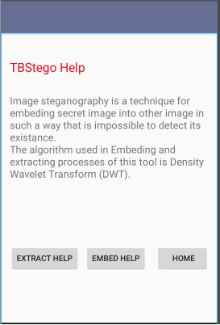
Figure [4-9] TBStego About screen.

4-TBStego help page consists two buttons to other related help windows. Press "Embed Help" to view instructions about hiding processes as shown in figure [4-10].
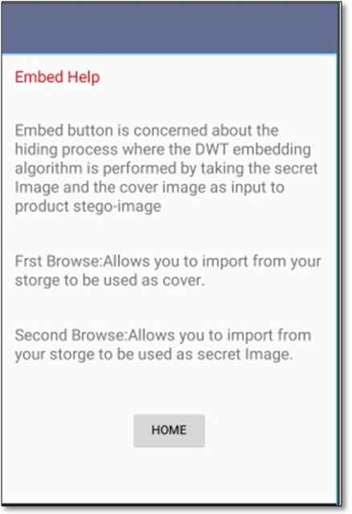
Figure [4-10] Embed help screen.

5-Press "Extract Help" to view instructions about extraction processes as shown in figure [4-11].
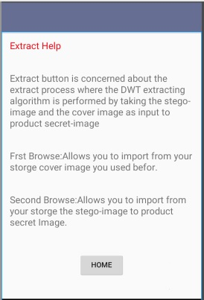
Figure [4-11] Extract help screen.

6-Press the "Embed" button to hide a secret image as shown in figure [4-12].
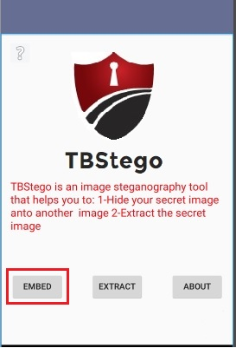
Figure [4-12]Choose Embed button.

7- Click on the "Browse" button to import a cover image from his/her storage media as shown in Figure [4-13].
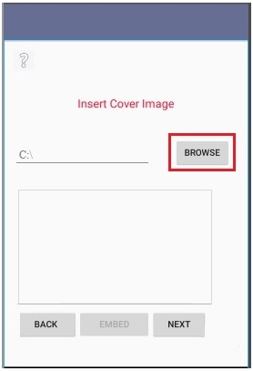
Display the selected image here
Figure [4-13] Embed screen.

7- Click on the "Next" button to show nextwindow,as shown in figure [4-14].

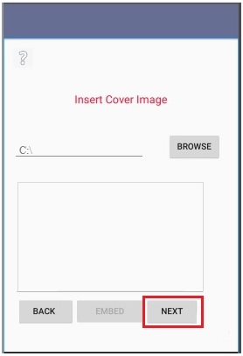
Display the selected image here
Figure [4-14] Embed screen.

8- Click on the "Browse" button to import a secret image from his/her storage media as shown in figure [4-15].
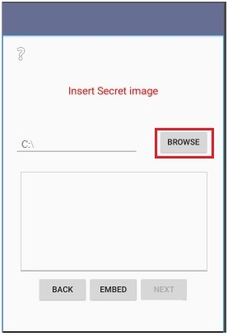
Display the selected image here
Figure [4-15] Embed screen.

9-Click on the "Embed" button to perform the hiding process and save the stego-image in your storage media, as shown in figure [4-16].
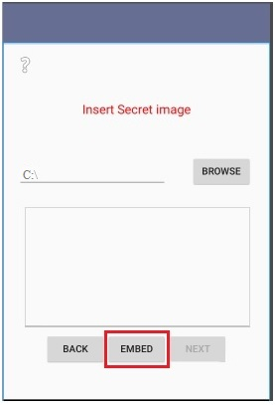
Display the selected image here
Figure [4-16] Embed screen.

10-Click the "Extract" button from the home page to perform the extracting process, as shown in figure [4-17].
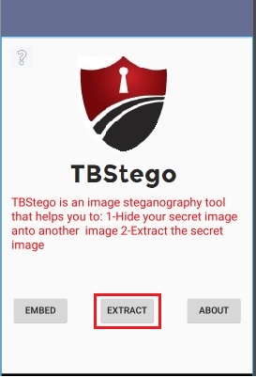
Figure [4-17] Extract screen.

12- Click on the "Browse" button to import a stego-image from his/her storage media, as shown in figure [4-18].
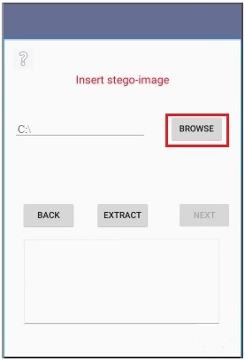
Display the selected image here
Figure [4-18] Extract screen.

13- Click on the " Extract " button to perform the Extracting process and appears the secret image, as shown in figure [4-19].
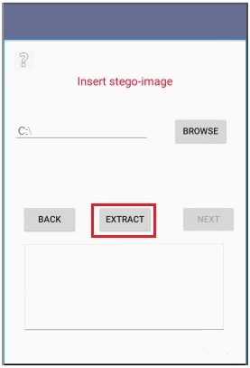
Figure [4-19] Extract screen.

Error Messages:
Error Messages | Case Description
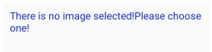  Figure [4-13] Error message#1. | Whenthe user clicks on the extract or embed button, before selecting a cover image, this error message will be shown.
Figure [4-14] Error message#2. | Whenthe user clicks on the extract or embed button, before selecting a secret image,this error message will be shown.
Table [4-1] Error message.

Informative massages:
Informative Messages | Case Description
Figure [4-16]Informative message#1. | After completing the hiding process successfully, this message will be shown.
Figure [4-17]Informative message #2. | Whenthe user select image which does not have a hidden image, this message will be shown.
Table [4-2] Informative message.
Notes :
- Interfaces are not necessarily the same colors, chose the colors of creativity consistent with logo
- Messages not necessarily comply with messages in the top, do the right
- Save the image in the same mobile user

Developmental points if you liked:
- The program works Sher of the image another communication programs
- You can save the image on Drobox or Google Drive

About (DWT) algorthme :
https://en.wikipedia.org/wiki/Discrete_wavelet_transform

