Northwind is a sample database released by Microsoft that contains the sales data for a fictitious company called Northwind Traders, which imports and exports specialty foods from around the world. Your final project will be to build an WPF application using Northwind database to support:
- Selection of a customer from a list of current customers in the database.
- Viewing the selected customer's details with support for editing and updating the customer's details.
- Sorting customer list in a ascending or descending order.
Sample output

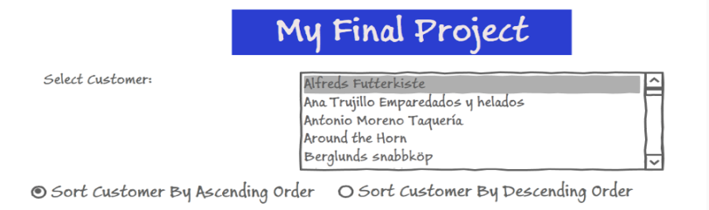
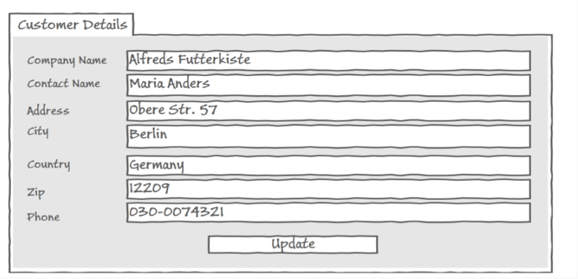
Project requirements:
- Create the visual layout of our WPF application. Refer to the attached user interface (UI) design sketch.
- Get a list of customers to display in the UI
- View the details for selected customer
- Allow for editing and updating customer details.
- You are expected to implement two-way binding using XmlDataProvider or LINQ to XML (use either one of the technique) for in-memory persistence only.
Supplied attachments:
- Application User interface (UI) design sketch.
- Northwind sample XML database.

