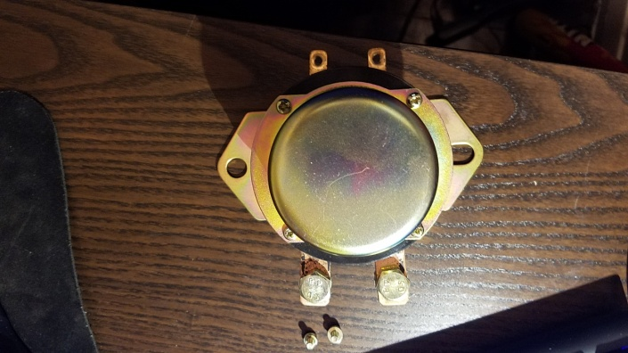

Battery

Toggle switch inside the car

Original positive battery cable of car