Network Design Proposal (Parts 1-3)

Overview
You will provide a detailed network design proposal. Your task is to design the network for this new building with the following criteria:
- Student-accessed computers should be on a separate network from the staff-accessed computers. In addition, computers for public use should be on a separate network. The open-WiFi network should also be on a separate network.
- There must be a minimum of 40 Mbps Internet connection, with a backup line capable of at least 20 Mbps. Cable, DSL, or FIOS should not be used for primary Internet service.
- The network has been assigned the 10.113.0.0/16 network address for all computers and devices.
Your proposal will be submitted in three major parts:
- Physical Network Design
- Network Addressing
- Network Services Design
To learn how you will be assessed on this assignment, take a moment to review the rubric. The final deliverable should adhere to the following criteria:
- Include at least five scholarly references.
- Use IEEE-style citations.
- Use correct network terminology.
- The use of diagrams is encouraged.
Use this template as a guide while creating your Network Design Proposal (Parts 1-3).

Physical Network Design
In this section, address each of the following.
- Define the topology that will be used.
- Select the appropriate network media.
- Select the appropriate network connecting devices, including network security devices.
- Select the appropriate computer systems to use to support the network design.
- Determine a physical layout of the computers on the floor plan, along with the network wires (network wiring diagram).
- Provide justifications for each element of your network design (numbers 1–4 above).

Network Addressing
In this section, address each of the following.
- Define the subnets (based on rooms, floor, department, or other criteria).
- For each subnet, explain which devices/groups/users/rooms will be on this subnet, and define the network address, subnet mask, and available IP addresses to be used by computers or devices.
- Show the calculations on how the subnet information is calculated.

Network Services Design
In this section, address each of the following.
- Identify network services needed.
- List additional servers or network devices needed to implement the network.
- List network security measures to be implemented.
- Justify the need for the network services, security measures, and devices you've selected.

Building Details
The 50-year-old, two-story building has the following layout:
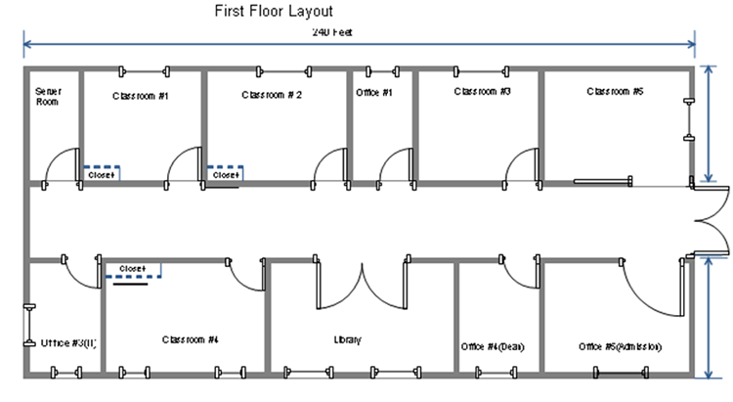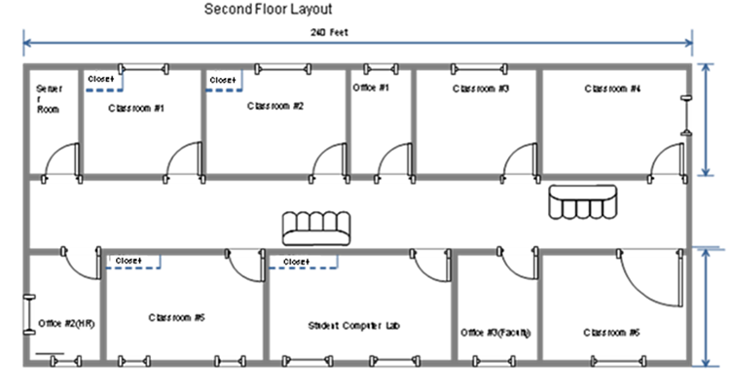
Building dimensions: length: 240 feet, width: 95 feet, height: 30 feet
The building will house six computer labs that will be used for instruction. In the building diagrams above, the labs are labeled Classroom #1, Classroom #2, and Classroom #4 on the first floor and Classroom #1, Classroom #2, and Classroom #5 on the second floor; each computer lab will have a closet. Each lab will have 26 computers: 24 student computers, one instructor computer, and one server in the closet for instructional use.
In addition, there will be a student computer lab that will provide computer access to students to do their homework. There will be 25 computers in this lab and a server in the closet. To allow students access to library resources, the library will also have 10 computers for the general public to use and five computers for library staff.
Finally, there are offices in the building. Each of these offices will have one computer for staff use, with the exception of the admissions office, which will have five computers. There will be two server rooms, one on the first floor and one on the second floor.

