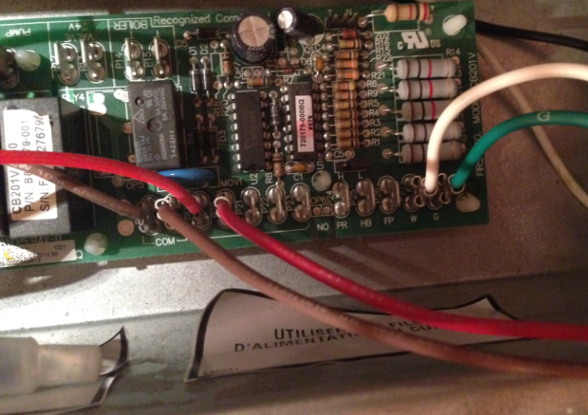
Russ:

I attached the blue wire to the same connection for the yellow from Thermostat and red to AC.

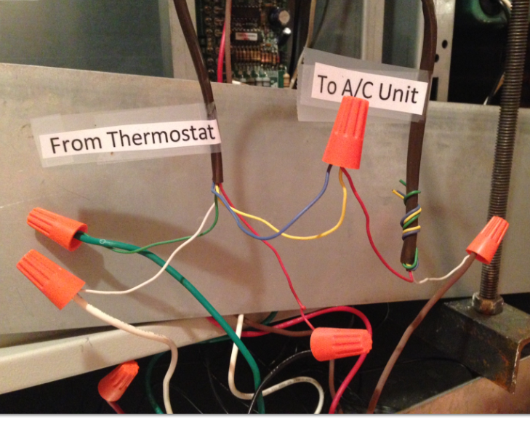

This is the circuit board on the unit.

