Q1. Determine algebraically whether the function is even, odd, or neither.
f(x) = -5x² + 4
a. even
b. odd
c. neither
Q2. Find the value for the function.
Find f(x + h) when f(x) = 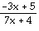.
a. 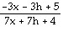
b. 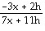
c. 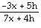
d. 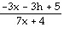
Q3. The graph of a piecewise-defined function is given. Write a definition for the function.
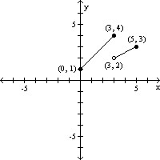<b
</b
a. 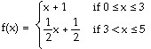
b. 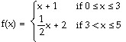
c. f(x) = 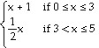
d. 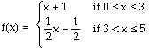
Q4. Find the value for the function.
Find -f(x) when f(x) = 2x² - 5x + 3.
a. -2x² + 5x + 3
b. 2x² + 5x + 3
c. -2x² + 5x - 3
d. 2x² + 5x - 3
Q5. Locate any intercepts of the function.
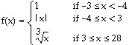
a. (0, 0), (0, 1)
b. (0, 0)
c. (0, 0), (1, 0)
d. none
Q6. The graph of a function is given. Decide whether it is even, odd, or neither.
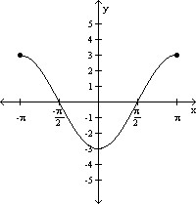
a. even
b. odd
c. neither
Q7. List the intercepts of the graph.Tell whether the graph is symmetric with respect to the x-axis, y-axis, origin, or none of these.
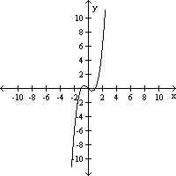<b
</b
a. (-1, 0), (0, 0), (1, 0); symmetric to origin, x-axis, and y-axis
b. (-1, 0), (0, 0), (1, 0); symmetric to origin
c. (-1, 0), (0, 0), (1, 0); symmetric to y-axis
d. (-1, 0), (0, 0), (1, 0); symmetric to x-axis
Q8. For the given functions f and g, find the requested function and state its domain.
f(x) = 2x + 1; g(x) = 5x - 2
Find .
a. ()(x) = 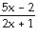; {x|x ≠ }
b. ()(x) = 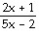; {x|x ≠ - }
c. ()(x) = ; {x|x ≠ - }
d. ()(x) = ; {x|x ≠ }
Q9. Based on the graph, find the range of y = f(x).
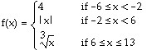
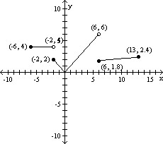<b
</b
a. [0, 6]
b. [0, 6)
c. [0, ]
d. [0, ∞)
Q10. The cost C of double-dipped chocolate pretzel O's varies directly with the number of pounds of pretzels purchased, P. If the cost is $5442 when 5.0 pounds are purchased, find a linear function that relates the cost C to the number of pounds of pretzels purchased P. Then find the cost C when 6.0 pounds are purchased.
a. C = 0.092P; $0.55
b. C = 10.884P; $65.30
c. C = 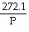; $45.35
d. C = 9.07P; $45.35
Q11. Match the graph to the function listed whose graph most resembles the one given.
a. square function
b. cube function
c. square root function
d. cube root function
Q12. Answer the question about the given function.
Given the function f(x) = -3x² - 6x - 6, is the point (-1, -3) on the graph of f?
a. Yes
b. No
Q13. Determine whether the equation is a function.
x + 8y = 5
a. function
b. not a function
Q14. Answer the question about the given function.
Given the function f(x) = x² + 3x - 40, list the x-intercepts, if any, of the graph of f.
a. (8, 0), (-5, 0)
b. (8, 0), (5, 0)
c. (-8, 0), (5, 0)
d. (-8, 0), (1, 0)
Q15. Answer the question about the given function.
Given the function f(x) = -7x² + 14x + 4, if x = 1, what is f(x)? What point is on the graph of f?
a. 11; (1, 11)
b. 11; (11, 1)
c. -17; (1, -17)
d. -17; (-17, 1)
Q16. Determine if the type of relation is linear, nonlinear, or none.
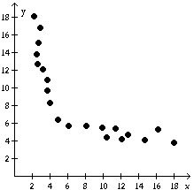
a. None
b. Linear
c. Nonlinear
Q17. If f(x) = 4x³ + 7x² - x + C and f(2) = 1, what is the value of C?
a. C = 7
b. C = 11
c. C = 63
d. C = -57
Q18. Given: E=I/R and P=IE with the values: P=10 and E=100 What are the values for I and R?
a. R=.001, I=0.1
b. R=100, I=100
c. R=0.1, I=1000
d. Cannot be solved without the value of another variable.
Q19. Determine whether the relation represents a function. If it is a function, state the domain and range.
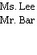
a. function
domain: {Ms. Lee, Mr. Bar}
range: {Bob, Ann, Dave}
b. function
domain: {Bob, Ann, Dave}
range: {Ms. Lee, Mr. Bar}
c. not a function
Q20. Find the domain of the function.
g(x) = 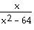
a. {x|x ≠ 0}
b. {x|x > 64}
c. {x|x ≠ -8, 8}
d. all real numbers

