Prior to part replacement, re-calibration of the HVAC actuator is recommended. Calibration is performed by disconnecting the battery negative cable or the removal of the instrument panel M-1 fuse. Electrical power should be re-established after (60) seconds which will automatically initiate the software calibration procedure. If this procedure fails, it will be necessary to replace the mode door actuator/motor.
The mode door actuator/motor is not serviceable and must be replaced if found to be defective.
The mode door actuator is located on the upper left side of the A/C- Heater housing Mode Door Motor Location
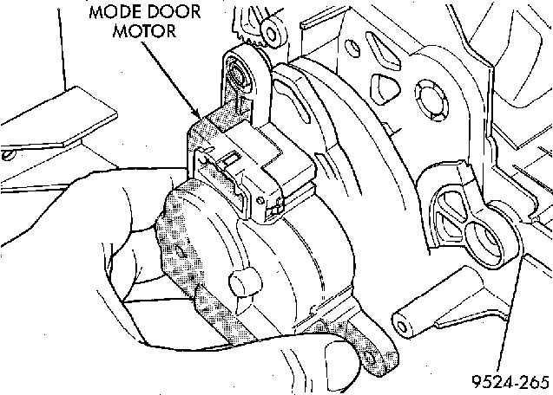

REMOVAL
- Disconnect battery negative cable.
- Remove left underpanel silencer/duct.
- Remove electrical connection on actuator Mode Motor Connector
- Remove actuator retaining screws. Then pull actuator straight down. Upon removal, note the shaft position of the actuator, because the shaft on this motor is keyed. When installing new actuator, its shaft must be positioned in the same location.

INSTALLATION
For installation, reverse the above procedures

