PEST analysis

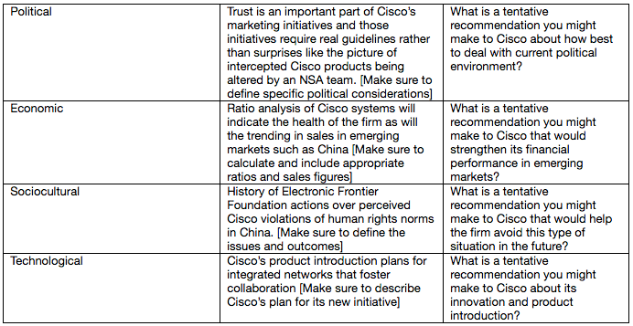

Examine your tentative recommendations from each of the worksheets you completed as part of the PEST analysis. Integrate the recommendations into a cohesive strategy for Cisco in a 3-page paper that includes the diagram below. Make sure to include adequate details to demonstrate what issues the recommendations will solve. The paper should be 3 pages in length in Word.

Get to your points quickly, make them completely by integrating qualitative and quantitative information as well as providing 3 references in APA style.

You must also create a PowerPoint presentation for your recommendations. The Faculty does not expect your assignment to be that detailed but do expect at least the total debt to asset ratio and debt to equity ratio to be clearly visible.
