Network Design Proposal
The university has recently leased a building in Adelphi, Florida. The building will house some offices, classrooms, a library, and computer labs. Security is very important for UC, as the university must protect students’ and employees’ data, as well as any intellectual property that UC has on its servers and computers. As a result, IT management would like to take the time to review some proposals on how best to move forward. As a network engineer, you have been asked to prepare a network proposal on how to set up a secure network infrastructure in this new building to support university operations.
Provide a detailed network design proposal. Your task is to design the network for this new building with the following criteria:
- Student-accessed computers should be on separate network from the staff-accessed computers. Computers for public use should be on a separate network.
- There must be a minimum of 40 Mbps Internet connection, with a backup line capable of at least 20Mbps. Cable, DSL, or FIOS should not be used for primary Internet service.
- The network should use physical cable, not wireless. But do provide wireless access in the Student Lobby area (second-floor hallway). Set the maximum simultaneous wireless users to 254.
- The network has been assigned the 10.11.12.0/23 network address for all computers and devices
The 50-year-old, two-story building has the following layout:
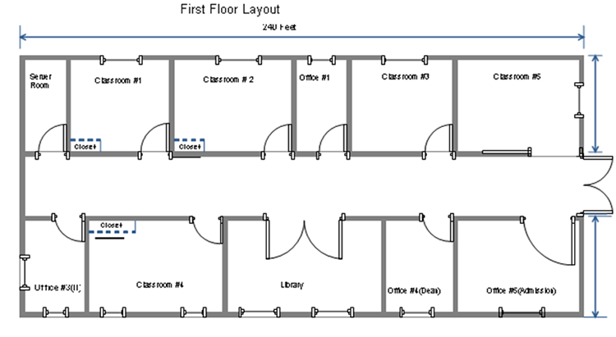
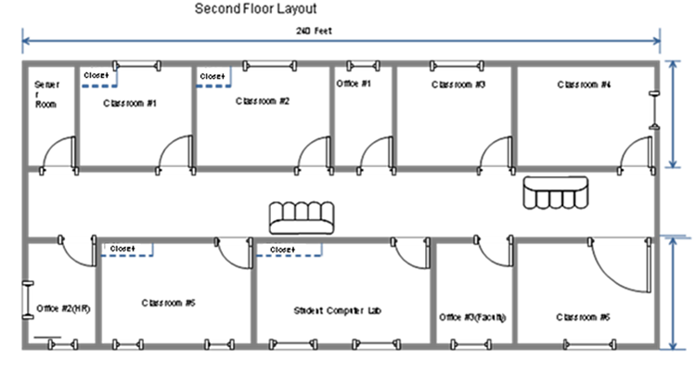
Building dimensions: Length: 240 Feet, Width: 95 Feet, Height: 30 Feet
The building will house six computer labs that will be used for instruction. In the building diagrams above, the labs are labeled Classroom #1, Classroom #2, and Classroom #4 on the first floor and Classroom #1, Classroom #2, and Classroom #5 on the second floor; each computer lab will have a closet. Each lab will have 32 computers: 30 student computers, 1 instructor computer, and 1 server in the closet for instructional use.
In addition, there will be a Student Computer Lab that will provide computer access to students to do their homework. There will be 50 computers in this lab and a server in the closet. To allow students access to library resources, the library will also have 10 computers for students and 5 computers for library staff.
Finally, there are various offices in the building. Each of these offices will have one computer for staff use, with the exception of the admissions office, which will have five computers. There will be two server rooms, one on the first floor and one on the second floor.
Your proposal should have three major sections:
  - Physical Network Design
In this section, address each of the following.
- Define the topology that will be used. Provide business needs and justification.
- Select the appropriate network media. Provide business needs and justification.
- Select the appropriate network connecting devices, including network security devices. Provide business needs and justification.
- Select the appropriate computer systems to use to support the network design. Provide business needs and justification.
- Determine a physical layout of the computers on the floor plan, along with the network wires (network wiring diagram).
- Provide justifications for each element of your network design (numbers 1–4 above).

  - Network Addressing
In this section, address each of the following.
- Define the subnets (based on rooms, floor, department, or other criteria).
- For each subnet, explain which devices/‌groups/‌users/‌rooms will be on this subnet, define the network address, subnet mask, and available IP addresses to be used by computers or devices.

  - Network Services Design

In this section, address each of the following.
- Identify network services needed.
- List additional servers or network devices needed to implement the network.
- List network security measures to be implemented.
- Justify the need for the network services, security measures, and devices you’ve selected.

