Instructions for Using SQL Fiddle

Part C Instructions: Access http://sqlfiddle.com/ and copy the SQL code for the creation of all of your tables in the left pane labeled “Schema Panel” to test your code and confirm the tables are built correctly without errors. Click on “Build Schema”. Once this is completed, do a screen capture of what is showing in the sqlfiddle environment including the schema success message and paste this in the word document with the project.

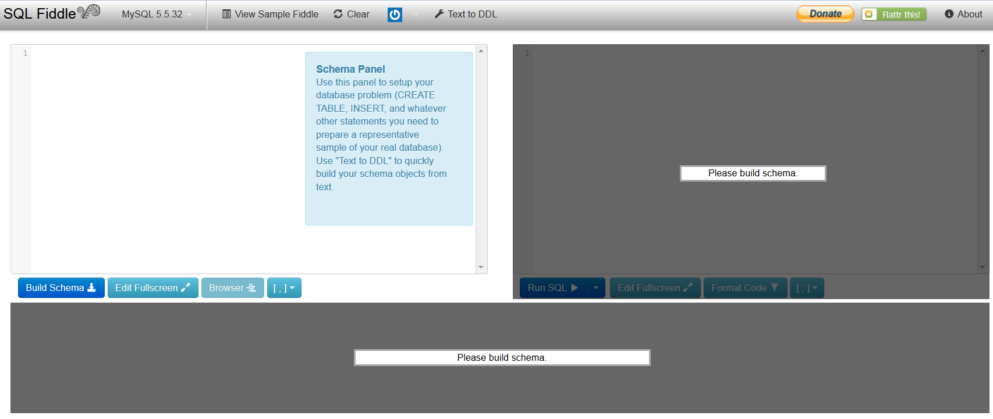

Part D Instructions: Access http://sqlfiddle.com/ and copy the SQL code for the creation of all of your tables and the creation of the new view in the left pane labeled “Schema Panel” to test your code and confirm the view is built correctly without errors. Click on “Build Schema”. Once this is completed, do a screen capture of what is showing in the sqlfiddle environment including the schema success message and paste this in the word document with the project.
Part E Instructions: Access http://sqlfiddle.com/ and copy the SQL code for the creation of all of your tables and the creation of the new index in the left pane labeled “Schema Panel” to test your code and confirm the index is built correctly without errors. Click on “Build Schema”. Once this is completed, do a screen capture of what is showing in the sqlfiddle environment including the schema success message and paste this in the word document with the project.
Part F Instructions: Access http://sqlfiddle.com/ and copy the SQL code for the creation of all of your tables and the insertion of all of your data into these tables in the left pane labeled “Schema Panel” to test your code and confirm the tables are populated correctly without errors. Click on “Build Schema”. Once this is completed, do a screen capture of what is showing in the sqlfiddle environment including the schema success message and paste this in the word document with the project.
Part G1 Instructions: Access http://sqlfiddle.com/ and copy the SQL code for the creation of all of your tables and the insertion of all of your data into these tables in the left pane labeled “Schema Panel” and click on “Build Schema”. Once this is completed, type in your SQL query code to view the contents of all of your tables in the right panel and click on “Run SQL” to test your query code and confirm that the queries run correctly without errors. Do a screen capture of what is showing in the sqlfiddle environment including the schema success message and paste this in the word document with the project. Next copy all of the data displayed in the tables below the two panels. Paste this in the word document with the project.
Part G2 Instructions: Access http://sqlfiddle.com/ and copy the SQL code for the creation of all of your tables and the insertion of all of your data into these tables in the left pane labeled “Schema Panel” and click on “Build Schema”. Once this is completed, type in your SQL query code to join your tables to present the order form data in the right panel and click on “Run SQL” to test your query code and confirm that the query ran correctly without errors. Do a screen capture of what is showing in the sqlfiddle environment including the schema success message and paste this in the word document with the project. Next copy all of the data displayed in the resulting table below the two panels. Paste this in the word document with the project.

