Network Design Proposal

Prepared for:
University College

Prepared by:
Jer

- Physical Network Design

- Network Topology
Business Needs
The University College’s lease of a two-story building in Adelphi, Florida needs to be outfitted with a high-speed, stable, and secure computer network. The installation is essential for UC to continue providing students and staff with advanced technological resources and accomplish their daily missions.
UC is in need of student-accessed, staff-accessed, and public computers that are on separate networks from each other. The Internet connection speed will have a minimum speed of 40 Mbps with a backup line capable of a minimum speed of 20 Mbps. The network will use physical cable connectivity with wireless connectivity only in the Student Lobby area of the second-floor hallway. The wireless network will have a maximum of 254 simultaneous users. The network will be assigned the 10.11.12.0/23 network address for all computers and devices.
Proposed Topology
Select one or more topologies to use for this design. This section should be used to provide details of the selected infrastructure or equipment. Include the model, manufacturer, features, and cost.

This proposal is for a computer network that will provide a secure, stable, and high-speed computer network throughout the 50-year-old, two-story building to include:
- Building dimensions: Length: 240 Feet, Width: 95 Feet, Height: 30 Feet
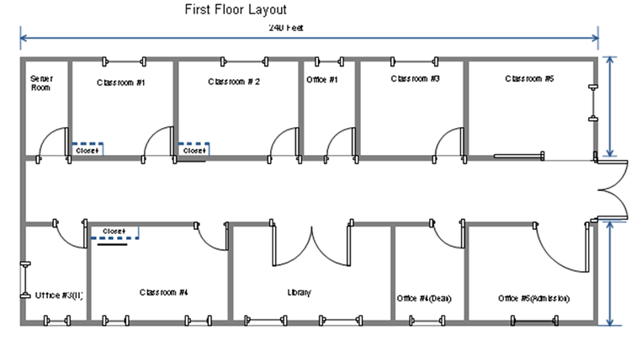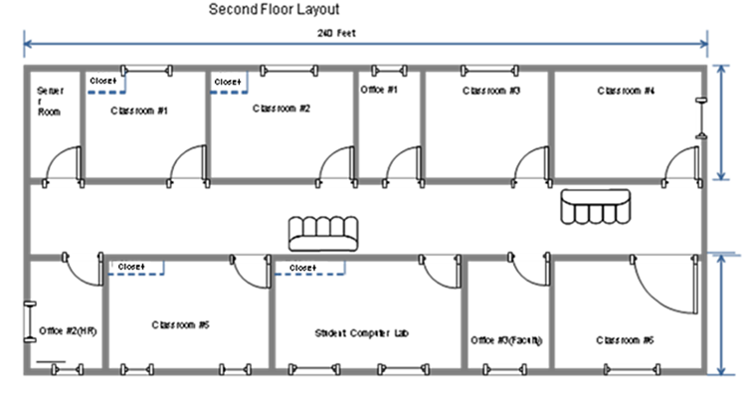
- Six computer labs for instruction – First and second floors
  - 132 total computers
  - Each lab with 30 student computers, 1 instructor computer, and 1 instructional server
- Student Computer Lab for homework – Second floor
  - 50 computers
  - 1 server in closet
- Library – First floor
  - 10 student computers and 5 library staff computers
- Various building offices
  - Admissions office – First floor
    - 5 computers
  - Various offices – First and second floors
    - 6 computers
A star topology will be used for this design; the computers in each classroom and office are to be connected to a central device (switch).
Justification
The use of a star topology allows for the network to be expanded without disruption, it is easy to implement troubleshooting and a break in any single cable will not cause the entire network to fail. This topology will meet needs of UC and everyone needing to use the network.
- Network Media
Business Needs
Proposed Network Media (include network wiring diagrams)
Select one or more network media to use for this design.
Switch x11 – For each room that requires more than one computer and the server rooms. The reason for this is so that ports can be allocated accordingly to staff or students as well.
Patch Panel x11 – For each room that has a switch so that multiple computers can access the ports on the switch. The patch panel will provide the network with a connection point between network equipment and the ports to which the PCs are connected.
Router x1 – This is where the default gateway for the network will be and is located at the demarcation point. It is used to route information obtained by the network and deliver packets returned by the Internet.
Wireless Access Point x1 – The WAP will be located in the Library and is used to grant wireless access to the internet via the router to those who need it.

Justification
The routers allow for a fully routed network. Since we are using different subnets, we need to have means to route packets from/to the correct networks.

- Network Devices
Business Needs
Proposed Network Devices
Justification

- Network Security Devices
Business Needs
Proposed Network Security Devices
Justification

- Computer Systems
Business Needs
Proposed Computer Systems
Justification

II. Network Addresses Design
- Subnetting
Business Needs

Proposed Subnetting (include the calculations)
List the quantity of subnets needed. For each subnet, provide the IP addressing info (network address, broadcast address, range of available IP addresses) and the systems, devices, or equipment that will be on that network. Also provide the calculations on how those IP addressing information are determined.
Subnets:
- 11 total subnets
  - 6 subnets
    - One per lab
  - 1 subnet
- One for Student Computer Lab
  - 1 subnet
    - One for all staff members in all offices
  - 1 subnet
    - One for Library
  - 1 subnet
    - One for all instructors in the 5 lecture rooms
  - 1 subnet
    - One for the servers on the first and second floors
Network Address: 10.11.0.0
Network Mask: 255.255.0.0
- A minimum of 11 subnets
  - A minimum of 31 addresses per subnet
Instructional Computer labs:
10.11.0.0/24 Addresses: 10.11.0.1 to 10.11.0.254
10.11.1.0/24 Addresses: 10.11.1.1 to 10.11.1.254
10.11.2.0/24 Addresses: 10.11.2.1 to 10.11.2.254
10.11.3.0/24 Addresses: 10.11.3.1 to 10.11.3.254
10.11.4.0/24 Addresses: 10.11.4.1 to 10.11.4.254
10.11.5.0/24 Addresses: 10.11.5.1 to 10.11.5.254
Student Computer Lab
10.11.10.0/24 Addresses: 10.11.10.1 to 10.11.10.254
Staff members in all offices
10.11.20.0/24 Addresses: 10.11.20.1 to 10.11.20.254
Students in the library
10.11.30.0/24 Addresses: 10.11.30.1 to 10.11.30.254
Instructor’s on the 5 lecture rooms
10.11.40.0/24 Addresses: 10.11.40.1 to 10.11.40.254
Servers on first and second floor (DMZ):
10.11.100.0/24 Addresses: 10.11.100.1 to 10.11.100.254

Justification

III. Network Services Design
- Network Services
Business Needs
Assess the business needs

Proposed Network Services
Implement a DNS server and a DHCP server. Implement routers, bridges, an Ethernet hub, and routing tables.
Justification
Justify your determination that the network services are needed and will meet the business needs
A DNS server is needed to easily find and access network services.
A DHCP server is needed for automatic, centralized IP address management.
Routes are needed to extend/segment networks by forwarding packets from one logical network to another.
Bridges are needed to join two network segments together, allowing computers on either segment to access resources on the other.
An Ethernet hub is needed to amplify signals and counteract the effects of attenuation.
Routing tables are needed to keep track of all known network addresses and possible paths throughout the interwork.

- Network Security Measures
Business Needs
UC will need security measures in place to protect the network from harm. Installation of security software will ensure the protection of the system.
Proposed Network Security Measures
- Firewalls
- Antivirus software
- Intrusion Detection System
Justification

Bibliography

