**Mid-Town XXXXXX**

*A ministry of Central Christian Church*

**CONCERT SET-UP CHECK LIST**

Thank you for being a part of the music ministry of Central Christian Church! Help us prepare for your event by completing the following:

1. Indicate items that need to be **removed** from the chancel area.
2. Indicate the items that need to be **installed** in the chancel area.
3. Provide a detailed diagram (on the back of this form) indicating the exact location of the items needed for your concert.

Event Name:       Event Date:       Event Time:

Contact Name:       Contact e-mail:

Contact phone       CCC Liaison:

**1. REMOVE** (check all that apply)

**NO items require removal**

Pulpit  Pulpit Chair  Lectern  Lectern Chair

Choir Modesty Rail

CHOIR CHAIRS

Front (east) row  Middle row  Back (west) Row

Partial Row(s) (describe):

CHOIR SEATED RISERS

First (front) Row  Second (back) Row

Partial Row(s) (describe):

Organ console (to SW corner of chancel)  Piano (to NW corner of chancel)

Communion Table & Chairs (by approval only)

**2. INSTALL** (check all that apply and complete diagram on back)

Chairs (number):        Stands (number):       (10 available)

Standing risers (number):       (3 step limit: 5, 4 step limit: 4)

Organ console (location):

Piano (location):

Other (describe):

**DEADLINE FOR SET** (day, date, and time):

**3. DIAGRAM**

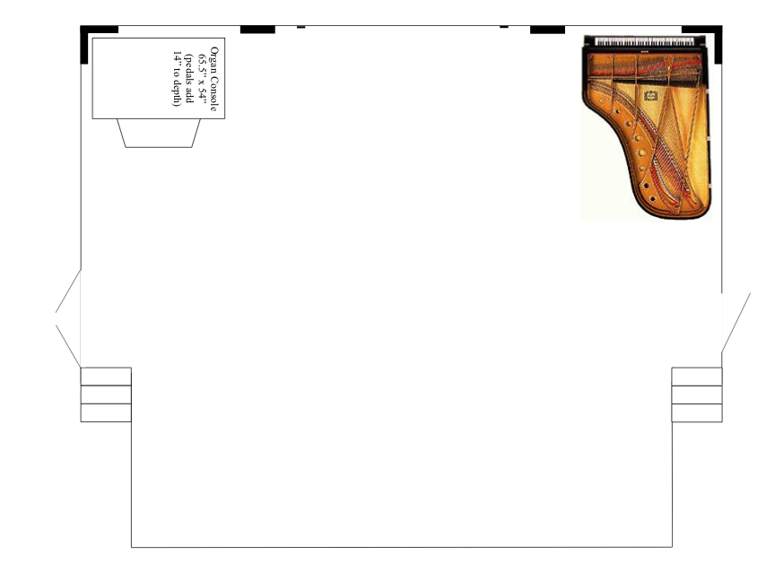**NB:** The piano and organ console are shown in their storage positions. They may be moved to any spot on the chancel for your event. Please indicate the desired location of the organ console and piano.

**OFFICE USE ONLY**

Stage Team Manager:       Stage Team:

Day/Date for Set:       Day/Date for Strike:

Notes: