REPLACEMENT INSTRUCTIONS
ERC3B Sanyo/Torisan
KIT WB27X23660 replaces WB27T10174, WB27T10190, WB27T10417, WB27T10418, and WB27T10419.
ELECTRIC MODELS
Kit WB27X23660 contains:
1 Control (WB00X21975)
3 WIRE HARNESS (WB00X6989)
1 WIRE HARNESS (WB00X7051)
1 WIRENUT SET, CERAMIC (WB1X371D)
1 Installation instructions (WB00X7375)
1 Clock Plate, Black (WB27T10041)
1 Clock Plate, White (WB27T10042)
1 Electronic Control (User manual) WB00X7065 (Pub# 31-10486)
Installing the Kit
Disconnect power to the unit.
- Preparation of Torisan ERC3B. Add a jumper (WB00X6989) with the piggyback side to tab L1 and the single ended side to COM terminal of violet relay (K2) as shown in Fig. B. If the single sided end has a hard cover, it will insert only one way as shown in Fig A. 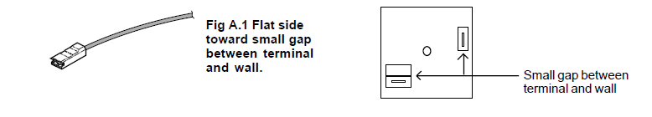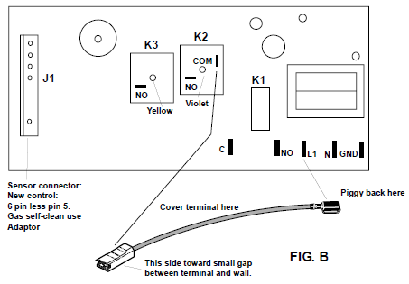
- Clock Plate. Center the correct colored graphic faceplate from the kit onto the new ERC. Allow even overhang or gap on all edges. Remove liner to expose adhesive.
- Element harness leads. Transfer the YELLOW (bake) and VIOLET (broil) leads from old to new control. The relays have color dots corresponding to the harness wire color. Insert the terminals to the NO tabs on the relay tops.
Connect BLACK harness lead to the added piggy-back terminal at tab L1.
- Ground wires. On models with steel control panels, a ground wire must remain connected to the clock bracket. If the unit has a GREEN ground wire to the control, cut it off.
- Sensor harness adaptor. If the 5-wire harness on the unit does not match the adaptor (WB00X7051) from the kit, cut off the connector and replace with the adaptor (WB00X7051) using ceramic wire nuts to the same wire colors. The white wires are interchangeable.
- Fan harness adaption. The new control does not have a 2-pin header for the fan relay. If the original control has a header, cut off the harness connector. Cut off the piggyback connectors from two of the WB00X6989 leads from the kit. Wire nut the leads to the two harness wires (black and black/white). Connect to C and NO in either order.

Additional step if replacing an ERC2C (steel chassis Robertshaw or Siebe, Fig D)
- START key. If replacing an ERC2C (steel chassis), advise customer the new ERC has a START key. Cooking and cleaning functions will not start themselves; the START key must be pressed. Leave the new User’s Manual (WB00X7065). 