Setting the Kali Linux VM to NAT Networking
In the VMware Player window showing your Kali Linux desktop, on the top left, click Player, Manage, "Virtual Machine Settings".
In the "Virtual Machine Settings" box, on the left side, click "Network Adapter".
On the right side, click "NAT". Click OK.
At the top left of the Kali Linux desktop, find these items:
- "Applications" menu
- "Places" menu
- A blue icon that opens IceWeasel, a free version of FireFox
- A rectangular black icon that opens a Terminal window
- The date and time
At the top left of the Kali Linux desktop, click the rectangular black icon to open a Terminal window.
In the Terminal window, type in this command to get a new IP address, and then press the Enter key:
dhclient -v

Finding the Kali Machine's IP Address
On your Kali Linux machine, in a Terminal window, execute this command:
ifconfig
Find your IP address and make a note of it. In the example below, it is 192.168.119.169.
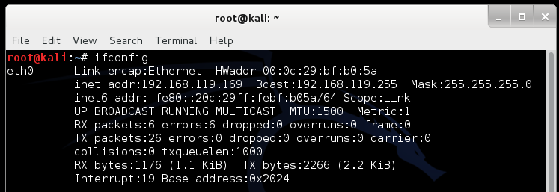

Checking for a Web server
On your Linux machine, in a Terminal window, execute this command:
lsof -i :80
This command shows processes listening on port 80. If you see apache2 processes, as shown below, execute this command to stop apache:
service apache2 stop
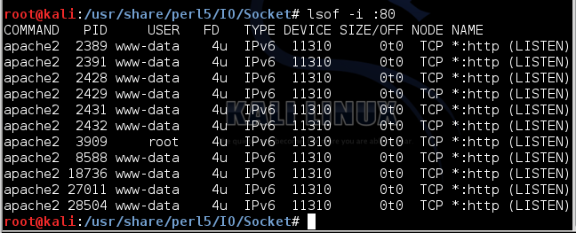

Installing INetSim
On your Linux machine, in a Terminal window, execute this command:
nano /etc/apt/sources.list
Add this line to the end of the file, as shown below:
deb http://www.inetsim.org/debian/ binary/
Save the file with Ctrl+X, Y, Enter.
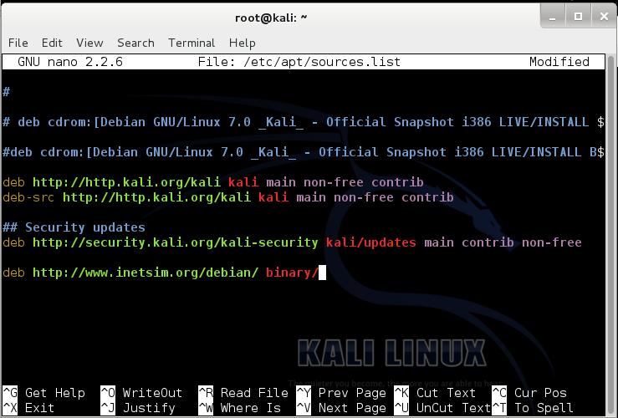
This tells your Linux machine where to find inetsim on the Internet.
On your Linux machine, in a Terminal window, execute these commands:
wget -O - http://www.inetsim.org/inetsim.org-archive-signing-key.asc | apt-key add -
apt-get update
apt-get install inetsim -y
These commands add the archive's signing key, update the list of archive contents, and install inetsim.
When I did it, I got an error message saying "Errors were encountered while processing: xplico". It seems to be OK to just ignore this message and keep going.
On your Linux machine, in a Terminal window, execute these commands:
cp /etc/inetsim/inetsim.conf /etc/inetsim/inetsim.conf.orig
nano /etc/inetsim/inetsim.conf
Scroll down about 3 screens. Find the service_bind_address section shown below. All these lines are comments because they start with the # character.
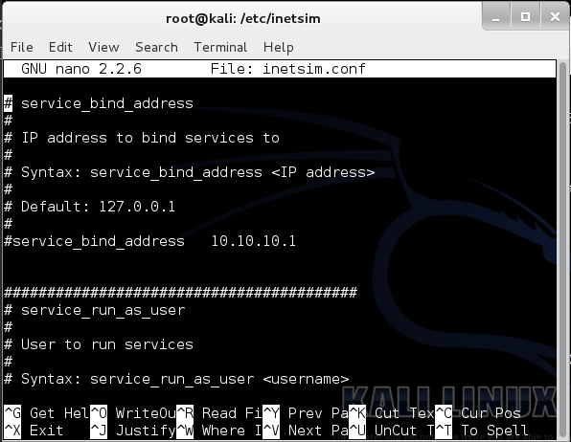
Change this line:
#service_bind_address 10.10.10.1
to this
service_bind_address 0.0.0.0
as shown below.
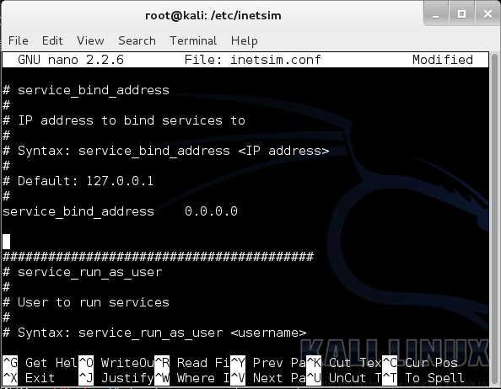
Don't forget to delete the # at the start of the line!
Scroll down another several screens to find the dns_default_ip section shown below. Find this line:
#dns_default_ip 10.10.10.1
Remove the # at the start of the line, and replace the IP address with the IP address of your Kali Linux machine, as shown below:
dns_default_ip 192.168.1.132
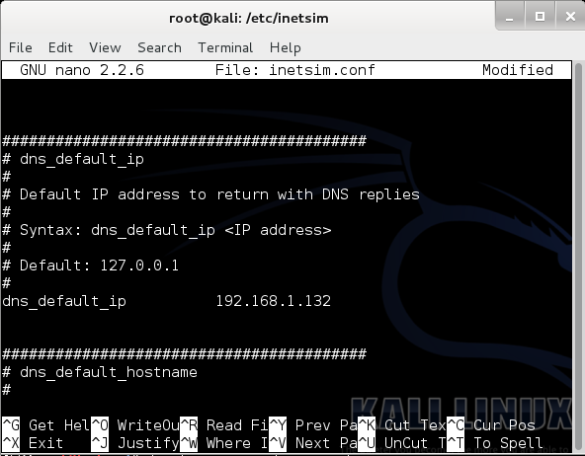
Use your correct IP address instead of "192.168.1.132"
Save the file with Ctrl+X, Y, Enter.
To start inetsim, on your Linux machine, in a Terminal window, execute this command:
inetsim

Start Your Windows VM
Start your Windows XP SP3 virtual machine, and set it to NAT networking.
Log in as Student with no password.

Installing Nmap
In your Windows XP SP3 virtual machine, open a Web browser and go to
http://nmap.org/
On the upper left, click Download.
Scroll down to the "Microsoft Windows binaries" section, as shown below.
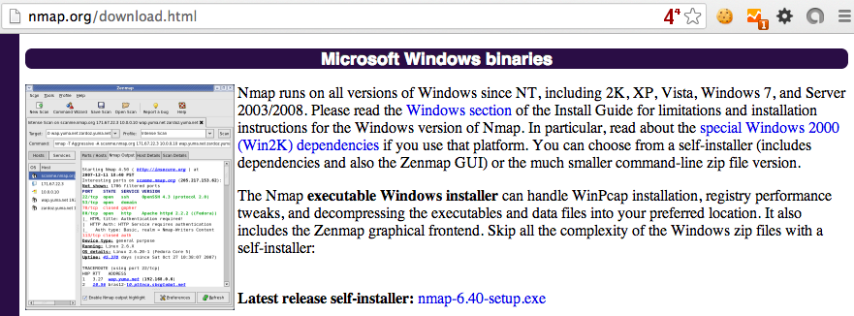
Click the link labelled "Latest release self-installer".
Install the software with the default options.

Setting the DNS Server
On your Windows VM, in Control Panel, open "Network Connections". Right-click "Local Area Connection" and click Properties.
Double-click "Internet Protocol (TCP/IP)".
Set your DNS server to the Kali Linux machine's IP address, as show below:
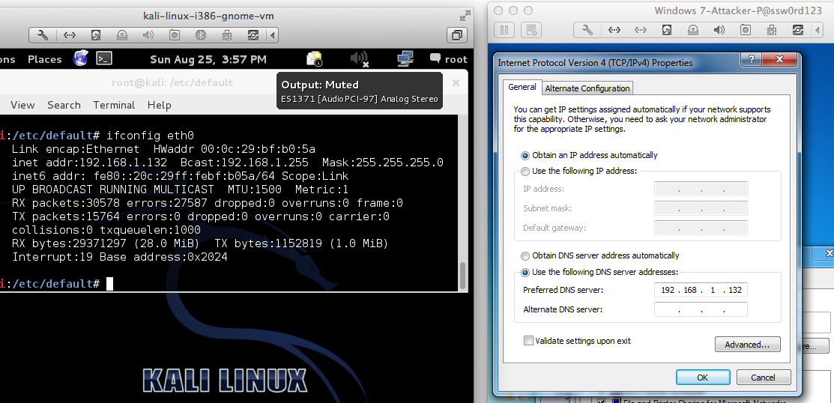

Viewing an HTTP Web Page
Open a Web browser on the Windows VM and go to this URL: http://YOURNAME.com, replacing "YOURNAME" with your real name.
You see the INetSim default HTML page, as shown below:
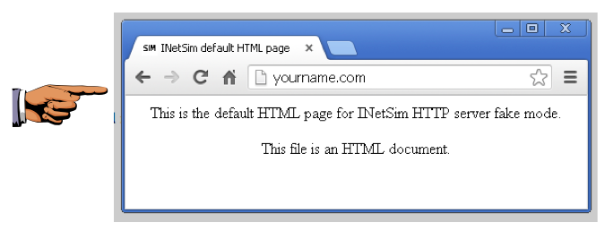

Saving a Screen Image
Make sure the Web browser shows these two things:
- YOUR NAME in the URL
- The "INetSim HTTP server" message
Click the taskbar at the bottom of your host Windows 7 desktop, to make the host machine listen to the keyboard, instead of the virtual machine.
Press the PrintScrn key in the upper-right portion of the keyboard. That will copy the whole desktop to the clipboard.
YOU MUST SUBMIT A FULL-SCREEN IMAGE FOR FULL CREDIT!
On the host machine, not the virtual machine, click Start.
Type mspaint into the Search box and press the Enter key.
Click in the untitled - Paint window, and press Ctrl+V on the keyboard. The desktop appears in the Paint window.
Save the document with the filename "YOUR NAME Proj 3a", replacing "YOUR NAME" with your real name.

Scanning YOURNAME.com
Start Nmap. Enter a Target of YOURNAME.com, replacing "YOURNAME" with your own name.
Click the Scan button.
You should see a lot of open ports, as shown below.
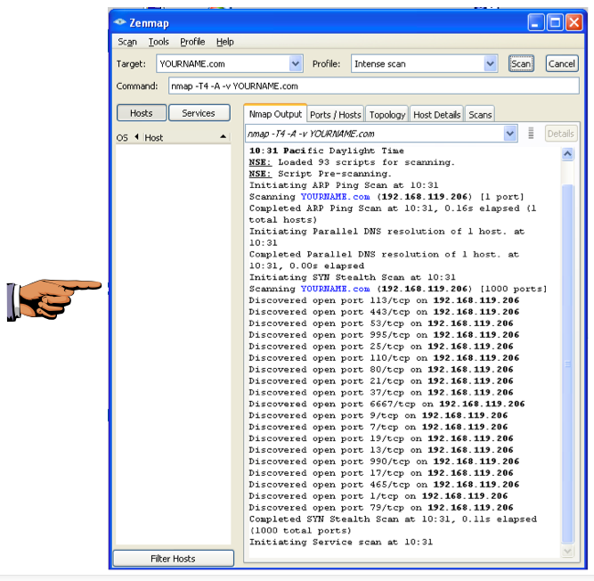

Saving a Screen Image
Make sure the Nmap window shows these two things:
- A long list of open ports is visible in the Nmap window, as shown above.
Note: If you wait too long, the scan will complete and scroll to the bottom. Drag the scroll bar back to the top to capture the image shown above.
- YOUR NAME in the Target field
Click the taskbar at the bottom of your host Windows 7 desktop, to make the host machine listen to the keyboard, instead of the virtual machine.
Press the PrintScrn key to copy the whole desktop to the clipboard.
YOU MUST SUBMIT A FULL-SCREEN IMAGE FOR FULL CREDIT!
Paste the image into Paint.
Save the document with the filename "YOUR NAME Proj 3b", replacing "YOUR NAME" with your real name.

