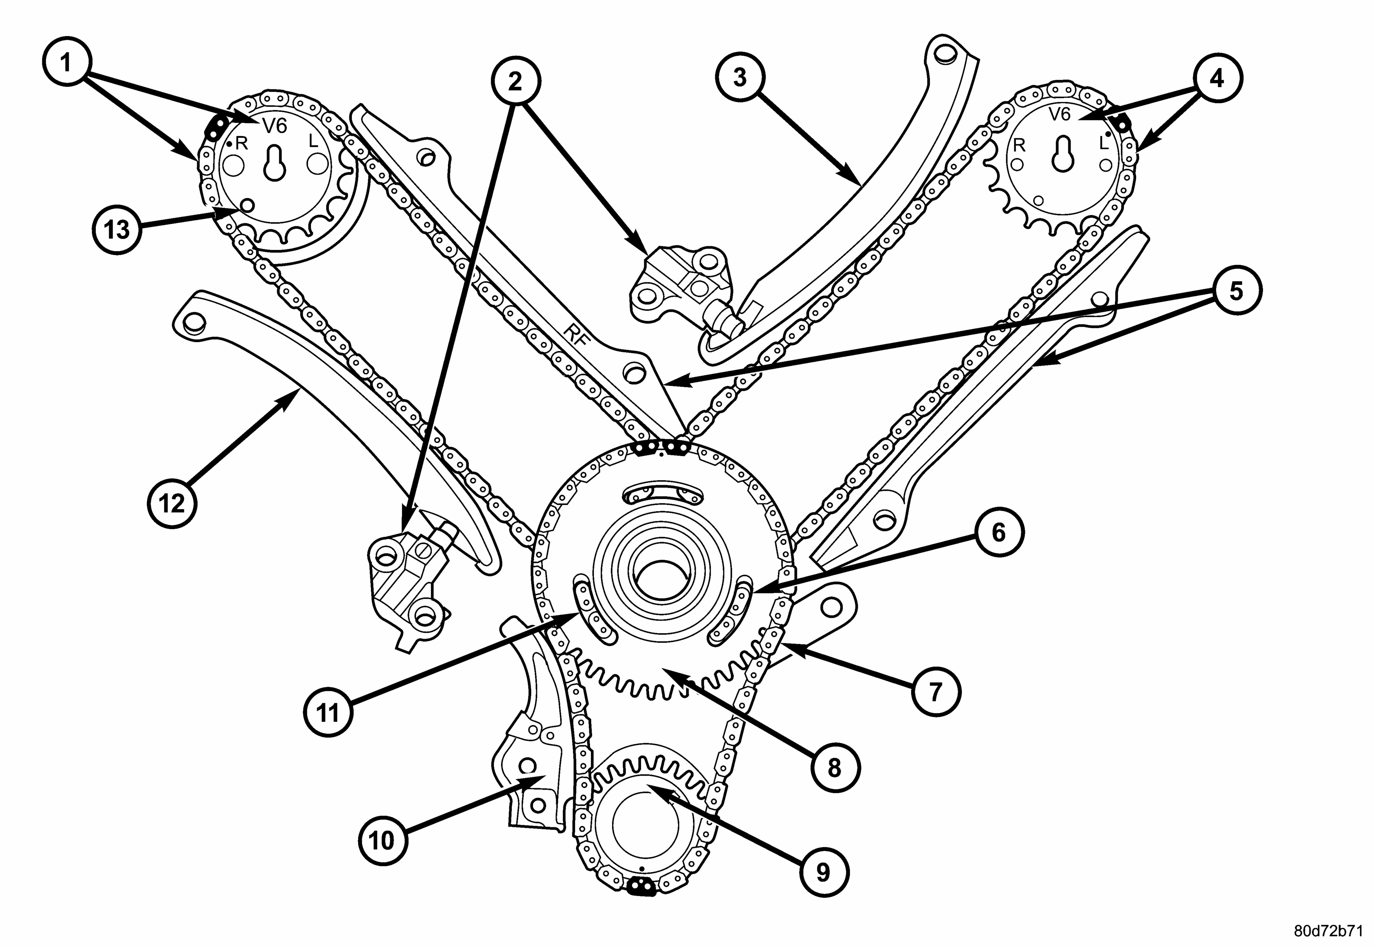

11 and 6 it does have only one link mark. Is not like on older model with two link marks to align inside window.

