- Print ArticleShare Article

01-01-2013

TF-81SC Solenoid Connector & Wire Color Identification
Valve Body Xpress
Questions? Email Sonnax Tech Support about this article.
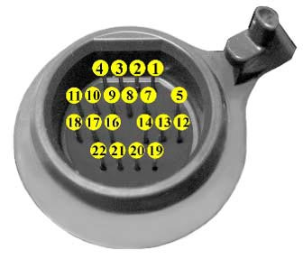Use the chart and connector diagram to check the solenoids from outside the transmission. Use the chart and valve body pictures to insure that the solenoids don't get cross-wired.
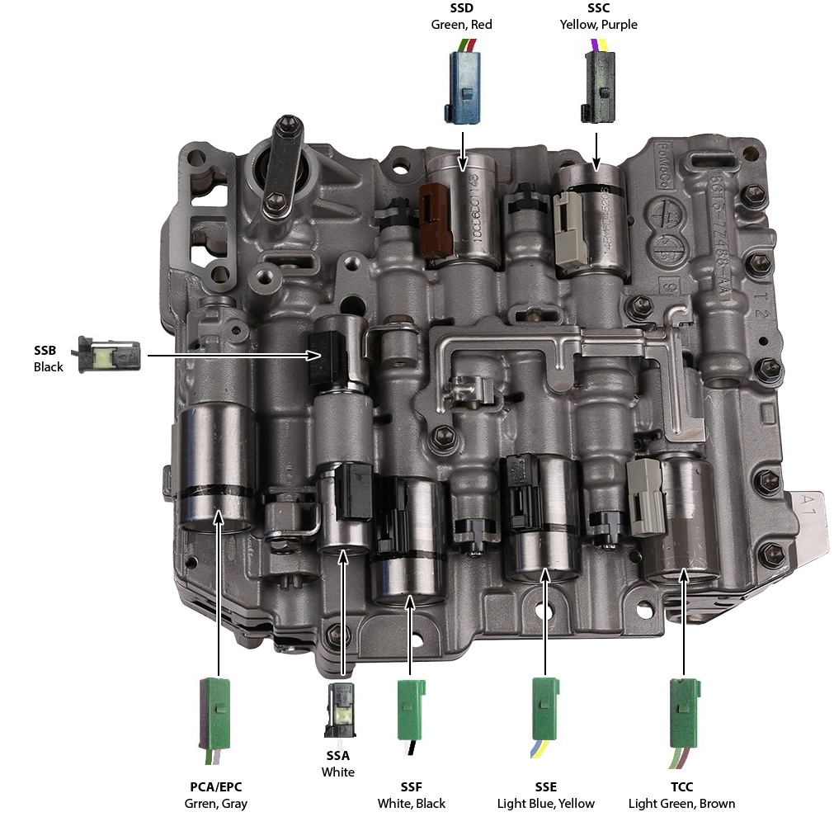
Name | Positive Terminal  (Wire Color) | Negative Terminal  (Wire Color) | Harness Connector Color | Resistance (Ohms)
SSA | 5 (White) | Grounds to Case | Black | 11-15
SSB | 2 (Black) | Grounds to Case | Black | 11-15
SSC | 11 (Yellow) | 10 (Purple) | Blue or Black | 5.0-5.6
SSD | 17 (Red) | 18 (Green) | Blue | 5.0-5.6
SSE | 14 (Light Blue) | 22 (Yellow) | Green | 5.0-5.6
SSF | 21 (White) | 16 (Black) | Green | 5.0-5.6
TCC | 9 (Light Green) | 4 (Brown) | Green | 5.0-5.6
PCA/EPC | 3 (Green) | 1 (Gray) | Green | 5.0-5.6
TFT Sensor | 8 (Orange) | 7 (Orange) | Sensor is gray and part of internal harness | 77F-3.5K
TSS | 12 (White) | 13 (Red) | Tan | Hall Effect
OSS | 10 (Orange) | 20 (Blue)

