Here is the wiring info for the vehicle. There are no RCAs to go to the factory amplifier.
2005 Chrysler 300
Boston Acoustics Systems
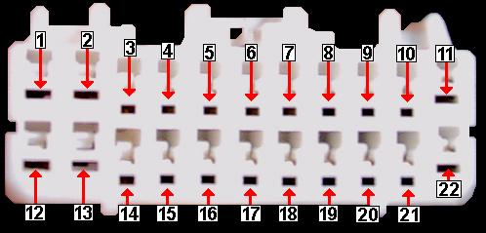

FUNCTION PIN WIRE COLOR  Accessory 12 Volt SEE NOTE ¹  Constant 12 Volt 1,12 GY/L.GN (2X)  Chassis Ground 11,22 BK/GN (2X)  Power Antenna  Remote SEE NOTE ²  Illumination  Dimmer | FUSE VALUE FUSE LABEL FUSEBOX LOCATION  20 AMP #36 IN TRUNK BESIDE SPARE
Left + to Amp | 18 | D.GN/D.BU ²
Left - to Amp | 19 | D.GN/OG ²
Right + to Amp | 21 | GY/D.BU ²
Right - to Amp | 20 | GY/OG ²
Hands Free Cellular | 4  16  17 | GY/OG  GN/YW  GN
PCI Bus Data | 5 | WT/OG
PCI Bus Data | 6 | WT
DO NOT USE THESE WIRES!

Amplifier Wiring
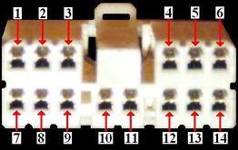 | 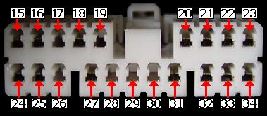
FUNCTION PIN WIRE COLOR  L/F Door Spkr + 1 GY/VT  R/F Door Spkr + 2 D.GN/VT  Left Rear Spkr + 3 D.GN/TN  Right Rear Spkr + 4 D.GN/BN  Deck Subwoofer + 5 GY/BN*  L/F Door Spkr - 7 GY/YW  R/F Door Spkr - 8 D.GN/YW  Left Rear Spkr - 9 D.GN/GY  Right Rear Spkr - 12 YW/GY  Deck Subwoofer - 13 D.GN/BN*  The amplifier is protected by a 20A fuse labeled #44 that is located in the fusebox beside the spare tire.  *These wires are only present in the eight-speaker system. | FUNCTION PIN WIRE COLOR  Left Dash Spkr + 15 GY/OG  Right Dash Spkr + 16 GY/D.GN  Center Dash Spkr + 17 GY/BN*  Constant 12 Volt 18 D.GN/GY  PCI Bus Data Line 20 WT/OG  Left + Input 21 D.GN/D.BU  Right + Input 22 GY/D.BU  Chassis Ground 23 BK/TN  Left Dash Spkr - 24 GY/YW  Right Dash Spkr - 25 GY/L.GN  Center Dash Spkr - 26 GY/OG*  Constant 12 Volt 27 D.GN/GY  PCI Bus Data Line 31 WT  Left - Input 32 D.GN/OG  Right - Input 33 GY/OG  Chassis Ground 34 BK/TN

Video and Navigation Wires
FUNCTION | LOCATION | COLOR
Vehicle Speed Sensor | (V6 models only)-Pin #32 of 38 pin plug at PCM (conn. color is black/green) PCM located on passengers rear of engine compartment (V8 models use Data system, must add speed pulse generator) | D.GN/BN (V6 only)
Reverse Light ( + ) | Pin #17 of 26-pin plug located high in RH kickpanel | WT/L.GN
Parking Brake ( - ) | At parking brake switch | GY/BK
Brake Light ( + ) | At brake pedal switch | D.GN/WT

The factory radio does not have a traditional Accessory 12 Volt lead, rather the radio turns on and off via the data lines in pins #5 and #6. If an aftermarket stereo is installed, a wire must be run to the fusebox to an Accessory 12 Volt fuse.
The amplifier receives a two channel signal from the receiver. The PCI Bus data lines control fading and amp remote functions.
There are two Boston Acoustics Systems available. The six-speaker system has corner dash, front door and rear deck speakers powered by an amplifier (total system power is rated at 288 Watts). The eight-speaker system adds a center dash speaker and rear deck subwoofer also powered by an amplifier (total system power increases to 380 Watts). The amplifier in both systems is located above the driver's side kickpanel.
Read more: http://www.justanswer.com/car-electronics/5o9iz-need-help-installing-pioneer-x930bt-chrysler-300c.html#ixzz3gRfL7CKt

