Question 21 of 40 | 2.5 Points
Select the best estimate of the correlation coefficient for the data depicted in the scatter diagram.
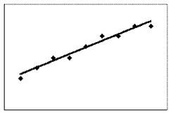

A. -0.9
B. 0.9
C. 0.5
D. -0.5

Question 22 of 40 | 2.5 Points
The scatter plot and best-fit line show the relation between the price per item (y) and the availability of that item (x) in arbitrary units. The correlation coefficient is -0.95. Determine the amount of variation in pricing explained by the variation in availability.
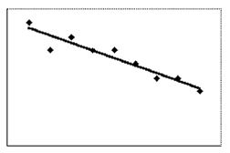

A. 5%
B. 10%
C. 95%
D. 90%

Question 23 of 40 | 2.5 Points
Select the best fit line on the scatter diagram below.
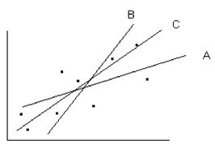

A. A
B. B
C. C
D. None of the lines is the line of best fit

Question 24 of 40 | 2.5 Points
Which line of the three shown in the scatter diagram below fits the data best?
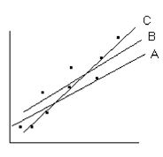

A. A
B. B
C. C
D. All the lines are equally good

Question 25 of 40 | 2.5 Points
Select the best estimate of the correlation coefficient for the data depicted in the scatter diagram.
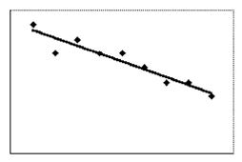

A. -0.9
B. 0.1
C. 0.5
D. 0.9

Question 26 of 40 | 2.5 Points
A sample of 64 statistics students at a small college had a mean mathematics ACT score of 28 with a standard deviation of 4. Estimate the mean mathematics ACT score for all statistics students at this college. Give the 95% confidence interval.

A. 28.0 to 30.0
B. 25.0 to 27.0
C. 29.0 to 31.0
D. 27.0 to 29.0

Question 27 of 40 | 2.5 Points
Which point below would be an outlier if it were on the following graph?
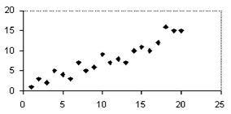

A. (25, 20)
B. (5, 12)
C. (7, 5)
D. (5, 3)

Question 28 of 40 | 2.5 Points
30% of the fifth grade students in a large school district read below grade level. The distribution of sample proportions of samples of 100 students from this population is normal with a mean of 0.30 and a standard deviation of 0.045. Suppose that you select a sample of 100 fifth grade students from this district and find that the proportion that reads below grade level in the sample is 0.36. What is the probability that a second sample would be selected with a proportion less than 0.36?

A. 0.8932
B. 0.8920
C. 0.9032
D. 0.9048

