Unless otherwise stated, answer in complete sentences, and be sure to use correct English spelling and grammar. Sources must be cited in APA format. Your response should be a minimum of one (1) single-spaced page to a maximum of two (2) pages in length; refer to the "Assignment Format" page for specific format requirements.
C10; Introduction to Computers
Assignment 8; Business Consulting
Remember Bill? He was the gentleman that you helped to start up his business in week 4. Well his business is doing well, but he has come to you with some questions and concerns. You discuss each of these with Bill and promise to send him a written report with your suggestions and recommendations. Submit your written response to Bill’s questions and concerns below.
- Bill has set up a spreadsheet in Excel that will help him keep track of expenses. So far, he has this:
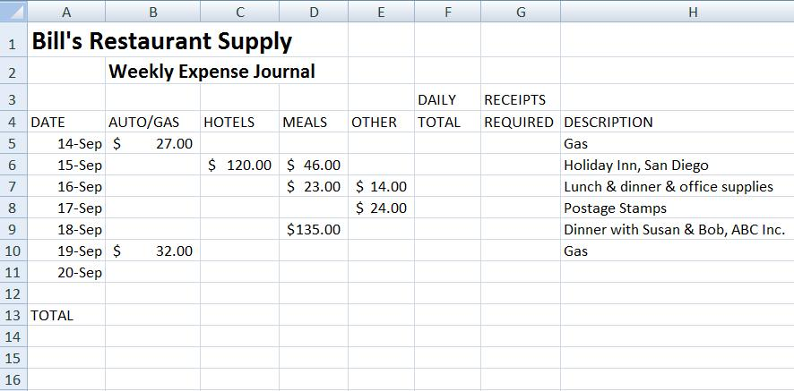
Tell Bill how to do the following tasks:
- What formula or function does he put in Column F that will show the total expenses for each day?
- What formula or function does he put in columns B through F in Row 13 that will give him the total expenses for the week in each category?
- Bill wants the entry in Column G to remind him of expenses that require receipts for the accountant. Tell Bill what to put in Column G to do this:
  - Print the word “Yes” in any row where the total daily expenses are greater than or equal to $100.00.
  - If the daily expenses total is less than $100.00, leave the Column G entry for that row blank.
- Bill’s business is already expanding. He thinks that in a few weeks, he will need to hire one or two employees to help him. He knows that each new employee will need their own computer. He is also making the necessary changes so that the new employees will be working in a spare room in Bill’s house. Explain to Bill what networking options he has. Go through each type or configuration of network possible for him, making sure that you explain the pros and cons of each configuration. Finish with your suggestion for the network that he should set up and explain what new hardware will be required to do this.
- With the possibility of three business computers in his home, and all of his business records possibly vulnerable, this would be a good time to advise Bill on how to set up a routine plan to protect and defend his new network. Provide a list of the five most important concerns for safety and security of the network and the computers in the network. For each concern, specify the action to be taken, and if applicable, what software you recommend be added to the system. Justify each of your recommendations.

Your proposal will be evaluated using the rubric below. Make sure you read the rubric and have a clear idea of what is expected. If there are any additional questions that you would have asked Bill be sure to note them as you explain to Bill what networking options he has so that you can explain what additional information could change your suggestion if any.

Rubric
