Before answering numerical exercises.. REMEMBER THE FOLLOWING:
1) Pay attention to the units in which you have to introduce your answer. They are always given in the exercise formulation.
2) You don't have to insert the units or the "%" symbol in the answer box; just the number.
3) If you want to put decimals, use the period symbol ".".
4) Some of the answers involve powers of 10. For example, one exercise may ask you for the electron concentration in 104cm−3. If your answer is, for example, 4.5∗104cm−3, you will just need to insert in the answer box "4.5". If, on the other hand, your answer is 4.5∗103cm−3, you will need to insert "0.45".
5) Lastly, if you want to be safe, do NOT round off your answer unless explicitly stated. Too many decimals will never result in a wrong answer.
For this assignment, you may have to apply some of the useful constants and/or formulas provided here:
Download the Constants and Formulas

EQ1.1.1 DRIFT OF CHARGE CARRIERS

(1 point possible)
Which of the following statements is false regarding the ‘drift’ of charge carriers?

It is the dominant carrier transport mechanism when an electric field is applied in the semiconductor. Holes move in the direction opposite to that of the applied field. During drift, the carrier transport is characterized by their respective electron/hole mobilities. During drift, electrons and holes move in opposite directions.
- unanswered

EQ1.2.1 BIASED P-N JUNCTION

(1 point possible)
The width of the space charge region at a p-n junction is reduced by applying a voltage bias over the p-n junction. What is the correct statement on both the bias voltage and the p-n junction?

The voltage is a forward bias and the diffusion of the majority charge carriers becomes more dominant. The voltage is a reverse bias and the diffusion of the majority charge carriers becomes more dominant. The voltage is a forward bias and the drift of the minority charge carriers becomes more dominant. The voltage is a reverse bias and the drift of the minority charge carriers becomes more dominant.

EQ1.3.1 OPEN-CIRCUIT VOLTAGE

(1 point possible)
The current density of an ideal p-n junction under illumination can be described by:
J(V)=Jph−J0(eqVkT−1)
where Jph is the photocurrent density, J0 the saturation current density, q the elementary charge, V the voltage, k the Boltzmann's constant, and T the temperature.
A crystalline silicon solar cell generates a photocurrent density of Jph=40mA/cm2 at T=300K. The saturation current density is J0=1.95∗10−10mA/cm2.
Assuming that the solar cell behaves as an ideal p-n junction, calculate the open-circuit voltage Voc (in V).
- unanswered

EQ1.4.1 FILL FACTOR AND EFFICIENCY

(1 point possible)
A solar cell with dimensions 12cm x 12cm is illuminated at standard test conditions. The cell presents the following external parameters:
Voc=0.8V,Isc=3A,Vmp=0.75V,Imp=2.5A
Calculate the fill factor (in %):
- unanswered
CHECKYOUR ANSWER SAVEYOUR ANSWER
You have used 0 of 3 submissions

EQ1.4.2 FILL FACTOR AND EFFICIENCY

(1 point possible)
Calculate the efficiency (in %):
- unanswered
CHECKYOUR ANSWER SAVEYOUR ANSWER
You have used 0 of 3 submissions
Show Discussion

EQ1.5.1 IDEAL I-V CURVE

(1 point possible)
John has used a solar simulator setup to measure the relation between the voltage and the current of a small photovoltaic module (40 cm long and 40 cm wide). The measurement setup maintains the standard measurement conditions: the temperature is controlled to 25oC, the incident spectrum is the AM1.5 spectrum and the incident power density is 1000W/m2. The result is illustrated in the figure below.
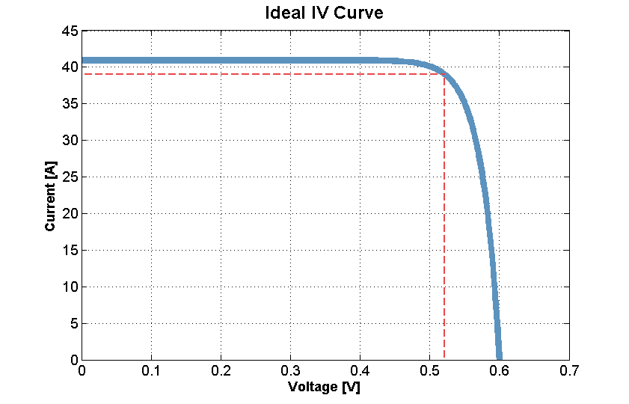
Calculate the short-circuit current density (in mA/cm2).
- unanswered
CHECKYOUR ANSWER SAVEYOUR ANSWER
You have used 0 of 3 submissions

EQ1.5.2 IDEAL I-V CURVE

(1 point possible)
John determined that the maximum power he could get out of this module is 19.5 W. Calculate the fill factor of the module (in %).
- unanswered
CHECKYOUR ANSWER SAVEYOUR ANSWER
You have used 0 of 3 submissions

EQ1.5.3 IDEAL I-V CURVE

(1 point possible)
What is the efficiency of the module (in %)?
- unanswered
CHECKYOUR ANSWER SAVEYOUR ANSWER
You have used 0 of 3 submissions

EQ1.5.4 IDEAL I-V CURVE

(1 point possible)
John decides to connect two of these modules with a cable in series. This results in an additional 2mΩ series resistance loss. What is the new fill factor (in %)? (Hint: use the voltage drop at the maximum power point).
- unanswered
CHECKYOUR ANSWER SAVEYOUR ANSWER
You have used 0 of 3 submissions

EQ1.6.1 NON-IDEAL J-V CURVE

(1 point possible)
Below you see a plot of an ideal and a non-ideal J-V curve. Based on this plot and assuming an irradiance of 1000W/m2, give approximately the numerical values to the questions below:
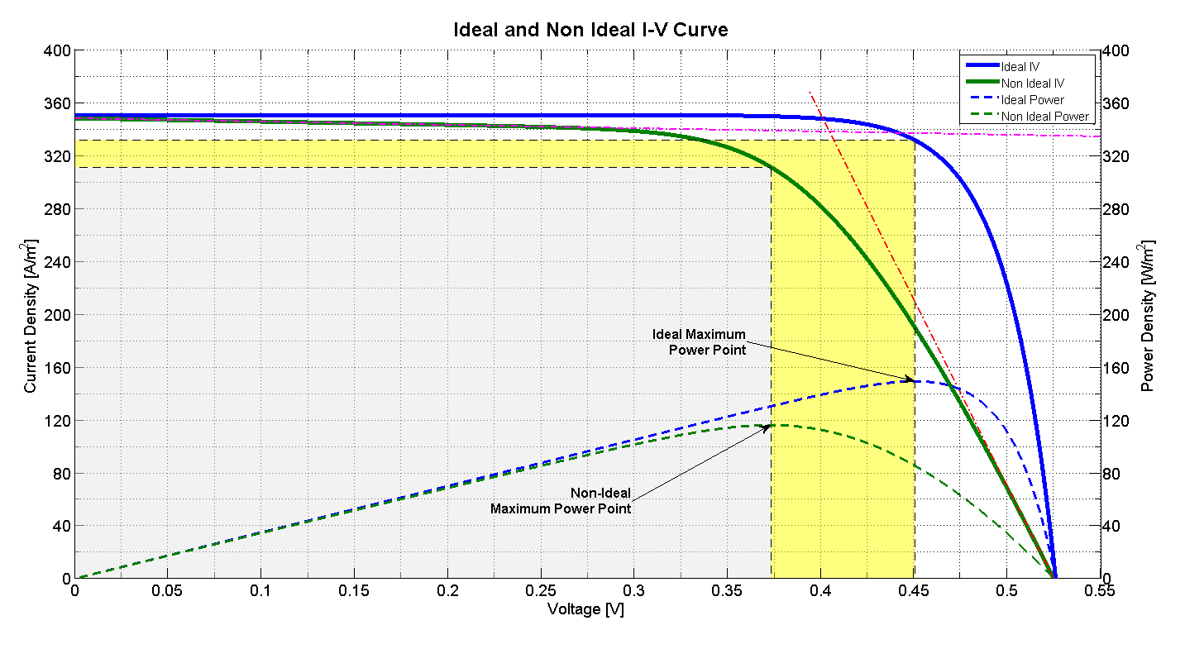
Estimate the ideal fill factor (in %):
- unanswered
CHECKYOUR ANSWER SAVEYOUR ANSWER
You have used 0 of 3 submissions

EQ1.6.2 NON-IDEAL J-V CURVE

(1 point possible)
Estimate the non-ideal fill factor (in %):
- unanswered
CHECKYOUR ANSWER SAVEYOUR ANSWER
You have used 0 of 3 submissions

EQ1.6.3 NON-IDEAL J-V CURVE

(1 point possible)
Estimate the ideal efficiency (in %):
- unanswered
CHECKYOUR ANSWER SAVEYOUR ANSWER
You have used 0 of 3 submissions

EQ1.6.4 NON-IDEAL J-V CURVE

(1 point possible)
Estimate the non-ideal efficiency (in %):
- unanswered
CHECKYOUR ANSWER SAVEYOUR ANSWER
You have used 0 of 3 submissions

EQ1.6.5 NON-IDEAL J-V CURVE

(1 point possible)
Which of the following statements is true?

The inverse of the slope of the non-ideal curve at V=Voc is approximately equal to the shunt resistance. An increase in shunt resistance will result in an decrease in fill factor in reference to the non-ideal case. A large current in the shunt branch will increase the efficiency of the solar cell The inverse of the slope of the non-ideal curve at V=Voc is approximately equal to the series resistance.
- unanswered

FINAL CHECKYOUR ANSWER SAVEYOUR ANSWER
You have used 0 of 1 submissions

EXTRA QUESTIONS (NO POINTS)

The Vmp and Jmp of a non-ideal solar cell are given in the plot above. The area of the solar cell is 4cm2. Having in mind the equivalent circuit of the non-ideal solar cell, calculate the current in mA at the shunt branch if Rsh=0.04Ω∗m2 and Rs=2.8∗10−4Ω∗m2 when the solar cell is operating at the maximum power point.
- unanswered
According to your answer above, calculate how much power in mW is dissipated due to shunting of the solar cell at the maximum power point. Hint: Remember two things: (1) the relation between power, current and voltage and (2) Ohm's law!
- unanswered

EQ1.7.1 ABSORPTION COEFFICIENT

(1 point possible)
In the figure below the absorption coefficient as a function of the wavelength for several semiconductor materials is presented. Let's consider monochromatic light of photons with energy of Eph=1.55eV that incidents a film with thickness d. If we ignore possible reflection losses at the rear and front interfaces of the film, what thickness d (in μm) is required to achieve a light absorption of 90%?
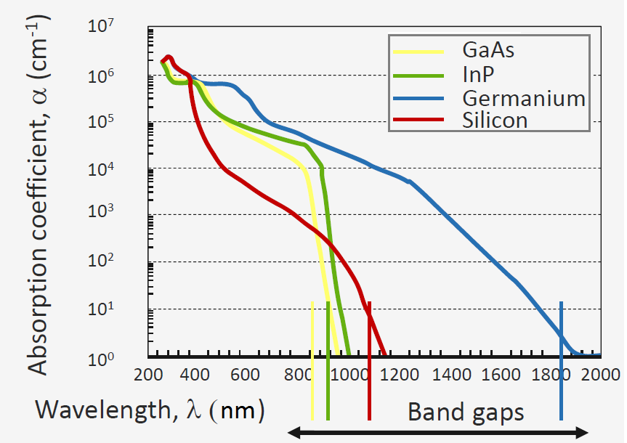
The absorption coefficients for the different semiconductor materials at α(800nm) are:
αGaAs=2∗104cm−1
αInP=4∗104cm−1
αGe=6∗104cm−1
αSi=1∗103cm−1.
The thickness d (in μm) required to achieve a light absorption of 90% for GaAs is:
- unanswered
CHECKYOUR ANSWER SAVEYOUR ANSWER
You have used 0 of 3 submissions

EQ1.7.2 ABSORPTION COEFFICIENT

(1 point possible)
The thickness d (in μm) required to achieve a light absorption of 90% for InP is:
- unanswered
CHECKYOUR ANSWER SAVEYOUR ANSWER
You have used 0 of 3 submissions

EQ1.7.3 ABSORPTION COEFFICIENT

(1 point possible)
The thickness d (in μm) required to achieve a light absorption of 90% for Ge is:
- unanswered
CHECKYOUR ANSWER SAVEYOUR ANSWER
You have used 0 of 3 submissions

EQ1.7.4 ABSORPTION COEFFICIENT

(1 point possible)
The thickness d (in μm) required to achieve a light absorption of 90% for Si is:
- unanswered
CHECKYOUR ANSWER SAVEYOUR ANSWER
You have used 0 of 3 submissions

EQ1.8.1 REFLECTION IN A SOLAR CELL

(1 point possible)
Let's assume that solar light reaches a silicon solar cell with an angle of incidence of θi=0o. For simplicity, let's consider the refractive index of silicon to be nSi=3.5. The refractive index of air is nair=1. What percentage of light would be lost due to reflection at the air-silicon interface? Assume that the solar light is randomly polarized.
incorrect

