ABC COMPANY CYBERSECURITY POLICY

Project Plan
ABC Company
Technology Project

Author: Abraham Brotsky
Creation Date: 1/26/17
Last Revised: 1/26/17
Version: 1.0

TABLE OF CONTENTS
INTRODUCTION 2
Purpose of Plan 2
Background Information/Available Alternatives 2
Project Approach 2
GOALS AND OBJECTIVES 3
Business Goals and Objectives 3
Project Benefits 3
SCOPE 4
Scope Definition 4
Items Beyond Scope 4
Projected Budget 4
Risk Assessment 5
Initial Project Risk Assessment 5
Milestones 7
PROJECT MANAGEMENT APPROACH 7
Project Timeline 7
Project Roles and Responsibilities 8
Communications Plan 9
APPROVALS 11
Sign-off Sheet 11

INTRODUCTION

Purpose of Plan

The ABC Company Technology Project Plan will provide a comprehensive plan of the project including the roles and responsibilities for each stakeholder, a budget and timeline, risks associated with the project and communication protocols to be used and followed throughout the project management life-cycle.

The Project Plan defines the following:

- Project purpose
- Business and project goals and objectives
- Scope and expectations
- Roles and responsibilities
- Project management approach
- Project budget
- Project timeline

Background Information/Available Alternatives

To date, I have outlined a Project Proposal which gives a broad overview of what to expect within the confines of the project, without delving into too many fine details. In working as an IT Specialist, particularly, a Cybersecurity Analyst along with my PM, Karl Rove, and two other stakeholders, my goal is to develop and implement a defined, workable cybersecurity policy for ABC Company. There will be three milestones, of which reports will be completed and delivered, that explain the key issues as pertaining to the cybersecurity policy.

Project Approach

Phase I: Secure agreement with vendors (ABC Company)
Phase II: Research Project Deliverables
Phase III: Deliver Milestones as Planned
Phase IV: Conduct Acceptance Testing
Phase V: Conduct Training
Phase VI: Implement Final User Acceptance Policy (UAP)

GOALS AND OBJECTIVES

Business Goals and Objectives

The business goals and objectives for this project will focus on implementing a cybersecurity policy that:

- Considers physical grounds security.
- Facilitates coordination and information sharing both internal and external to the participating companies.
- Enhances the ability and effectiveness of staff to perform their jobs.
- Facilitates coordinated cybercrime prevention and reduction.
- Provides high levels of data security.
- Provides an open, flexible, reliable security policy for the future.
- Is easy to understand, implement and use.
- Eliminate holes in the physical and technological infrastructure that could put the company at risk for attack.

Project Benefits

- Create a workable cybersecurity policy that meets the needs and demands of ABVC Company
- Satisfy the PM life-cycle triad of time, scope and budget.
- Minimize impact to standard business operations within the affected units.

Return on Investment

Return on investment is calculated by (expected returns – cost of investment) divided by costs of investment. According to ibm.com, the average cost of a data breach is $4 million (“IBM 2016 Cost of Data Breach Study – United States,” n.d.). According to smallbiztrends.com, small businesses are targets of cyberattacks 43% of the time (Sophy, 2016). 43% of 4 million is $1.72 million. If we can assume that with the project outcome the threat of a cyberattack will be reduced to 20%, then 20% of $4 million is $800,000. The net gain is ($1.72 million - $800,000) $920,000. If we subtract the cost of investments, (roughly $10,000), from expected returns ($920,000) the result is $910,000. $910,000 divided by $10,000 equals 91. This means the expected return on investment (ROI) is 91%. This is a very good return on investment because of how much the client, Company ABC, can profit from the diversion of potential cyberattacks.
SCOPE

Scope Definition

The Project will introduce a new cybersecurity policy; including the following:

- Next Generation Firewalls
- Intrusion Detection and Prevention Systems (IDPS)
- Remote Access Management and BYOD (Bring Your Own Device) Policies

Items Beyond Scope

The project does not include the following:

Actual, physical security devices mentioned above or video security cameras, biometric scanning devices, employee monitoring software, etc.
- Physical hardware/software upgrade or replacement
- Collaboration with outside vendors pertaining to the project

Projected Budget

 |  | Quantity per Week
Expense | Cost per Unit | Week 2 | Week 3 | Week 4 | Week 5 | Week 6 | Sub Total | Total
Labor by Hour | $35.00 | 10 | 10 | 10 | 10 | 15 | 55 | $1,925
Consultation Fees | $40.00 | 1 | 2 | 1 | 2 | 1 | 7 | $280
Interviews | $45.00 | 6 | 4 | 2 | 0 | 0 | 12 | $540
Workshops | $65.00 | 0 | 0 | 2 | 3 | 4 | 9 | $585
Training | $100.00 | 0 | 0 | 2 | 3 | 4 | 9 | $900
Policy Implementation | $5,500.00 | 0 | 0 | 0 | 0 | 0 | 1 | $5,500
 |  |  |  |  |  | Grand Total |  | $9730

The Budget includes hourly labor fees for the time spent researching the subject matter which will be presented in each of the three milestone reports. The Consultation fees are for the Consultations that will transpire between the IT Specialist, Abraham Brotsky, and ABC Company. During these consultations, Abraham Brotsky will brief the sponsor, ABC Company on the nature of the technology being researched and how these technologies may be applied to ABC Company. Interviews and Workshops will be carried out. Interviews will be towards the beginning of the project with the CTO, to gain a thorough understanding of where ABC Company stands presently and what policies need to be updated and revamped. Workshops will involve Abraham Brotsky and the Manager of Employees in which the topics covered in the milestones reports will be explained on the level of the Manager, minus the technical jargon. Training will be conducted for the CTO and Manager towards the second half of the project when the milestones are being implemented into the security policy. Finally, the User Acceptance Policy (UAP), the finalized cybersecurity policy, will be delivered before the Closing of the project to ABC Company.

Risk Assessment

The initial Risk Assessment attempts to identify, characterize, prioritize and document a mitigation approach relative to those risks which can be identified prior to the start of the project.

The Risk Assessment will be continuously monitored and updated throughout the life of the project, with Weekly assessments included in the status report (see Communications Plan) and open to amendment by the Project Manager.

Initial Project Risk Assessment

Risk | Risk Level  L/M/H | Likelihood of Event | Mitigation Strategy
Project Size
Person Hours | H: Over 55 | Certainty | The PM will lead the Project based on his skills and expertise and the CTO and IT Specialist will conform to the needs of the Project as deliniated by the PM
Estimated Project Schedule | M: Over 3 weeks | Likely | The pProject timeline will guide the Project and there are set milestones and weekly meetrings to ensure compliance
Project Definition
Project Scope Creep | L: Scope generally defined, subject to revision | Unlikely | The Project will be scrutinized on the outset and threafter in order to ensure that the scope is defined and not changed unneccesarily
IT Specialist Project Deliverables unclear | L: Well defined | Unlikely | Included in project plan, subject to being updated
Cost Estimates Unrealistic | L: Thoroughly predicted by industry experts using proven practices to 15% margin of error | Unlikely | Included in project plan, subject to being updated as new details rpertainingto the project scope are revealed
Timeline Estimates Unrealistic | M: Timeline assumes no derailment | Somewhat likely | Timeline will be reviewed weekly by the PM and CTO to maske sure Project stays witihng timeline
Policy Creator
Team’s Lack of Knowledge of Package | M: Conceptual understanding | Somewhat likely | Experience of the IT Specialist based on prior work of the same kind and extensive research will provide for a good, thourough grasping of the project deliverbles
Poor Functional Match of Package to Initial System Requirements | L: Minimal customization required | Unlikely | Although a package has not yet been selected, the IT Specialist has conducted research and interviews to pinpoint the needs of the system and ensure a smooth changeover with a policy that matches the project and company requirements
Team’s Involvement in Package Selection Impacts Success of Implementation | L: High involvement in selection | Unlikely | Comprehensive company vettingprocess to ensure that qualified employees oversee and adopt the new security policy

Milestones

The following represent key project milestones, with estimated completion dates:

Milestone Estimated Completion Date
Report on Next Generation Firewalls 01/31/2017
Intrusion Detection and Prevention Systems 02/07/2017
Remote Access and BYOD 02/14/2017

PROJECT MANAGEMENT APPROACH

Project Timeline

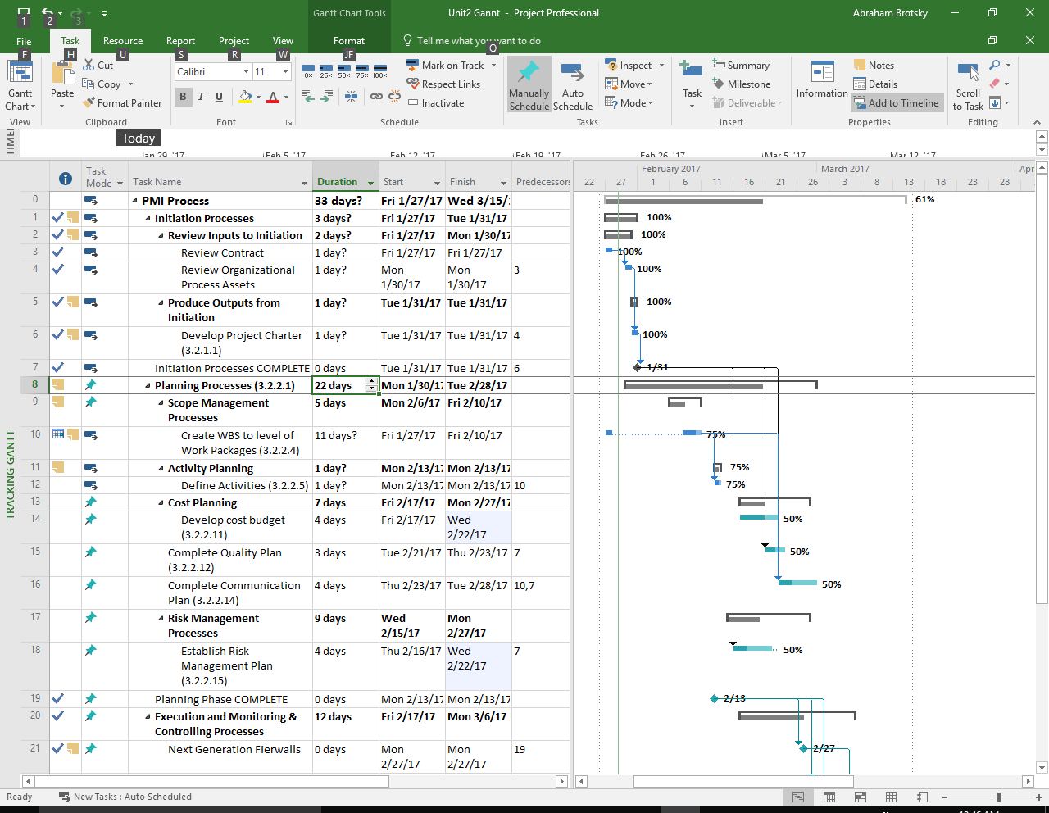
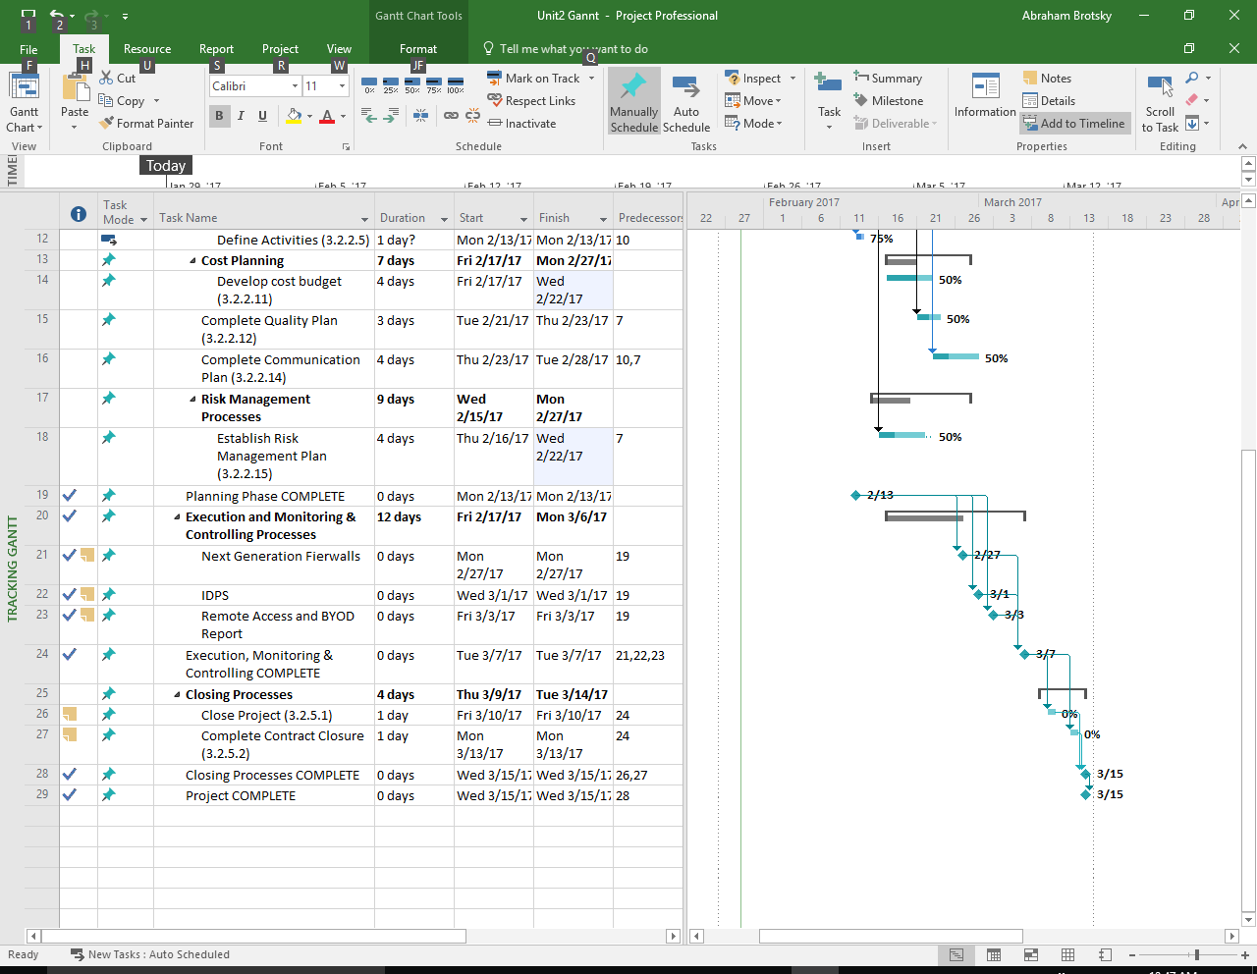
Project Roles and Responsibilities

Role | Responsibilities | Participant(s)
Project Sponsor | - Financer of the Project  - Has overall last word  - Has the authority to make/break all deals | ABC Company
Corporate Technology Officer | - Manages funding and related issues in allocating resources for the project  - Resolves disputes and conflicts  - Provides direction to the Project Manager  - Review project deliverables | Allison Sweeney
Project Manager | - Manages project in accordance to the project plan  - Serves as liaison to the CTO  - Receive guidance from CTO  - Provide overall project direction  - Direct/lead employees in development and implementation of project  - Ensures quality control  - Manages the project budget | Karl Rove
IT Specialist | - Understand the user needs and project requirements/deliverables of their area  - Act as consumer advocate in representing the area for end-users  - Communicate project status and progress throughout the project to PM and employees  - Review and approve project deliverables  - Coordinates participation of work groups, individuals and stakeholders  - Provide knowledge and recommendations  - Helps identify and remove project barriers  - Assure quality of products that will meet the project goals and objectives | Abraham Brotsky
Manager of Employees | - Lend expertise and guidance as needed | Rick Springfield

Communications Plan

This plan provides a framework for informing, involving, and obtaining buy-in from all participants throughout the duration of the project.

Audience This communication plan is for the following audiences:

- Project Sponsor
- CTO
- Project Manager
- Manager of Employees
- IT Specialist

Communications Methodology The communications methodology utilizes three directions for effective communication:

Top-Down It is crucial that everyone involved in the project gets their fair share of air time and input regarding the deliverables of the project and their implementation. To facilitate direct involvement from all levels of the company, it is very important that executives make themselves available, open and amenable to managers, employees, all stakeholders and their ideas. This project is not the result of an individual or group of individuals, but a result of the entire company processing the information together to the best of their abilities. As such, executives must see to it that they can have open communication with all levels of the company and they do not block out anyone in the company who may in any way have a stake in the success and outcomes of the project.

Bottom-Up To ensure that employees at all levels of the company will adapt to and welcome the changes of the intended project, it is important to communicate to every employee that their input is important and makes a difference. It cannot seem like the executives made all the decisions and left the rest of the company in the dark. To accomplish across-the-board implementation and adaption of the project, the end-users and lower level employees must approve of the changes and understand that their combined input and insights are what drives the project.

Middle-Out For the company to fully grasp and accept the project output, it is necessary that the core of the company’s functioning be up-to-date with changes being made. It is not enough for executives to be open-minded and available and for lower level employees to be on-board, barring the approach that a communal exchange must occur. At the end of the day, the company must jointly adopt the new system and work on it together as a team.

APPROVALS

Sign-off Sheet

I have read the above Project Plan and will abide by its terms and conditions and pledge my full commitment and support for the Project Plan.

Project Sponsor:
Date
Project Manager:
Date

CTO:
Date
IT Specialist:
Date

References
Retrieved from http://www.search.org/files/doc/Sample%20Project%20Plan.doc
IBM 2016 Cost of Data Breach Study - United States. (n.d.). Retrieved from http://www-03.ibm.com/security/data-breach/
Sophy, J. (2016, April 28). 43 Percent of Cyber Attacks Target Small Business. Retrieved from https://smallbiztrends.com/2016/04/cyber-attacks-target-small-business.html

