MODULE 1 ASSIGNMENT:
DECISION STRUCTURES AND INFORMATION SYSTEMS

OVERVIEW
In the third exploration for this module, you were shown a diagram that illustrated the different types of information systems used to facilitate various decision structures. In this assignment, you are to research one of the three decision structures and the information systems used to facilitate that type of decision.
Write a paper that meets the guidelines shown below in the instructions section.

OUTCOMES
- Define an information system.
- Describe how organizations are structured.

INSTRUCTIONS
Here is the diagram referenced in the exploration:
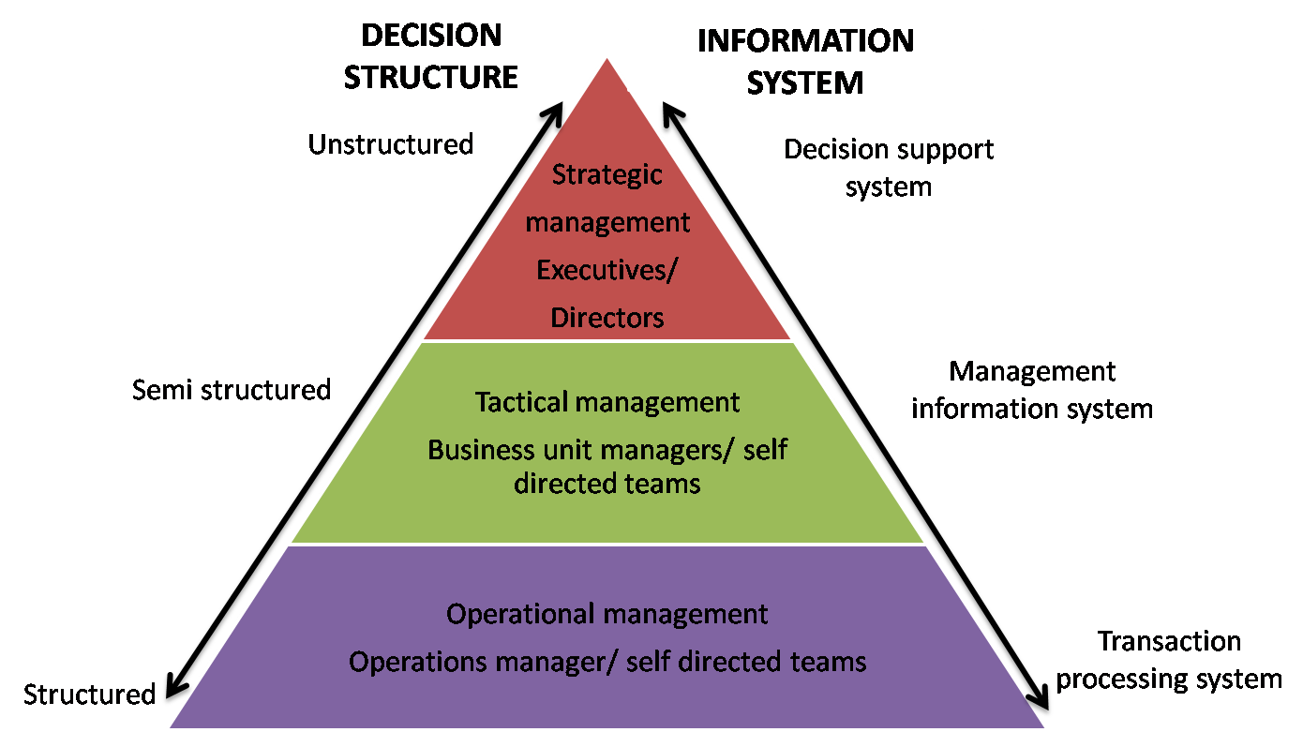
Parul Batra,"Types of Information Systems" [© Parul Batra]
For this assignment, write a research paper that defines and describes one of the three decision structures and the types of information systems that are used to support the decision structure that you selected.
The following points will be addressed regarding decision structures and the information systems that support those structures:
- Define the decision structure you select using multiple sources.
- Describe and analyze the information systems supporting the decision structure you select using the information found in your research.
- Identify at least three examples of information systems.
- Compare and contrast the three example information systems using your source information.
- List and critique any improvements to the systems that are recommended by your research sources.
Your finished work must meet the above requirements and comply with the Deliverables instructions below to earn full points.

Recommended Resources
Review the Research section in the Syllabus Module of the Course Content area for resources.

Deliverable
- The assignment will:
  - exhibit college-level writing, grammar and punctuation.
  - Include an introductory paragraph and a conclusion paragraph.
  - Include a minimum of three (3) sources external to the explorations and text used for this course.
    - All sources properly cited using APA citation guidelines (see Research Module in course content). Papers without cited sources will be assigned a grade of zero.
    - No wikis of any kind are allowed as sources for this paper. Your grade will be reduced by 10% for each source that is a wiki.
  - Properly cite sources using APA citation guidelines.
- The assignment will also meet the following specifications:
  - The length will be at least 3 pages but no more than 5 pages in length.
  - The pages will use 1.5 line spacing.
  - Page margins will be one inch all around.
  - The font used will be 11 or 12 point Arial.
- Submit the assignment by the posted deadline as an attachment to the appropriate Module dropbox in D2L.
- The file format of the paper will be Word readable document.
- See the assignment grading rubric for how this paper will be graded.

